Number 202, May 31, 2023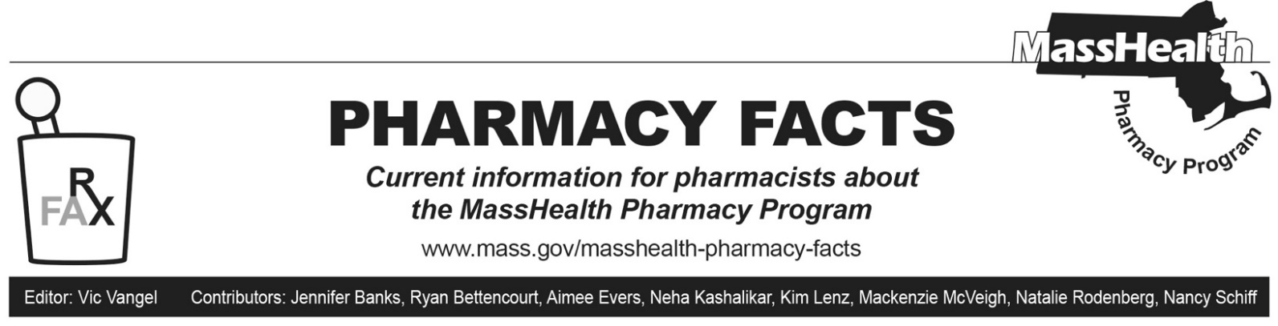

MHDL Update

The MassHealth Drug List (MHDL) has been updated. What follows is a list of some of the more notable changes. See the MHDL for a complete listing of updates.

Additions

Effective June 5, 2023, the following newly marketed drugs have been added to the MassHealth Drug List.

- Auvelity (dextromethorphan/bupropion) – PA
- Basaglar Tempo (insulin glargine) – PA
- Byooviz (ranibizumab-nuna); MB
- Cimerli (ranibizumab-eqrn); MB
- Dyanavel XR (amphetamine extended-release chewable tablet) – PA
  - Fylnetra (pegfilgrastim-pbbk)
- Humalog Tempo (insulin lispro 100 units/mL prefilled syringe) – PA
- Imjudo (tremelimumab-actl) – PA, MB
- Krazati (adagrasib) – PA
- Lytgobi (futibatinib) – PA
- Lyumjev Tempo (insulin lispro-aabc) – PA
- Noxafil (posaconazole powder for oral suspension) – PA
- Orserdu (elacestrant) – PA
- Rebyota (fecal microbiota, live-jslm) – PA
- Relexxi (methylphenidate extended-release) – PA
  - Rolvedon (eflapegrastim-xnst)
- Ryplazim (plasminogen, human-tvmh) – PA
- Stimufend (pegfilgrastim-fpgk)
- Tadliq (tadalafil suspension) – PA
- Tecvayli (teclistamab-cqyv) – PA; MB
- Tzield (teplizumab-mzwv) – PA
- Vegzelma (bevacizumab-adcd) – PA; MB
- Xelstrym (dextroamphetamine transdermal) – PA
- Xenpozyme (olipudase alfa-rpcp) – PA; MB
- Zonisade (zonisamide suspension) – PA
- Ztalmy (ganaxolone) – PA
- Zynteglo (betibeglogene autotemcel) ^{PD} – PA; CO, MB

Change in Prior-Authorization Status

- Effective June 5, 2023, the following antidepressant will require prior authorization (PA).
- Fetzima (levomilnacipran) – PA
- Effective June 5, 2023, the following antitubercular agent will no longer require PA.
  - pretomanid; A90
- Effective June 5, 2023, the following ophthalmic antibiotic agents will no longer require PA.
  - Tobradex ST (tobramycin 0.3%/dexamethasone 0.05% ophthalmic suspension)
  - Zylet (tobramycin/loteprednol ophthalmic suspension)
  - Zymaxid (gatifloxacin ophthalmic solution); #
Change in Coverage Status
Effective June 5, 2023, the following agents will be available through medical billing only and will no longer be available through pharmacy billing.
  - daunorubicin; MB
  - gemcitabine vial; MB
  - Jemperli (dostarlimab-gxly) – PA; MB
  - Opdualag (nivolumab/relatlimab-rmbw) – PA; MB
  - Tivdak (tisotumab vedotin-tftv) – PA; MB
  - Vyxeos (daunorubicin/cytarabine) – PA; MB
  - Xipere (triamcinolone ophthalmic suspension); MB

Updated MassHealth Brand Name Preferred Over Generic Drug List

The MassHealth Brand Name Preferred Over Generic Drug List has been updated to reflect recent changes to the MassHealth Drug List.

- Effective June 5, 2023, the following agents will be added to the MassHealth Brand Name Preferred Over Generic Drug List.
- Advair (fluticasone/salmeterol inhalation aerosol); BP, A90
- Denavir (penciclovir); BP, A90
- Hetlioz (tasimelteon) – PA; BP, A90
- Mycobutin (rifabutin); BP, A90
- Vyvanse (lisdexamfetamine capsule) – PA < 3 years or ≥ 21 years and PA > 2 units/day; BP
- Vyvanse (lisdexamfetamine chewable tablet) – PA; BP
- Zioptan (tafluprost) – PA; BP, A90
- Effective June 5, 2023, the following agents will be removed from the MassHealth Brand Name Preferred Over Generic Drug List.
- Amicar (aminocaproic acid); #, A90
- Androgel (testosterone 1.62% gel pump) – PA
- Evamist (estradiol)
- Hepsera (adefovir) – PA > 1 unit/day; #, A90
- Jublia (efinaconazole) – PA
- Monurol (fosfomycin); #, A90
- Sandostatin LAR (octreotide injectable suspension)
- Strattera (atomoxetine) – PA < 6 years; #, A90

____________________________________
Legend

PA Prior authorization is required. The prescriber must obtain prior authorization for the drug in order for the pharmacy to receive payment. Note: PA applies to both the brand-name and the FDA “A”-rated generic equivalent of listed product.

# Designates a brand-name drug with FDA “A”-rated generic equivalents. Prior authorization is required for the brand, unless a particular form of that drug (for example, tablet, capsule, or liquid) does not have an FDA “A”-rated generic equivalent.

BP Brand preferred over generic equivalents. In general, MassHealth requires a trial of the preferred drug or clinical rationale for prescribing the nonpreferred drug generic equivalent.

^{PD} In general, MassHealth requires a trial of the preferred drug (PD) or a clinical rationale for prescribing a nonpreferred drug within a therapeutic class.

CO Carve-Out. This agent is listed on the Acute Hospital Carve-Out Drugs List and is subject to additional monitoring and billing requirements.
MB This drug is available through the health care professional who administers the drug or in an outpatient or inpatient hospital setting. MassHealth does not pay for this drug to be dispensed through the retail pharmacy. If listed, prior authorization does not apply through the hospital outpatient and inpatient settings. Please refer to 130 CMR 433.408 for prior authorization requirements for other health care professionals.

A90 Allowable 90-day supply. Dispensing in up to a 90-day supply is allowed. May not include all strengths or formulations. Quantity limits and other restrictions may apply.

