Number 203, June 5, 2023
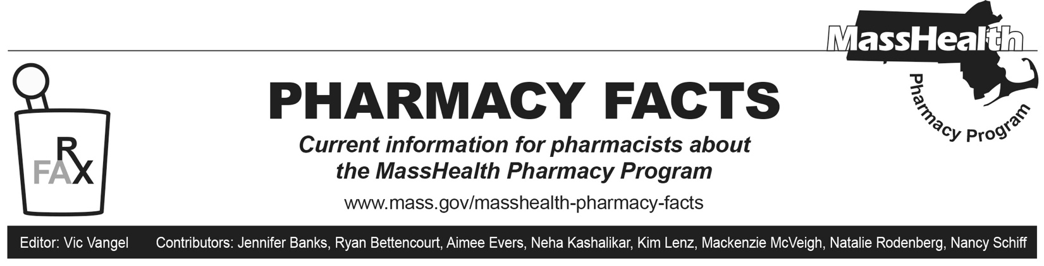
Pharmacy Claims Processing Update
Opioid First-Fill Seven-Day Supply Restriction
Effective June 5, 2023, members who are naïve to opioids (defined as no history of a paid MassHealth pharmacy claim for an opioid in the past 90 days) will be limited to a seven-day supply for their first fill except as described below. When submitting an opioid claim for these members, a pharmacy may see a claim rejection that reads as follows:
- AG – Days’ supply limitation for product/service, with text message, “Opioid first-fill 7-day limit. For members where 7-day supply limit does not apply, please submit with SCC-10 to exceed a 7-day supply. Please see the MassHealth Drug List for additional information.”

Seven-day supply opioid restrictions do not apply to members who already take opioids. Other exemptions may apply to seven-day supply opioid restrictions, including the following:
- members receiving palliative care treatment
- members with a current diagnosis of cancer or sickle cell disease
- members who live in nursing homes, chronic care facilities, or hospice care as indicated by submitted residence codes (NCPDP Field 384-4X) of 2-Skilled nursing facility, 3-Nursing facility, 4-Assisted living facility, 5-Custodial care facility, 6-Group home, or 11-Hospice.

MassHealth has implemented point-of-sale rules that will usually allow for a more than seven days’ supply of an opioid when a member meets the above exemption criteria. If a pharmacy receives a rejected claim for an opioid for a member who already takes opioids or who meets these exemption criteria, the pharmacy should submit the claim with a value of “10” (meets plan limitations) in the submission clarification code field (NCPDP Field 420-DK). This submission clarification code will allow processing of a more than seven days’ supply of an opioid.
A pharmacy processing a partial first fill for an opioid should enter the reduced number of days’ supply, quantity dispensed, and submission clarification code 47-Initial fill for the initial dispense (NCPDP Field 420-DK). This allows for the prescribed quantity to be shortened.
If a subsequent fill is required, then the pharmacy should use submission clarification code 48-Incremental fill. This submission clarification code can be used twice per prescription. The subsequent claim should have the same prescription number, fill number, refill number, and prescribed quantity as the initial claim.

