Number 206, July 26, 2023
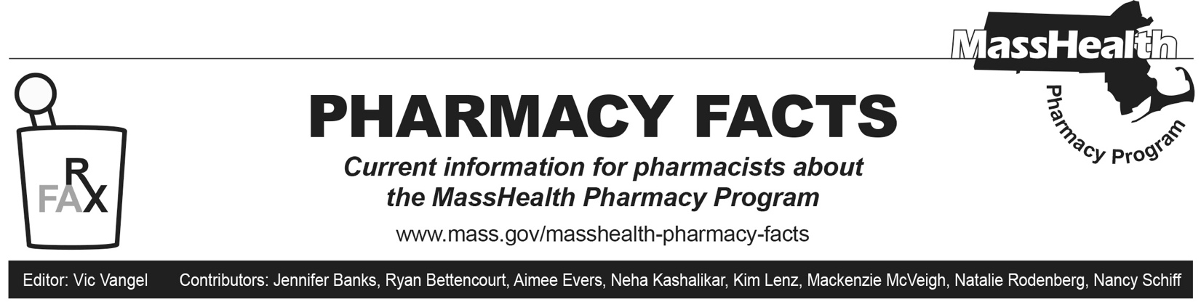
MassHealth Drug List Update

Below are certain updates to the MassHealth Drug List (MHDL). See the MHDL for a complete listing of updates.

Additions
Effective July 31, 2023, the following newly marketed drugs have been added to the MHDL.

- Altuviiio (antihemophilic factor, recombinant, fc-vwf-xten fusion protein-ehtl)
- Aspruzyo (ranolazine extended-release granules) – PA
- Atorvaliq (atorvastatin suspension) – PA
- Briumvi (ublituximab-xiiy) – PA
- Elahere (mirvetuximab soravtansine-gynx) – PA; MB
- Furoscix (furosemide on-body infusor) – PA
  - Gohibic (vilobelimab COVID EUA - April 4, 2023); MB
- Konvomep (omeprazole/sodium bicarbonate suspension) – PA
- Lamzede (velmanase alfa-tycv) – PA; MB
- Lunsumio (mosunetuzumab-axgb) – PA; MB
- Nexobrid (anacaulase-bcdb) – PA; MB
- oxybutynin immediate-release 2.5 mg tablet – PA; A90
- Pedmark (sodium thiosulfate) – PA; MB
- Pradaxa (dabigatran oral pellet) – PA
- Relyvrio (sodium phenylbutyrate/sodium taurursodiol) – PA
- Rezlidhia (olutasidenib) – PA
- Skyclarys (omaveloxolone) – PA
- Sunlenca (lenacapavir) – PA
- Vivimusta (bendamustine); MB

Change in Prior-Authorization Status
- Effective July 31, 2023, the following anticonvulsant will no longer require prior authorization (PA).
- Vimpat (lacosamide solution, tablet); #, A90
- Effective July 31, 2023, the following triptan will no longer require PA within quantity limits.
  - naratriptan – PA > 18 units/30 days; A90
- Effective July 31, 2023, the following triptan will no longer require PA within quantity limits.
  - Imitrex (sumatriptan 5 mg, 20 mg nasal spray) – PA > 18 units/30 days; BP; A90
- Effective July 31, 2023, the following urinary dysfunction agent will no longer require PA within quantity limits.
  - darifenacin – PA > 1 unit/day; A90
- Effective July 31, 2023, the following antiparasitic agent will no longer require PA when exceeding previously established quantity limits.
  - Stromectol (ivermectin tablet); #
- Effective July 31, 2023, the following antiviral agent will no longer require PA.
  - Veklury (remdesivir); MB
- Effective July 31, 2023, the following bowel preparation agent will no longer require PA.
  - Suprep (sodium sulfate / potassium sulfate / magnesium sulfate); BP, A90
- Effective July 31, 2023, the following multiple sclerosis agents will no longer require PA within quantity limits.
  - Ampyra (dalfampridine) – PA > 2 units/day; #, A90
  - Aubagio (teriflunomide) – PA > 1 unit/day; #, A90
  - Tecfidera (dimethyl fumarate) – PA > 2 units/day; #, A90
  - Gilenya (fingolimod capsule) – PA > 1 unit/day; #, A90
- Effective July 31, 2023, the following antiretroviral agents will no longer require PA.
  - Apretude (cabotegravir injection) ^{PD}
- Effective July 31, 2023, the following antipsychotic agent will no longer require PA within age and quantity limits. Pediatric Behavioral Health Medication Initiative criteria will still apply. For additional information, please see the Pediatric Behavioral Health Initiative documents found at www.mass.gov/druglist.
  - Perseris (risperidone extended-release subcutaneous injection) ^{PD} – PA < 6 years and > 1 injection/28 days
- Effective July 31, 2023, the following proton pump inhibitor agent will no longer require PA.
  - Zegerid (omeprazole/sodium bicarbonate suspension); BP, M90

Change in Coverage Status

- Effective July 31, 2023, the following agents will be available through medical billing only and will no longer be available through pharmacy billing.
  - Darzalex Faspro (daratumumab/hyaluronidase-fihj) – PA; MB
  - Durysta (bimatoprost implant) – PA; MB
  - Miochol-E (acetylcholine chloride); MB
  - Miostat (carbachol 0.01%); MB
  - Sarclisa (isatuximab-irfc) – PA; MB
  - Trodelvy (sacituzumab govitecan-hziy) – PA; MB
  - Veklury (remdesivir); MB
- Effective July 31, 2023, the following agents will no longer be restricted to medical billing.
- Crysvita (burosumab-twza) – PA
- Spravato (esketamine) – PA

Updated MassHealth Brand Name Preferred Over Generic Drug List

The MassHealth Brand Name Preferred Over Generic Drug List has been updated to reflect recent changes to the MHDL.

- Effective July 31, 2023, the following agents will be added to the MassHealth Brand Name Preferred Over Generic Drug List.
- Pylera (bismuth subcitrate/metronidazole/tetracycline); BP, A90
- Zegerid (omeprazole/sodium bicarbonate capsule); BP, M90
- Zegerid (omeprazole/sodium bicarbonate suspension); BP, M90
- Effective July 31, 2023, the following agent will be removed from the MassHealth Brand Name Preferred Over Generic Drug List.
- Gilenya (fingolimod capsule) – PA> 1 unit/day; #, A90

Updated MassHealth Non-Drug Product List

The MassHealth Non-Drug Product List has been updated to reflect recent changes to the MHDL. Effective July 31, 2023, the following products will require PA with updated quantity limits.
- Binaxnow (COVID-19 antigen self-test) – PA > 2 tests/28 days
- Carestart (COVID-19 antigen self-test) – PA > 2 tests/28 days
- CVS COVID-19 At-Home Test (COVID-19 antigen self-test) – PA > 2 tests/28 days
- Flowflex (COVID-19 antigen self-test) – PA > 2 tests/28 days
- Genabio (COVID-19 antigen self-test) – PA > 2 tests/28 days
- Ihealth (COVID-19 antigen self-test) – PA > 2 tests/28 days
- Inteliswab (COVID-19 antigen self-test) – PA > 2 tests/28 days
- On-Go (COVID-19 antigen self-test) – PA > 2 tests/28 days
- Quickvue (COVID-19 antigen self-test) – PA > 2 tests/28 days

Legend

PA Prior authorization is required. The prescriber must obtain prior authorization for the drug in order for the pharmacy to receive payment. Note: PA applies to both the brand-name and the FDA “A”-rated generic equivalent of listed product.

# Designates a brand-name drug with FDA “A”-rated generic equivalents. Prior authorization is required for the brand, unless a particular form of that drug (for example, tablet, capsule, or liquid) does not have an FDA “A”-rated generic equivalent.

BP Brand preferred over generic equivalents. In general, MassHealth requires a trial of the preferred drug or clinical rationale for prescribing the nonpreferred drug generic equivalent. A90 Allowable 90-day supply. Dispensing in up to a 90-day supply is allowed. May not include all strengths or formulations. Quantity limits and other restrictions may apply.

^{PD} In general, MassHealth requires a trial of the preferred drug (PD) or a clinical rationale for prescribing a nonpreferred drug within a therapeutic class.

MB This drug is available through the health care professional who administers the drug or in an outpatient or inpatient hospital setting. MassHealth does not pay for this drug to be dispensed through a retail pharmacy. If listed, prior authorization does not apply through the hospital outpatient and inpatient settings. Please refer to 130 CMR 433.408 for PA requirements for other health care professionals. Notwithstanding the above, this drug may be an exception to the unified pharmacy policy; please refer to respective MassHealth Accountable Care Partnership Plans (ACPPs) and managed care organizations (MCOs) for PA status and criteria, if applicable.

A90 Allowable 90-day supply. Dispensing in up to a 90-day supply is allowed. May not include all strengths or formulations. Quantity limits and other restrictions may apply.

M90 Mandatory 90-day supply. After dispensing up to a 30-day supply initial fill, dispensing in a 90-day supply is required. May not include all strengths or formulations. Quantity limits and other restrictions may also apply.

