Number 208, September 12, 2023
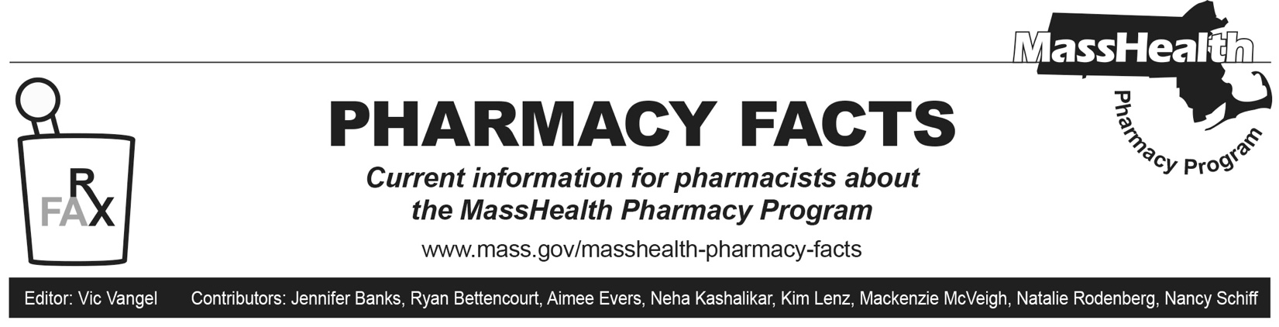
MassHealth Naloxone Availability and Coverage
As over-the-counter (OTC) formulations of naloxone become available, MassHealth remains committed to ensuring member access to multiple covered naloxone products available at no out-of-pocket cost, without prior authorization (PA) and without quantity limits.

The recently FDA-approved generic OTC naloxone nasal spray and brand OTC Narcan (naloxone) nasal spray are covered and have been added to the MassHealth OTC Drug List. The MassHealth OTC Drug List may be updated in the future with new OTC naloxone formulations as they become available. The following naloxone products are covered by MassHealth without PA at the time of this publication.

- Kloxxado (naloxone 8 mg/0.1 mL nasal spray)
- naloxone 4 mg/0.1 mL nasal spray*
- naloxone vial, 0.4 mg/mL syringe, 2 mg/2 mL syringe
- Narcan (naloxone 4 mg/0.1 mL nasal spray)*
- Zimhi (naloxone 5 mg /0.5 mL syringe)

*FDA-approved over-the-counter formulation

Please note: a prescription is required for pharmacies to process any OTC drug through the MassHealth pharmacy benefit. If a prescription is not available, the standing order for dispensing naloxone rescue kits authorizes licensed pharmacists to dispense naloxone rescue kits to a person at risk of experiencing an opioid-related overdose, or to a family member, friend, or other person in a position to assist a person at risk of experiencing an opioid-related overdose. Please refer to M.G.L. c. 94C, § 19B for further information on the standing order for naloxone (https://www.mass.gov/doc/naloxone-standing-order-1/download).
For the most up-to-date information on the current coverage status of naloxone products and OTC drugs, please see MassHealth Drug List Therapeutic Table 36 and the MassHealth Covered OTC Drug List. The MassHealth Drug List can be found at www.mass.gov/masshealth-pharmacy-program.

