Number 209, September 15, 2023
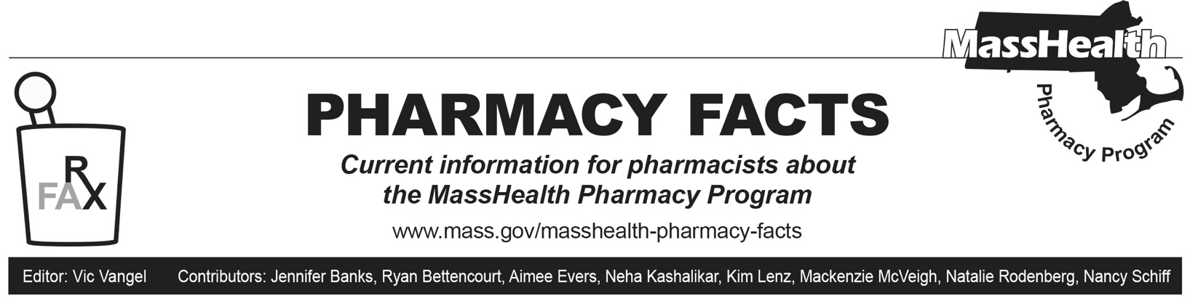
Update to Pharmaceutical Compounding Requirements

MassHealth will require prior authorization (PA) on compounded pharmaceutical products beginning on October 2, 2023. These requirements will apply to members enrolled in the Primary Care Clinician (PCC) Plan or a primary care accountable care organization (PCACO), as well as members enrolled in accountable care partnership plans (ACPPs) and managed care organizations (MCOs). The requirements are as follows.
- Compounded pharmaceutical products using covered ingredients with a total allowed ingredient cost < $100 and non-topical route of administration will be covered without PA.
- Compounded pharmaceutical products with a total allowed ingredient cost of ≥ $100 will require PA. Compounded pharmaceutical products submitted with an infusion, intravenous, intravenous piggyback, intravenous push, or subcutaneous route of administration are excluded from this requirement.
- Compounded pharmaceutical products submitted with a topical route of administration will require PA regardless of total allowed ingredient cost.
- Certain compounding ingredients will not be covered unless PA is obtained. These ingredients will be posted on the MassHealth Drug List and are subject to change at any time.
- Prescribing providers may submit a PA for compounded pharmaceutical products using the General Drug PA form. Medical necessity criteria will be outlined on the MassHealth Drug List in Therapeutic Class Table 79: Pharmaceutical Compounds.
- The MassHealth Drug List, including Therapeutic Class Table 79: Pharmaceutical Compounds and the General Drug PA form, will be updated to reflect these changes on October 2, 2023. The MassHealth Drug List can be found at www.mass.gov/masshealth-pharmacy-program.

Claims submitted through the Pharmacy Online Processing System (POPS) for compounded pharmaceutical products should be submitted with a compound code of “2” (field 406-D6) and an appropriate route of administration (field 995-E2). The POPS Billing Guide contains a list of supported route-of-administration codes. You can find the billing guide at www.mass.gov/doc/pops-billing-guide-10/download.

When submitting these claims, a pharmacy may see the following claim rejections.
- 75 – PA required for compounds with an allowed ingredient cost greater than or equal to $100. See the MassHealth Drug List for more information.
- 75 – PA required for compounds with a topical route of administration. See the MassHealth Drug List for more information.

Claims-processing requirements and rejection messaging may differ for claims submitted for members enrolled in MassHealth ACPPs and MCOs.

To ensure that MassHealth members do not experience gaps in care, pharmacists may initiate an emergency override if they encounter a rejected claim for a medication requiring PA. MassHealth will pay the pharmacy for at least a 72-hour, nonrefillable supply of the drug. To obtain an emergency override for members enrolled in the PCC Plan or a PCACO, pharmacists should contact the Drug Utilization Review Unit at (800) 745-7318 during normal business hours. Outside of business hours, pharmacies may submit an emergency override claim with a value of “03” for level of service (field 418). After the prescription is adjudicated, the pharmacy should remove the “03” from the level of service field before the next fill.
For members in ACPPs and MCOs, pharmacies should follow specific directions in the Appendix of this Pharmacy Facts to submit emergency override claims.

Appendix

Emergency Override Codes for Plans

To ensure that MassHealth members do not experience gaps in care, pharmacists may initiate an emergency override if they encounter a rejected claim for a medication requiring PA. Prescribers may contact the pharmacy and request that an override be provided. MassHealth will pay the pharmacy for at least a 72-hour, non-refillable supply of the drug. The following table lists emergency override codes.

Accountable Care Partnership Plans | Emergency Override Code
Fallon Health-Atrius Health Care Collaborative | 11112222333
Berkshire Fallon Health Collaborative | 11112222333
Fallon 365 Care | 11112222333
Be Healthy Partnership Plan (HNE) | Call (800) 918-7545 (Optum Rx) for override
Mass General Brigham Health Plan with Mass General Brigham ACO | 11112222333
Tufts Health Together with Cambridge Health Alliance (CHA) | 11112222333
Tufts Health Together with UMass Memorial Health | 11112222333
East Boston Neighborhood Health WellSense Alliance | PA Type 1, Code 1111
WellSense Beth Israel Lahey Health (BILH) Performance Network ACO | PA Type 1, Code 1111
WellSense Boston Children’s ACO | PA Type 1, Code 1111
WellSense Care Alliance | PA Type 1, Code 1111
WellSense Community Alliance | PA Type 1, Code 1111
WellSense Mercy Alliance | PA Type 1, Code 1111
WellSense Signature Alliance | PA Type 1, Code 1111
WellSense Southcoast Alliance | PA Type 1, Code 1111
PCACOs and PCC Plan
Community Care Cooperative (C3) | Value of “03” in field 418 (claims processed through POPS)
Steward Health Choice | Value of “03” in field 418 (claims processed through POPS)
Primary Care Clinician (PCC) plan | Value of “03” in field 418 (claims processed through POPS)
MCOs
WellSense Essential MCO | PA Type 1, Code 1111
Tufts Health Together | 11112222333

