Number 21
July 20, 2006

www.mass.gov/masshealth/pharmacy
- Editor: Vic Vangel• Contributors: Chris Burke, Gary Gilmore, Paul Jeffrey, James Monah•an

Medicare Part D Prescription Drug Coverage Update
We previously informed pharmacists that the legislatively mandated override allowing MassHealth to pay for a one-time 30-day supply of medication not covered by the member’s prescription plan would end on June 30, 2006. The use of this one-time override will continue until further notice.

Suboxone
MassHealth is taking steps to ensure that MassHealth members are receiving prescriptions for Suboxone only from prescribers who are certified to prescribe Suboxone. These prescribers have received a DEA number that begins with the letter “X.” We have created a file of these prescribers based on information received from the Substance Abuse and Mental Health Services Administration (SAMHSA) Buprenorphine Physician Locator Web site. This site does not list all certified prescribers of Suboxone, only prescribers who wish to be listed. If a pharmacy receives a denial on a claim with a message “25- Invalid Suboxone Prescriber,” the pharmacy may fax proof of prescriber certification to ACS at 617-423- 9846. The prescriber’s “X” DEA number will then be added to the Suboxone prescriber file. Only claims for Suboxone will be accepted with this unique DEA number beginning with an “X.” Claims for drugs other than Suboxone will be denied with a message “70- Drug Not covered for prescriber” when submitted with the Suboxone DEA number. Other drugs will pay using the prescriber’s regular DEA number.

Claims Adjudication — “Automatic” Prior Authorization
You may wonder why you receive a paid response more often when you submit a claim for a drug that would normally require prior authorization (PA). For example, the drug Topamax (or any other anticonvulsant requiring PA on the MassHealth Drug List), requires PA for members over 18 years old, but will pay without PA under certain conditions.
MassHealth is implementing an automated solution that uses diagnosis codes from medical claims in the pharmacy claims adjudication process. If the system recognizes the patient has a diagnosis code for a seizure disorder in their medical billing record, MassHealth will pay the pharmacy claim without additional PA. In the past, for anticonvulsants, the prescriber submitted a PA form providing the seizure disorder diagnosis; now, with this new process in place, we hope to avoid that step in many cases. One limitation in this process is the lag-time before a medical diagnosis code is displayed in the pharmacy system. If a member has a newly diagnosed seizure disorder, MassHealth may deny a claim for Topamax because the POPS (Pharmacy Online Processing System) has not received the diagnosis data yet. In this circumstance a prescriber would need to request PA. The MassHealth database contains member drug and diagnosis information exclusive to MassHealth and no other health plans. This article serves as a reminder to submit all claims through POPS even if you believe the drug requires PA. As we systemically roll out additional “automatic” PA rules by therapeutic class, we hope to greatly reduce the number of drugs for which prescribers will have to request PA.

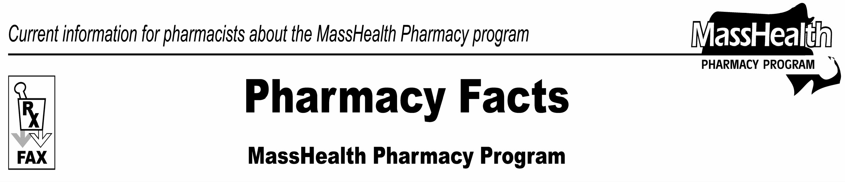

Please direct any questions or comments (or to be taken off of this fax distribution) to
Victor Moquin of ACS at 617-423-9830.

