Number 210, September 26, 2023
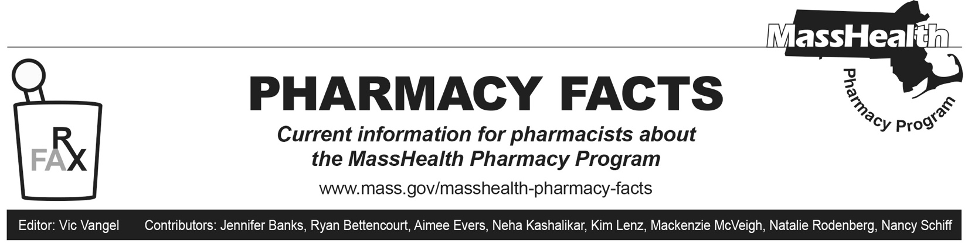
New 2023–2024 mRNA COVID Vaccines

Updated 2023–2024 mRNA COVID vaccines have recently entered the commercial market. Effective September 11, 2023, the MassHealth Pharmacy Program covers the updated 2023–2024 mRNA COVID vaccines and their administration as approved or authorized for emergency use by the Food and Drug Administration (FDA) and recommended by the Advisory Committee on Immunization Practices (ACIP) of the Centers for Disease Control (CDC).

Pharmacies may bill for administration of commercially available COVID vaccines through the Pharmacy Online Processing System (POPS), using the following instructions.
- Include the National Drug Code (NDC) of the vaccine serum.
- A dollar amount in the dispensing fee field is not required. (MassHealth will pay an administration fee to pharmacies instead of a dispensing fee.)
- Enter “MA” in the field named “Professional Service” (440-E5).
- Enter the appropriate administration fee in the field named “Incentive Amount Submitted” (438-E8).
- Include the cost of the vaccine serum, plus the administration fee, as the Gross Amount Due (430-DU).
- Enter the pharmacy’s usual and customary price for the vaccine in the field named “Usual & Customary Charge” (426-DQ) if it differs from the Gross Amount Due (430-DU).

For additional information on claims processing requirements, please refer to the POPS Billing guide. The POPS Billing Guide can be found at https://www.mass.gov/doc/pops-billing-guide-10/download.

MassHealth Drug List Update

What follows are certain updates to the MassHealth Drug List (MHDL). See the MHDL for a complete listing of updates.

Additions

- Effective October 2, 2023, the following newly marketed drugs have been added to the MassHealth Drug List.
- Abilify Asimtufii (aripiprazole extended-release injection) – PA
- Abrysvo (respiratory syncytial virus vaccine) – PA < 60 years
- allopurinol 200 mg tablet – PA; M90
- Arexvy (respiratory syncytial virus vaccine, adjuvanted) – PA < 60 years
- Beyfortus (nirsevimab-alip) – PA ≥ 8 months of age
- Cuvrior (trientine tablet) – PA
- Leqembi (lecanemab-irmb) – PA
- Syfovre (pegcetacoplan 150 mg/mL vial) – PA; MB
- Uzedy (risperidone 50 mg, 75 mg, 100 mg, 125 mg extended-release subcutaneous injection) ^{PD} – PA < 6 years and PA > 1 injection/28 days
- Uzedy (risperidone 150 mg, 200 mg, 250 mg extended-release subcutaneous injection) ^{PD} – PA < 6 years and PA > 1 injection/56 days
- Vowst (fecal microbiota spores, live-brpk) – PA
- Effective for the date listed below, the following COVID-19 preventive therapies will be added to the MassHealth Drug List on October 2, 2023.
- Comirnaty (COVID-19 Pfizer vaccine, COVID EUA – September 11, 2023, for members ≥ 6 months of age)
- Spikevax (COVID-19 Moderna vaccine, COVID EUA – September 11, 2023, for members ≥ 6 months of age)

Change in Prior-Authorization Status

- Effective October 2, 2023, the following compounded pharmaceutical product will not require prior authorization (PA).
  - compounded pharmaceutical product with a total allowed ingredient cost < $100 and non-topical route of administration; CP
- Effective October 2, 2023, the following compounded pharmaceutical products will require PA.
  - compounded pharmaceutical product with a total allowed ingredient cost ≥ $100 – PA; CP
  - compounded pharmaceutical product with topical route of administration – PA; CP

Change in Coverage Status

Effective October 2, 2023, the following agents will be available through medical billing only and will no longer be available through pharmacy billing.
  - Enjaymo (sutimlimab-jome) – PA; MB
  - Soliris (eculizumab) – PA; MB
  - Padcev (enfortumab vedotin-ejfv) – PA; MB
  - Uplizna (inebilizumab-cdon) – PA; MB
  - Vyvgart (efgartigimod alfa-fcab) – PA; MB

Updated MassHealth Brand Name Preferred Over Generic Drug LIst

The MassHealth Brand Name Preferred Over Generic Drug List has been updated to reflect recent changes to the MassHealth Drug List.

- Effective October 2, 2023, the following agent will be added to the MassHealth Brand Name Preferred Over Generic Drug List.
- Flovent (fluticasone propionate inhalation powder); BP
- Effective October 2, 2023, the following agents will be removed from the MassHealth Brand Name Preferred Over Generic Drug List.
- Exelderm (sulconazole) – PA; A90
- Invega (paliperidone tablet) – PA; A90

Updated MassHealth Non-Drug Product List

The MassHealth Non-Drug Product List has been updated to reflect recent changes to the MassHealth Drug List. Effective October 2, 2023, the following product will be added to the MassHealth Non-Drug Product list.
- Omnipod Go – PA

Legend

^{MB} This drug is available through the health care professional who administers the drug or in an outpatient or inpatient hospital setting. MassHealth does not pay for this drug to be dispensed through the retail pharmacy. If listed, prior authorization (PA) does not apply through the hospital outpatient and inpatient settings. Please refer to 130 CMR 433.408 for PA requirements for other health care professionals. Notwithstanding the above, this drug may be an exception to the unified pharmacy policy; please refer to respective MassHealth Accountable Care Partnership Plans (ACPPs) and Managed Care Organizations (MCOs) for PA status and criteria, if applicable.
PA Prior authorization (PA) is required. The prescriber must obtain PA for the drug in order for the pharmacy to receive payment. Note: PA applies to both
the brand-name and the FDA “A”-rated generic equivalent of listed product.

^{BP} Brand preferred over generic equivalents. In general, MassHealth requires a trial of the preferred drug or clinical rationale for prescribing the nonpreferred drug generic equivalent.

A90 Allowable 90-day supply. Dispensing in up to a 90-day supply is allowed. May not include all strengths or formulations. Quantity limits and other restrictions may apply.

^{PD} In general, MassHealth requires a trial of the preferred drug (PD) or a clinical rationale for prescribing a nonpreferred drug within a therapeutic class.

CP Compounded pharmaceutical products with a total allowed ingredient cost ≥ $100 require PA. In addition, compounded pharmaceutical products with topical route of administration require PA. The following routes of administration are excluded from the PA requirement for products with a total allowed ingredient cost ≥ $100: infusion, intravenous, intravenous piggyback, intravenous push, subcutaneous. Compounded pharmaceutical products using any PA-requiring agent or not-covered ingredient as part of the compound require PA.

