Number 211, September 29, 2023
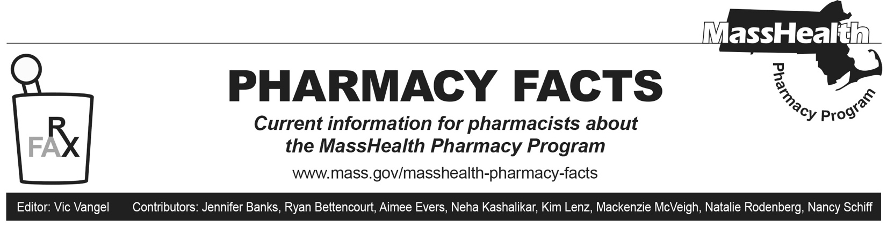
Discontinuation of Brand Flovent Products

GlaxoSmithKline (GSK) notified the United States Food and Drug Administration (FDA) on June 2, 2023, of an upcoming discontinuation of brand Flovent HFA (fluticasone propionate inhalation aerosol) and Flovent Diskus (fluticasone propionate inhalation powder) products. These brand products will no longer be available for ordering as of December 31, 2023.1 It is anticipated that supply of these products will be depleted early 2024.

Generic Fluticasone Products Update

An authorized generic (AG) of Flovent HFA is currently available. MassHealth expects that Teva will launch a generic version of Flovent HFA 110 mcg/inhalation in 2023 upon successful completion of a bioequivalence study. Additionally, an unidentified competitor has filed an abbreviated New Drug Application (aNDA) for a generic version of Flovent HFA 220 mcg/inhalation, with the goal of launching in 2024 or 2025.2 GSK plans on launching an AG of Flovent Diskus (fluticasone propionate inhalation powder) in October 2023.

Coverage of Inhaled Respiratory Agents for MassHealth Members
MassHealth has reevaluated coverage of inhaled respiratory agents. The following changes will be posted to the MassHealth Drug List and are effective on the listed dates.

Changes in Prior-Authorization (PA) Status
- Effective December 4, 2023, the following respiratory agents will require PA for new utilizers.
- fluticasone propionate inhalation aerosol (generic Flovent HFA) – PA
- fluticasone propionate inhalation powder (generic Flovent Diskus) – PA
MassHealth will allow members already stable on Flovent® inhalers to use generic fluticasone inhalers without PA until March 4, 2024, to give prescribers time to transition members to an alternate inhaler. After this time, PA will be required for all utilizers of generic fluticasone inhalers.
- Effective December 4, 2023, the following respiratory agents will no longer require PA.
- Anoro Ellipta (umeclidinium and vilanterol inhalation powder)
- Arnuity Ellipta (fluticasone furoate inhalation powder)
  - Before December 4, 2023, MassHealth may allow Arnuity to process without PA to facilitate access for members transitioning from Flovent products. Additional guidance will be issued through a Pharmacy Facts if PA for Arnuity is removed.
- Serevent Diskus (salmeterol xinafoate inhalation powder)

MassHealth Brand Name Preferred Over Generic Drug List
Flovent HFA is currently on the MassHealth Brand Name Preferred Over Generic List.

Effective October 2, 2023, the following respiratory agent will be added to the MassHealth Brand Name Preferred Over Generic Drug List.
- Flovent Diskus ^{BP}

MassHealth will continue to pay for branded Flovent HFA and Flovent Diskus products without PA until the remaining supply in circulation is exhausted.

Medications Available Without PA
The following respiratory agents will continue to be available without PA.
- Asmanex HFA (mometasone inhalation aerosol)
- Asmanex Twisthaler (mometasone inhalation powder)
- Pulmicort Flexhaler (budesonide inhalation powder)

For the most up-to-date information on current MassHealth coverage of inhaled respiratory agents, please see Therapeutic Class Table 23: Respiratory Agents – Inhaled in the MassHealth Drug List. The MassHealth Drug List can be found at www.mass.gov/masshealth-pharmacy-program.

Emergency Overrides

To ensure that MassHealth members do not experience gaps in care, pharmacists may initiate an emergency override if they encounter a rejected claim for a medication requiring PA. MassHealth will pay the pharmacy for at least a 72-hour, nonrefillable supply of the drug.

To obtain an emergency override for members enrolled in the Primary Care Clinician (PCC) Plan or a primary care accountable care organization (PCACO), pharmacists should contact the Drug Utilization Review Unit at (800) 745-7318 during normal business hours. Outside of business hours, pharmacies may submit an emergency override claim with a value of “03” for Level of Service (field 418). After the prescription is adjudicated, the pharmacy should remove the “03” from the level of service field before the next fill.

For members in accountable care partnership plans (ACPPs) and managed care organizations (MCOs), pharmacies should follow specific directions in the Appendix of this Pharmacy Facts to submit emergency override claims.

Appendix

Emergency Override Codes for Plans

To ensure that MassHealth members do not experience gaps in care, pharmacists may initiate an emergency override if they encounter a rejected claim for a medication requiring PA. Prescribers may contact the pharmacy and request that an override be provided. MassHealth will pay the pharmacy for at least a 72-hour, non-refillable supply of the drug. The following table lists emergency override codes.

Accountable Care Partnership Plans | Emergency Override Code
Fallon Health-Atrius Health Care Collaborative | 11112222333
Berkshire Fallon Health Collaborative | 11112222333
Fallon 365 Care | 11112222333
Be Healthy Partnership Plan (HNE) | 11112222333
Mass General Brigham Health Plan with Mass General Brigham ACO | 11112222333
Tufts Health Together with Cambridge Health Alliance (CHA) | 11112222333
Tufts Health Together with UMass Memorial Health | 11112222333
East Boston Neighborhood Health WellSense Alliance | PA Type 1, Code 1111
WellSense Beth Israel Lahey Health (BILH) Performance Network ACO | PA Type 1, Code 1111
WellSense Boston Children’s ACO | PA Type 1, Code 1111
WellSense Care Alliance | PA Type 1, Code 1111
WellSense Community Alliance | PA Type 1, Code 1111
WellSense Mercy Alliance | PA Type 1, Code 1111
WellSense Signature Alliance | PA Type 1, Code 1111
WellSense Southcoast Alliance | PA Type 1, Code 1111
PCACOs and PCC Plan
Community Care Cooperative (C3) | Value of “03” in field 418 (claims processed through POPS)
Steward Health Choice | Value of “03” in field 418 (claims processed through POPS)
Primary Care Clinician (PCC) plan | Value of “03” in field 418 (claims processed through POPS)
MCOs
WellSense Essential MCO | PA Type 1, Code 1111
Tufts Health Together | 11112222333

References

- U.S. Food & Drug Administration. FDA Drug Shortages. 2023 Jun 2 [cited 2023 Sep 4]. Available from: FDA Drug Shortages.
- IPD Analytics. Projected generic launch schedule. [cited 2023 Sep 4]. Data on file.

