Number 212, October 3, 2023
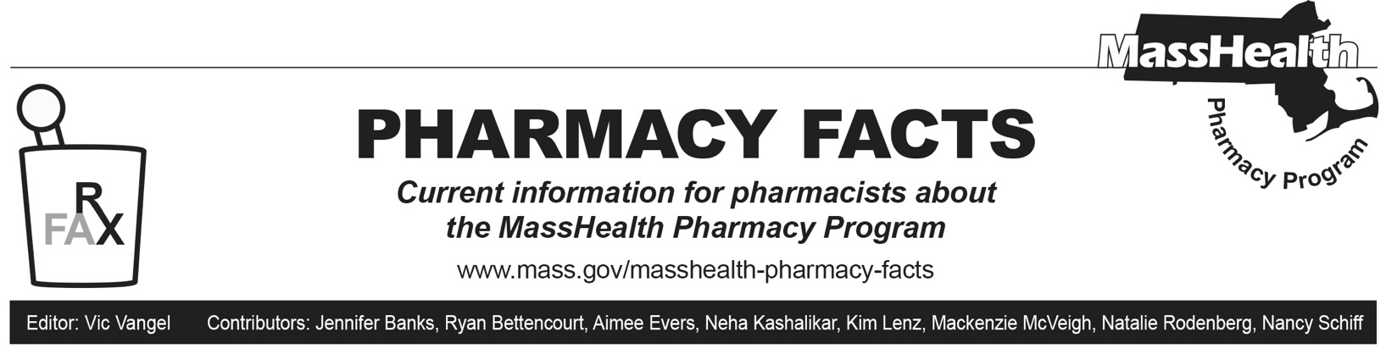

Coverage of Over-the-Counter Diagnostic Antigen Tests for SARS-CoV-2
MassHealth announced in Pharmacy Facts #177 its coverage of COVID-19 at-home antigen self-test kits. Prior authorization (PA) is required for > 2 tests per 28 days, as described in Pharmacy Facts 206.

MassHealth reminds pharmacy providers that the Massachusetts Department of Public Health has issued a statewide standing order that allows licensed pharmacists to dispense at-home antigen self-test kits to any individual, and to treat that standing order as a prescription for any such test kit. Accordingly, an individual prescription is not required for any such test kit. That standing order can be found here:
https://www.mass.gov/doc/covid-19-otc-diagnostic-test-standing-order-pdf/download.

Coverage for Medically Necessary Enteral Nutrition Liquid Products through Pharmacy Providers

MassHealth already covers medically necessary formula and thickening agents through both pharmacy and durable medical equipment (DME) providers. See All Provider Bulletin 373. There have been recent shortages reported for enteral nutritional liquid products available through DME providers. Accordingly, MassHealth is adding coverage of medically necessary enteral nutritional liquid products through the Pharmacy Online Processing System (POPS), as well.
To address shortages, effective September 22, 2023, MassHealth pays pharmacies to process and dispense medically necessary enteral nutrition liquid products through POPS. MassHealth will update the MassHealth Non-
Drug Product List to include medically necessary enteral nutrition liquid products on December 4, 2023. In each case, a valid prescription is required. MassHealth anticipates ending coverage of enteral nutritional products through pharmacy providers by early 2024. MassHealth will provide further written guidance once it ends coverage of enteral nutritional liquid products through pharmacy providers.

Please note that while enteral nutritional liquid products require a prescription, MassHealth strongly encourages prescribers to write down any appropriate substitute products on the prescriptions for formula, in addition to the preferred product. This will enable the pharmacy provider to dispense the substitute formula in the event the preferred product is unavailable, without the need for a new or modified prescription.

If a preferred product is unavailable and no substitute products are identified on the prescription, MassHealth is encouraging pharmacists to communicate with prescribers to obtain authorization to substitute a clinically equivalent product. MassHealth considers the following to be clinically appropriate.

- Ensure Original (B4150) may be substituted with a clinically equivalent product within Healthcare Common Procedure Coding System (HCPCS) code B4150 that is no more costly, including, but not limited to, Boost Original (B4150), if the Abbott product is out of stock.
- Ensure Plus (B4152) may be substituted with a clinically equivalent product within HCPCS code B4152 that is no more costly, including, but not limited to, Boost Plus (B4152), if the Abbott product is out of stock.

Pharmacies are encouraged to remind prescribing providers to list appropriate substitute products during initial and subsequent communications.

Payment for Enteral Nutrition Liquid Products Dispensed by Pharmacy Providers
Pharmacies will be paid for medically necessary enteral nutrition liquid products at the lowest of the Wholesale Acquisition Cost, the usual fee for patients other than publicly aided individuals, or the actual charges submitted.

