Number 213, October 19, 2023
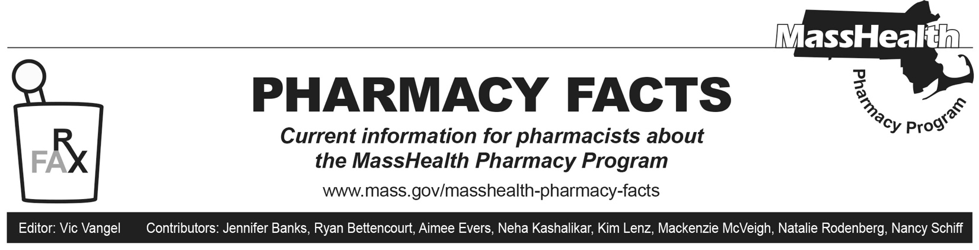
Cost-of-Dispensing and Average Acquisition Cost (AAC) Surveys
The Centers for Medicare & Medicaid Services (CMS) requires fee-for-service Medicaid to pay pharmacies for the actual acquisition cost of drugs, plus a reasonable professional dispensing fee, based on the actual costs of dispensing drugs to Medicaid beneficiaries.

Massachusetts pharmacy providers are asked to complete both a pharmacy cost-of-dispensing survey and an AAC survey. MassHealth has contracted with Mercer Government Human Services Consulting (Mercer), who is conducting these surveys.

Pharmacy cost-of-dispensing and AAC surveys were distributed to MassHealth pharmacy providers by Mercer on October 9, 2023. All MassHealth pharmacy providers must complete these surveys. Survey data will be used only in aggregate and will remain anonymous. These surveys will help in analyzing the cost of dispensing prescription medications to MassHealth fee-for-service members and will allow MassHealth to establish AAC for prescription drugs consistent with 101 CMR 331.00.

We greatly appreciate your cooperation in providing the information for these surveys.

Off-Cycle Change in Prior Authorization (PA) Status
Pharmacy Facts 211 outlined the upcoming discontinuation of brand Flovent products and several associated changes to MassHealth’s coverage of inhaled respiratory agents. To facilitate transition from Flovent products to alternative inhalers, MassHealth has removed the PA requirement from Arnuity Ellipta (fluticasone furoate inhalation powder) earlier than anticipated. Claims for Arnuity Ellipta processed through the Pharmacy Online Processing System (POPS) will be paid without PA beginning October 19, 2023. The MassHealth Drug List will be updated to reflect this change in PA status on December 4, 2023.

