Number 216, December 1, 2023
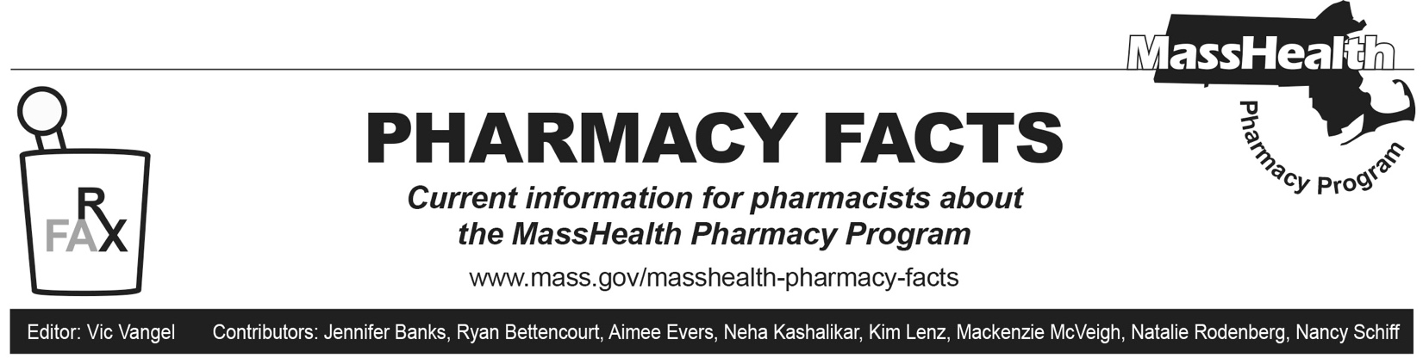
Upcoming Drug Discontinuations
Levemir (insulin detemir)
Novo Nordisk announced to the United States Food and Drug Administration (FDA) on November 8, 2023, the planned discontinuation of Levemir (insulin detemir) FlexPen and vials. Supply disruptions of the FlexPen are anticipated to begin mid-January 2024, followed by discontinuation of the FlexPen formulation on April 1, 2024, and discontinuation of the vial formulation on December 31, 2024.
There are currently no commercially available biosimilars or authorized generics for insulin detemir. Alternative long-acting insulin products covered under the MassHealth pharmacy benefit without prior authorization (PA) include the following.
- Lantus (insulin glargine)
- Toujeo (insulin glargine)
- Tresiba (insulin degludec)
GlucaGen HypoKit (glucagon)
Novo Nordisk announced to the FDA on November 18, 2023, the planned discontinuation of GlucaGen HypoKit (glucagon) in the United States. This discontinuation will be effective July 1, 2024. GlucaGen HypoKit (glucagon) will remain available in markets outside the United States where treatment options are limited.¹
Generic formulations of glucagon emergency kits are commercially available and are covered without PA. Alternative glucagon products available through the MassHealth pharmacy benefit without PA include the following.
- Baqsimi (glucagon nasal powder)
- glucagon vial
- Gvoke (glucagon auto-injection, prefilled syringe, vial)
MassHealth plans to remove PA requirements from Zegalogue (dasiglucagon) effective March 4, 2024.
Flovent (fluticasone propionate inhalation)
GlaxoSmithKline announced to the FDA on June 2, 2023, the planned discontinuation of brand Flovent HFA (fluticasone propionate inhalation aerosol) and Flovent Diskus (fluticasone propionate inhalation powder) products. These brand products will no longer be available for ordering as of December 31, 2023.¹
Effective December 4, 2023, generic fluticasone propionate inhalation will require PA. MassHealth will allow members already stable on Flovent inhalers to use generic fluticasone propionate inhalers without PA until March 4, 2024, to give prescribers time to transition members to an alternate inhaler. After this time, PA will be required for all users of generic fluticasone inhalers. MassHealth will continue to pay for branded Flovent inhalers without PA until the remaining supply in circulation is exhausted.
For more information on the discontinuation of brand Flovent inhalers and associated changes to MassHealth’s coverage of inhaled respiratory agents, please see Pharmacy Facts 211 and 213.
MHDL Update
Below are certain updates to the MassHealth Drug List (MHDL). See the MHDL for a complete list of updates.
Additions
- Effective December 4, 2023, the following newly marketed drugs will be added to the MassHealth Drug List.
- Adstiladrin (nadofaragene firadenovec-vncg) – PA; MB
- Balfaxar (prothrombin complex concentrate, human)
- Brixadi (buprenorphine extended-release injection) – PA
- nitrofurantoin 50 mg/5 mL suspension – PA; A90
- Rezvoglar (insulin glargine-aglr) – PA
- Roctavian (valoctocogene roxaparvovec-rvox) – PA; CO, MB
- Skysona (elivaldogene autotemcel) – PA; CO, MB
- Sogroya (somapacitan-beco) – PA
- zolpidem 7.5 mg capsule – PA
- Zynyz (retifanlimab-dlwr) – PA; MB
- Effective for the date listed below, the following COVID-19 preventative will be added to the MassHealth Drug List on December 4, 2023.
- Novavax COVID-19 vaccine, adjuvanted (COVID EUA – October 3, 2023 for members ≥ 12 years of age)
Change in Prior-Authorization Status
- Effective December 4, 2023, the following inhaled respiratory agent will require PA.
- fluticasone propionate inhalation – PA; A90
- Effective December 4, 2023, the following inhaled respiratory agents will no longer require PA.
- Anoro (umeclidinium/vilanterol)
- Serevent (salmeterol)
- Effective October 19, 2023, the following inhaled respiratory agent no longer requires PA.
- Arnuity (fluticasone furoate inhalation powder)
- Effective December 4, 2023, the following anticoagulant agent will no longer require PA within quantity limits.
- Xarelto (rivaroxaban 2.5 mg tablet) – PA > 2 units/day
- Effective December 4, 2023, the following anticoagulant agent will no longer require PA within age limits.
- Xarelto (rivaroxaban suspension) – PA ≥ 18 years
Change in Coverage Status
Effective December 4, 2023, the following agent will be available through medical billing only and will no longer be available through pharmacy billing.
- Nexviazyme (avalglucosidase alfa-ngpt) – PA; MB
Updated MassHealth Brand Name Preferred Over Generic Drug List
The MassHealth Brand Name Preferred Over Generic Drug List has been updated to reflect recent changes to the MassHealth Drug List.
Effective December 4, 2023, the following agents will be removed from the MassHealth Brand Name Preferred Over Generic Drug List.
- Asacol HD (mesalamine high dose delayed-release); #, A90
- Canasa (mesalamine suppository); #, A90
- Coreg CR (carvedilol extended-release) – PA; M90
- Veletri (epoprostenol) – PA
- Viibryd (vilazodone) – PA; A90
- Zytiga (abiraterone 500 mg) – PA; A90
Updated MassHealth Non-Drug Product List
The MassHealth Non-Drug Product List has been updated to reflect recent changes to the MassHealth Drug List.
Effective September 20, 2023, the following product will be added to the MassHealth Non-Drug Product List on December 4, 2023.
- Medically necessary enteral nutritional liquid
Legend

PA Prior authorization is required. The prescriber must obtain prior authorization for the drug in order for the provider to receive reimbursement. Note: PA applies to both the brand-name and the FDA “A”-rated generic equivalent of listed product.

CO Carve-Out. This agent is listed on the Acute Hospital Carve-Out Drugs List and is subject to additional monitoring and billing requirements.

# Designates a brand-name drug with FDA “A”-rated generic equivalents. PA is required for the brand, unless a particular form of that drug (for example, tablet, capsule, or liquid) does not have an FDA “A”-rated generic equivalent.

^{BP} Brand preferred over generic equivalents. In general, MassHealth requires a trial of the preferred drug or clinical rationale for prescribing the nonpreferred drug generic equivalent.

^{MB} Available through the health care professional who administers the drug or in an outpatient or inpatient hospital setting. MassHealth does not pay for this drug to be dispensed through the retail pharmacy. If listed, PA does not apply through the hospital outpatient and inpatient settings. Please refer to 130 CMR 433.408 for PA requirements for other health care professionals. Notwithstanding the above, this drug may be an exception to the unified pharmacy policy; please refer to respective MassHealth Accountable Care Partnership Plans (ACPPs) and Managed Care Organizations (MCOs) for PA status and criteria, if applicable.

^{A90} Allowable 90-day supply. Dispensing in up to a 90-day supply is allowed. May not include all strengths or formulations. Quantity limits and other restrictions may apply.

^{M90} Mandatory 90-day supply. After dispensing up to a 30-day supply initial fill, dispensing in a 90-day supply is required. May not include all strengths or formulations. Quantity limits and other restrictions may also apply.

. U.S. Food & Drug Administration. FDA Drug Shortages. 2023 [accessed November 16, 2023]. Available from FDA Drug Shortages.

