Number 219, December 29, 2023
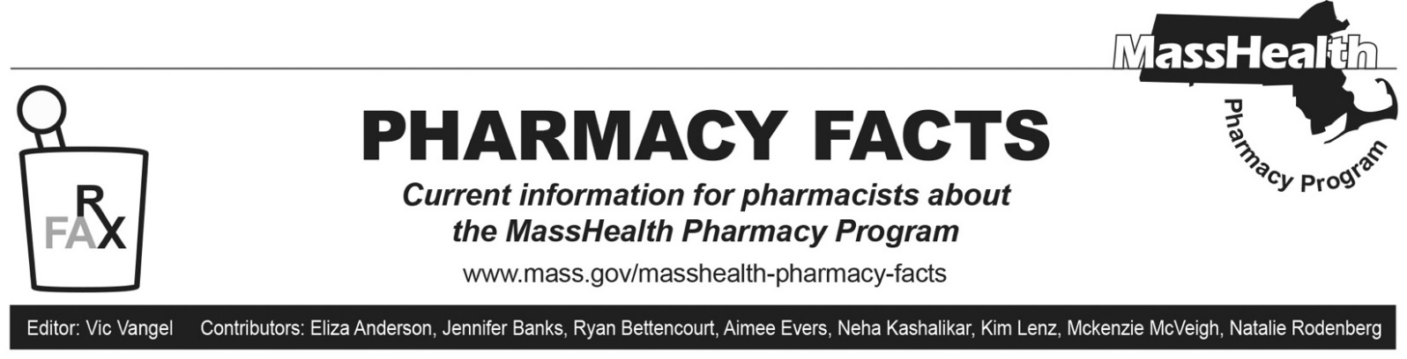

MassHealth Pharmacy Regulation Changes
This Pharmacy Facts describes revisions to the pharmacy regulations at 130 CMR 406.000: Pharmacy Services, effective January 1, 2024. These revisions provide coverage for drugs used for the treatment of obesity, implement new policies to address step therapy protocol exceptions, and include language regarding state requirements around prospective drug review and counseling. Amendments were made to clarify or update existing policies. This includes updating language about fertility drugs and drugs for sexual dysfunction to make the language gender inclusive; clarifying that drugs for cosmetic purposes will only be covered if medically necessary; clarifying coverage of compounded drugs; and adding back language regarding the payment rates for non-drug products.

Drug Exclusion Changes
- 130 CMR 406.413(B), which includes drug exclusions, was updated to allow coverage of medications that treat obesity
- 130 CMR 406.413(B) was updated to allow the use of drugs for cosmetic purposes only when medically necessary
- 130 CMR 406.413(B) language in fertility and drugs for sexual dysfunction was updated to be gender inclusive

Step Therapy Exceptions
- 130 CMR 406.422(G) was added to include language regarding step therapy protocols consistent with M.G.L. c.118E, § 51A. MassHealth will allow exceptions to step therapy. The specific process for seeking an exception to step therapy will be posted on the MassHealth Drug List, including necessary documentation to establish medical necessity. MassHealth will grant or deny a request for an exception to step therapy or a request to appeal a denial of an exception not more than three business days after the receipt of all necessary information to establish the medical necessity of the prescribed treatment. If additional delay would result in significant risk to the enrollee’s health or well-being, then this three-business day period will be reduced to 24 hours after the receipt of all necessary information. The appeal of a denial of a step therapy exception will occur through informal consultation with a clinical pharmacist with the MassHealth program or its utilization review organization. MassHealth is not required to consider samples prescribed without a prescription provided to members to be sufficient to establish stability.

Prospective Drug Review
- 130 CMR 406.446 was added to describe prospective drug review and counseling consistent with the requirements in M.G.L. c. 94C, § 21A and 247 CMR 9.07. Pharmacies must offer prospective drug review and counseling and only a member’s refusal of counseling must be documented, except as otherwise required under applicable state law.

Covered Drugs and Medical Supplies
- 130 CMR 406.412(A), which discusses covered drugs and medical supplies, was updated to include compounded drugs specified in the MassHealth Drug List. Payment for compounds will be calculated in accordance with 101 CMR 331.00: Prescribed Drugs.

Non-drug Product Rates
- 130 CMR 406.412(B), which describes non-drug products paid through the Pharmacy Online Processing System (POPS), was updated to specifically include rates published in 101 CMR 317.00: Rates for Medicine Services.

