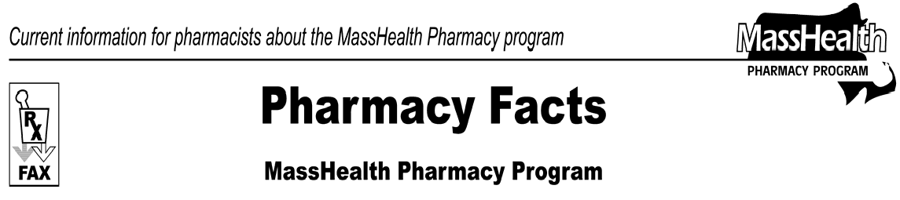
Number 22
September 1, 2006
www.mass.gov/masshealth/pharmacy

- Editor: Vic Vangel • Contributors: Chris Burke, Gary Gilmore, Paul Jeffrey, James Monahan •
Medicare Part D Prescription Drug Coverage Update  The Massachusetts legislature made a number of changes to the assistance available to MassHealth dually eligible members, effective July 1, 2006.  The legislation extended the availability of the one-time 30-day supply of medication through December 31, 2006. The override for a one-time 72-hour supply of medication will continue until further notice. The one- time overrides are no longer limited to instances involving drug coverage by a known Medicare Part D plan. Pharmacists may now use standard NCPDP other payer reject codes (NCPDP field 472-6E) to override a denied claim when a Part D plan does not pay a claim for a Part D drug. Pharmacists must attempt to bill the MassHealth member’s Part D plan, if the member is enrolled in one, or the Wellpoint/Anthem point-of-sale contingency plan, if not enrolled in a Part D plan. After these attempts, pharmacies may submit the claim to MassHealth for an override.  The legislation also expanded Part D copayment assistance for MassHealth members. You can still use the process described in Pharmacy Facts No. 17 to reduce a dually eligible member’s copayment from $2 and $5 levels (as determined by the Part D plan) to the standard MassHealth copayment levels of $1 and $3. This process can also be used to reduce the copayment to $0 for members under 18, members who reside in long-term-care facilities, and pregnant women who are assessed a copayment by a Part D plan. This process also may be used to reduce copayments when the Part D plan refuses to reduce an incorrectly high copayment. The maximum copayment that a Part D plan is permitted to charge a dually eligible member is $5. In the event that the Part D plan assesses a copayment in excess of $5 for a dually eligible member, contact the plan. If the plan refuses to correct the copayment amount, MassHealth will supplement the copayment to standard MassHealth levels. | MassHealth Drug List Update Additions Effective 9/15/2006  The following newly marketed drugs have been added to the MassHealth Drug List.  Abilify Discmelt (apriprazole, orally disintegrating tablet) – PA  Alcet (oxycodone/acetaminophen) – PA Atripla (efavirenz/emtricitabine/tenofovir) Azilect (rasagiline)  Cardura XL (doxazosin extended release) – PA  Cesamet (nabilone) – PA  Chantix (varenicline) – PA > 24 weeks  Dacogen (decitabine) H  Daytrana (methylphenidate transdermal system) –  PA  Deplin (L-methylfolate) – PA  EMSAM (selegiline transdermal system) – PA  Enjuvia (estrogens, conjugated) Eraxis (anidulafungin)  Exubera (regular insulin, inhalation) – PA  Increlex (mecasermin) – PA  Iplex (mecasermin) – PA  Keflex (cephalexin) 750 mg – PA  Lucentis (ranibizumab) ^  Lynox (oxycodone/acetaminophen) – PA Myozyme (alglucosidase) – PA NeoProfen (ibuprofen lysine) H  Opana (oxymorphone) – PA  Opana ER (oxymorphone extended release) – PA  Oracea (doxycycline) – PA Prezista (darunavir) Ranexa (ranolazine) – PA  Requip Starter Kit (ropinirole) – PA Seasonique (ethinyl estradiol/levonorgestrel) Solodyn (minocycline extended release) – PA Soltamox (tamoxifen) – PA  Sprycel (dasatinib)  Synera (lidocaine/tetracaine) – PA > 4 patches/month  Tysabri (natalizumab) Vaprisol (conivaptan) H  Vivitrol (naltrexone injection) – PA  Yaz (ethinyl estradiol/drospirenone)  Zelapar (selegiline, orally disintegrating tablet) – PA  (Explanations of symbols used can be found at mass.gov/druglist.)
Please direct any questions or comments (or to be taken off of this fax distribution) to
Victor Moquin of ACS at 617-423-9830.

