Number 220, February 20, 2024
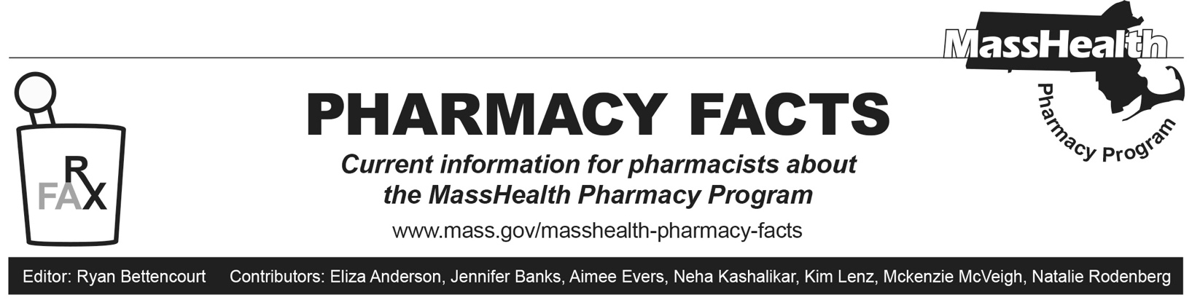
Updated Nonbilling Provider Enrollment Application
As described in Pharmacy Facts 215, the Massachusetts Board of Registration in Pharmacy has issued Circular Letter DCP 23-10-121 regarding pharmacist prescribing and dispensing of hormonal contraceptive patches and self-administered oral hormonal contraceptives. Pharmacy Facts 215 instructed pharmacists wishing to prescribe drugs to MassHealth members to enroll with MassHealth before 5/1/2024, when ordering, referring, and prescribing (ORP) requirements will be enforced.

This Pharmacy Facts serves as a notice to pharmacists that the MassHealth Nonbilling Provider Application has been updated to facilitate enrollment of a second group of pharmacists under provider type 90, labeled as “Pharmacist – Other.” Pharmacists who have not entered into a collaborative drug therapy management (CDTM) agreement but wish to enroll to prescribe drugs or non-drug products to the extent permitted by state law should enroll using this provider type.

There have been no changes to the enrollment of CDTM pharmacists. Any pharmacist that has entered into a CDTM agreement and wishes to enroll for the purpose of prescribing drugs or non-drug products to the extent permitted by their CDTM agreement and state law should enroll using the “CDTM Pharmacist” provider type. CDTM pharmacists will also be required to provide their Massachusetts Controlled Substance Registration Number and supervising physician information.

Pharmacists should visit the MassHealth website or contact MassHealth Customer Service at (800) 841-2900, TDD/TTY: 711 for more information about enrolling. For more information on ordering, referring, and prescribing (ORP) requirements, including those for pharmacy claims, please see All Provider Bulletins (APB) 361 and 376 and Pharmacy Facts 214. The updated nonbilling provider enrollment application may be found at https://www.mass.gov/how-to/how-to-enroll-to-be-a-masshealth-orp-provider.

