Number 223, March 2024
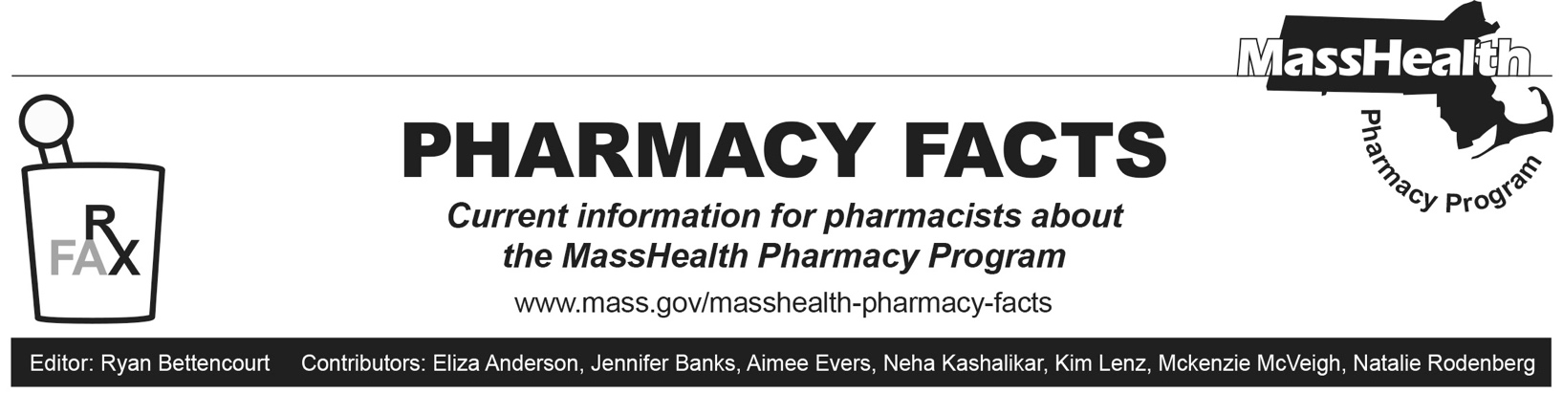
Managed Care Update to GLP-1 Agonist Drugs Purchased Through the 340B Drug Pricing Program – Change in Effective Date
This section concerns Accountable Care Partnership Plans (ACPPs), Managed Care Organizations (MCOs), One Care Plans, and Senior Care Organizations (SCOs) (collectively referred to as “Managed Care Entities”). As described in Pharmacy Facts 222 and Managed Care Entity Bulletin 109, the Executive Office of Health and Human Services (EOHHS) directed Managed Care Entities not to pay for specified GLP-1 Agonist Drugs if those drugs were purchased through the 340B Drug Pricing Program, effective April 1, 2024. EOHHS has announced that the effective date of this policy will be changed from April 1, 2024, to July 1, 2024. EOHHS is making no other changes to the policy. For more information, please see Managed Care Entity Bulletin 112.
MHDL Update
Below are certain updates to the MassHealth Drug List (MHDL). See the MHDL for a complete listing of updates.
Additions
Effective April 1, 2024, the following newly marketed drug has been added to the MassHealth Drug List.
- Casgevy (exagamglogene autotemcel for sickle cell disease) ^{PD} – PA; CO, MB
Updated MassHealth Supplemental Rebate/Preferred Drug List
The MassHealth Supplemental Rebate/Preferred Drug List has been updated to reflect recent changes to the MassHealth Drug List.
- Effective April 1, 2024, the following anti-hemophilia agent will be added to the MassHealth Supplemental Rebate/Preferred Drug List.
- Hemlibra (emicizumab-kxwh) ^{PD}
- Effective April 1, 2024, the following diabetic agent will be added to the MassHealth Supplemental Rebate/Preferred Drug List.
- Lantus (insulin glargine) ^{PD}; BP
- Effective April 1, 2024, the following anti-obesity agent will be added to the MassHealth Supplemental Rebate/Preferred Drug List.
- Saxenda (liraglutide) ^{PD} – PA
- Effective April 1, 2024, the following sickle cell disease agent will be added to the MassHealth Supplemental Rebate/Preferred Drug List.
- Casgevy (exagamglogene autotemcel for sickle cell disease) ^{PD} – PA; CO, MB
Legend
PA Prior authorization is required. The prescriber must obtain prior authorization for the drug in order for the pharmacy to receive payment. Note: PA applies to both the brand-name and the FDA “A”-rated generic equivalent of listed product.

MB This drug is available through the health care professional who administers the drug or in an outpatient or inpatient hospital setting. MassHealth does not pay for this drug to be dispensed through the retail pharmacy. If listed, PA does not apply through the hospital outpatient and inpatient settings. Please refer to 130 CMR 433.408 for PA requirements for other health care professionals. Notwithstanding the above, this drug may be an exception to the unified pharmacy policy; please refer to respective MassHealth Accountable Care Partnership Plans (ACPPs) and Managed Care Organizations (MCOs) for PA status and criteria, if applicable.

^{BP} Brand preferred over generic equivalents. In general, MassHealth requires a trial of the preferred drug or clinical rationale for prescribing the nonpreferred drug generic equivalent.

CO Carve-Out. This agent is listed on the Acute Hospital Carve-Out Drugs List and is subject to additional monitoring and billing requirements.
^{PD} In general, MassHealth requires a trial of the preferred drug (PD) or a clinical rationale for prescribing a nonpreferred drug within a therapeutic class.

