Number 224, March 29, 2024
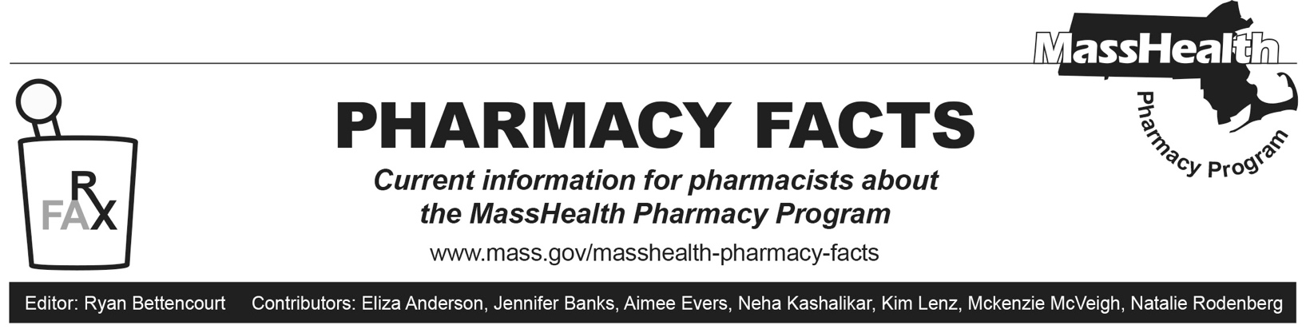
Pharmacy Copay Changes Effective April 1, 2024
As described in Pharmacy Facts 199, copayments have been temporarily eliminated since May 1, 2023, for MassHealth members and for Health Safety Net (HSN) patients. MassHealth intends to extend this policy indefinitely beginning April 1, 2024. This policy includes members in MassHealth Fee-For-Service (FFS), Primary Care Accountable Care Organizations, Accountable Care Partnership Plans (ACPPs), Managed Care Organizations (MCOs), One Care Plans, Senior Care Options (SCO) Plans, and Program of All-inclusive Care for the Elderly (PACE) Organizations.

This does not apply to Children’s Medical Security Plan (CMSP) members – CMSP members must still pay copays.

MassHealth will publish an updated copay poster on its website that will reflect these changes.

