Number 226, April 22, 2024
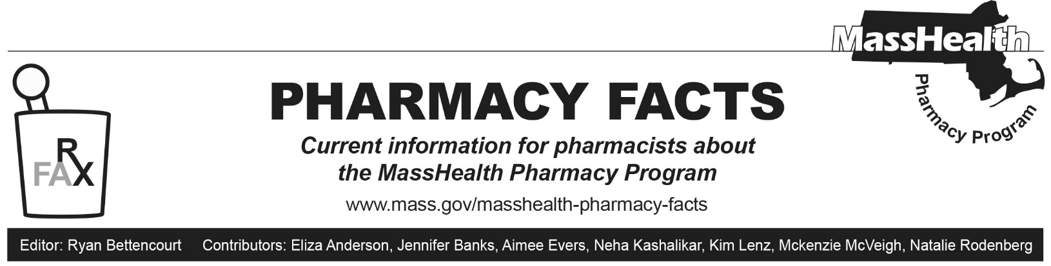
Updates to the Implementation of Prescriber Requirements for Pharmacies
Summary
- Section 6401(b) of the Affordable Care Act (ACA) requires that ordering, referring, and prescribing (ORP) providers be enrolled with MassHealth.
- ORP requirements are described in All Provider Bulletin (ALL) 286. Additional Information on ORP requirements was included in ALL 361, 376, and 380, and Pharmacy Facts 214 and 220.
- Beginning May 1, 2024, pharmacies may start to see claims with messaging alerting to the fact that a prescriber is not enrolled.
- There is a 60-day grace period for the prescriber to enroll. After that point, a claim will reject noting the enrollment status.
- Pharmacies may override rejected claims by entering a Submission Clarification Code (SCC) field value of “55.”
- Pharmacies are encouraged to notify the provider and may continue to use the override process to ensure members receive access to therapy.
Background
Pharmacy Facts 214 announced that MassHealth will begin to enforce ORP requirements for claims processed by the Pharmacy Online Processing System (POPS) on May 1, 2024. Beginning on that date, claims processed by POPS must include a prescriber who is actively enrolled with MassHealth for dates of service on or after May 1, 2024.
This Pharmacy Facts provides further information about claims processing and available overrides beginning May 1, 2024.
ORP requirements arise under federal law, Section 6401(b) of the ACA. If MassHealth requires a service to be ordered, referred, or prescribed, then ACA Section 6401(b) requires the ORP provider to be enrolled with MassHealth as a fully participating provider or as a nonbilling provider; to be an authorized ORP provider type as described on page 2 of ALL 286; and to have their National Provider Identifier (NPI) on the claim. This means that (1) a prescriber of a drug or of medical equipment/supplies for a member enrolled in MassHealth fee-for-service, Primary Care Accountable Care Organization, or the Primary Care Clinician Plan will be required to be enrolled as a MassHealth provider, and (2) the pharmacy provider must include the prescriber’s NPI on the claim. Please refer to Pharmacy Facts 214 and to All Provider Bulletins 286, 361, 376, and 380 for more information regarding the ORP requirements under Section 6401(b) of the Affordable Care Act.
Pharmacists eligible to prescribe are subject to the same ORP requirements for MassHealth claims. Pharmacists who are eligible to prescribe can participate in MassHealth only as nonbilling providers, and should visit the MassHealth website for more information on enrolling, or contact MassHealth Customer Service at (800) 841-2900, TDD/TTY: 711. Pharmacists must possess a valid NPI to enroll. Additional information for pharmacists wishing to prescribe drugs to MassHealth members can be found in Pharmacy Facts 220.

Claims Processing
These requirements are applicable to all claims submitted through POPS, including MassHealth fee-For-service claims, Health Safety Net and Children’s Medical Security Plan claims, claims for secondary coverage, and Medicare Crossover claims. ORP requirements do not apply to claims submitted to managed care entities.
As required under HIPAA billing rules, providers are to continue to enter the NPI of the individual prescriber on each claim submitted to POPS, and claims submitted to POPS without a prescriber NPI are not accepted. Also, under existing HIPAA rules, if an NPI is submitted, but is not known to POPS, then NCPDP reject code 826 – ‘Prescriber NPI Submitted Not Found Within Processor’s NPI File’ is posted.
Based on ORP requirements, once a NPI is known to POPS, if the prescriber has not enrolled with MassHealth, pharmacies submitting claims with the NPI of an unenrolled prescriber and a date of service that is on or after May 1, 2024, will receive a rejection that reads as follows.
NCPDP reject code 889 - PRESCRIBER NOT ENROLLED WITH STATE MEDICAID PLAN, with text message PRESCRIBER OF THIS CLAIM IS NOT ENROLLED WITH MASSHEALTH. PRESCRIBER MUST ENROLL WITH MASSHEALTH. OVERRIDE AVAILABLE VIA SCC-55.
Note that POPS will allow processing of claims that include the NPI of an unenrolled prescriber if the claim is processed during the prescriber’s 60-day grace period. The purpose of the grace period is to allow time for the unenrolled prescriber to enroll with MassHealth before pharmacy claims containing that prescriber’s NPI will deny. POPS will use the processing date associated with the first claim received from the first pharmacy on which the unenrolled prescriber’s NPI appears as the start date for the 60-day grace period. The grace period is not pharmacy specific. It is a prescriber-specific single 60-day period that will apply across the board to all pharmacies.
Pharmacies that submit a claim with the known NPI of an unenrolled prescriber that is within the 60-day grace period will see an informational message that reads ‘PRESCRIBER OF THIS CLAIM HAS NOT ENROLLED WITH MASSHEALTH. CLAIMS WILL DENY IN FUTURE IF PRESCRIBER DOES NOT ENROLL BY [DATE]. PLEASE INFORM MEMBER AND PRESCRIBER OF THAT FACT’.
In order to prevent future claim denials, MassHealth requests that pharmacy providers continue to share this information with the member and the prescriber.
Please note, because the grace period begins on the processing date associated with the first claim received from the first pharmacy on which the unenrolled prescriber’s NPI appears, some unenrolled prescribers may have already exceeded the 60-day grace period. Claims submitted with the NPI of an unenrolled prescriber that has exceeded the 60-day grace period and a date of service that is on or after May 1, 2024, will be denied.
Overrides
MassHealth encourages pharmacies who encounter this claim rejection to alert the prescriber of the requirement to enroll with MassHealth. If it is necessary that the member receives the medication, an override will be available. To override the claim rejection, pharmacies may submit a value of “55” into the SCC field (NCPDP Field 420-DK). Please note, MassHealth does not require the pharmacy to validate that the prescriber has enrolled with MassHealth in order to submit a SCC of “55” on the claim.

