Number 227, April 29, 2024
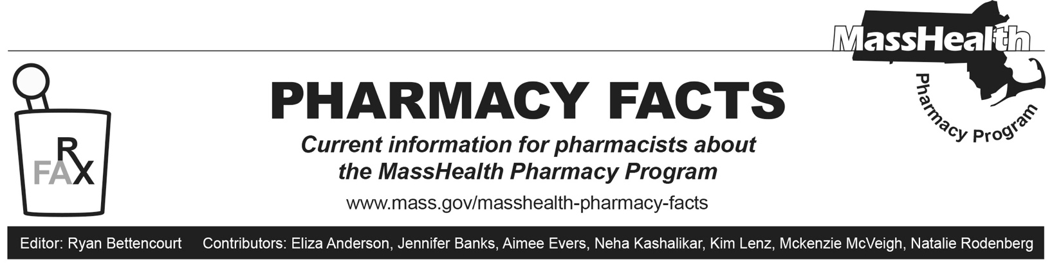
MHDL Update
Below are certain updates to the MassHealth Drug List (MHDL). See the MHDL for a complete listing of updates.

Additions
- Effective May 6, 2024, the following newly marketed drugs have been added to the MassHealth Drug List.
- Agamree (vamorolone) – PA
- Elrexfio (elranatamab-bcmm) – PA; MB
- Fruzaqla (fruquintinib) – PA
- Izervay (avacincaptad pegol) – PA; MB
- Jesduvroq (daprodustat) – PA
- Likmez (metronidazole suspension) – PA
- Motpoly XR (lacosamide extended-release capsule) – PA
- Sohonos (palovarotene) – PA
- Suflave (polyethylene glycol/sodium sulfate/potassium chloride/magnesium sulfate/sodium chloride) – PA
- Talvey (talquetamab-tgvs) – PA; MB
- Vanflyta (quizartinib) – PA
- Veopoz (pozelimab-bbfg) – PA; MB
- Vevye (cyclosporine 0.1% ophthalmic solution) – PA
- Voquezna (vonoprazan) – PA
- Xdemvy (lotilaner) – PA
- Effective May 6, 2024, the following preventative therapy has been added to the MassHealth Drug List Bullets – PA
- Penbraya (pentavalent meningococcal groups A, B, C, W, and Y vaccine)
Change in Prior Authorization Status
- Effective May 6, 2024, the following agent will no longer require PA within newly established quantity limits.
  - Marinol (dronabinol capsule) – PA > 2 units/day; BP
- Effective May 6, 2024, the following Alzheimer’s agent will require PA.
  - Namzaric (memantine/donepezil extended-release) – PA
- Effective May 6, 2024, the following osteoporosis agent will require PA.
  - alendronate solution – PA; M90
- Effective May 6, 2024, the following antiglaucoma agent will no longer require PA.
  - Lumigan (bimatoprost 0.01% ophthalmic solution)
- Effective April 8, 2024, the following inhaled respiratory agent will no longer require PA within the updated age limit.
  - fluticasone propionate inhalation aerosol – PA ≥ 12 years; A90
Change in Coverage Status
- Effective May 6, 2024, the following agents will be available through medical billing only and will no longer be available through pharmacy billing.
  - Mylotarg (gemtuzumab ozogamicin) – PA; MB
  - Portrazza (necitumumab) – PA; MB
  - Rybrevant (amivantamab-vmjw) – PA; MB
  - Zepzelca (lurbinectedin) – PA; MB
  - Zilretta (triamcinolone extended-release injectable suspension) – PA; MB
- Effective May 6, 2024, the following agents will no longer be restricted to medical billing.
  - Vyjuvek (beremagene geperpavec-svdt) – PA
Updated MassHealth Brand Name Preferred Over Generic Drug List
The MassHealth Brand Name Preferred Over Generic Drug List has been updated to reflect recent changes to the MassHealth Drug List.
- Effective May 6, 2024, the following agents will be added to the MassHealth Brand Name Preferred Over Generic Drug List.
- Emflaza (deflazacort) – PA; BP
- Farxiga (dapagliflozin); BP, M90
- Isentress (raltegravir); BP
- Marinol (dronabinol) – PA > 2 units/day; BP
- Restasis (cyclosporine 0.05% ophthalmic emulsion); BP, A90
- Sprycel (dasatinib); BP
- Toujeo (insulin glargine); BP
- Xigduo XR (dapagliflozin/metformin extended-release); BP, M90
- Effective May 6, 2024, the following agents will be removed from the MassHealth Brand Name Preferred Over Generic Drug List.
- Fortesta (testosterone 2% gel pump) – PA
- Kazano (alogliptin/metformin) – PA; M90
- Luzu (luliconazole) – PA; A90
- Nesina (alogliptin) – PA; M90
- Oseni (alogliptin/pioglitazone) – PA; M90
- Oxistat (oxiconazole cream) – PA; A90
- Pennsaid (diclofenac topical solution); #; A90
- Pristiq (desvenlafaxine succinate extended-release) – PA < 6 years and PA > 1 unit/day; #, A90
- Rapamune (sirolimus solution); #, A90
- Welchol (colesevelam); #, M90
Updated MassHealth Over-the-Counter Drug List
The MassHealth Over-the-Counter Drug List has been updated to reflect recent changes to the MassHealth Drug List.
- Effective May 6, 2024, the following antioxidant agent will require PA above newly updated age limits.
  - coenzyme Q10 – PA ≥ 21 years
- Effective May 6, 2024, the following antifungal agent will be removed from the MassHealth Over-the-Counter Drug List.
  - tolnaftate liquid; *, A90
____________________________________
Legend
PA Prior authorization is required. The prescriber must obtain prior authorization for the drug in order for the pharmacy to receive payment. Note: PA applies to both the brand-name and the FDA “A”-rated generic equivalent of listed product.

# Designates a brand-name drug with FDA “A”-rated generic equivalents. Prior authorization is required for the brand, unless a particular form of that drug (for example, tablet, capsule, or liquid) does not have an FDA “A”-rated generic equivalent.

^{BP} Brand preferred over generic equivalents. In general, MassHealth requires a trial of the preferred drug or clinical rationale for prescribing the nonpreferred drug generic equivalent.

^{A90} Allowable 90-day supply. Dispensing in up to a 90-day supply is allowed. May not include all strengths or formulations. Quantity limits and other restrictions may apply.
^{M90} Mandatory 90-day supply. After dispensing up to a 30-day supply initial fill, dispensing in a 90-day supply is required. May not include all strengths or formulations. Quantity limits and other restrictions may also apply.

^{MB} This drug is available through the health care professional who administers the drug or in an outpatient or inpatient hospital setting. MassHealth does not pay for this drug to be dispensed through the retail pharmacy. If listed, PA does not apply through the hospital outpatient and inpatient settings. Please refer to 130 CMR 433.408 for PA requirements for other health care professionals. Notwithstanding the above, this drug may be an exception to the unified pharmacy policy; please refer to respective MassHealth Accountable Care Partnership Plans (ACPPs) and Managed Care Organizations (MCOs) for PA status and criteria, if applicable.
* The generic OTC and, if any, generic prescription versions of the drug are payable under MassHealth without PA.

