Number 228, May 10, 2024
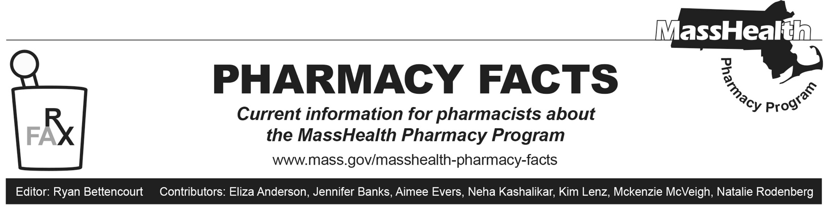
Naloxone Days’ Supply Guidance
MassHealth remains committed to ensuring members have access to multiple covered naloxone products available at no out-of-pocket cost, without prior authorization (PA) and without quantity limits. The following naloxone products are covered by MassHealth without PA or quantity limits and should be dispensed as a 1-day supply:
- Kloxxado (naloxone 8 mg/0.1 mL nasal spray)
- naloxone 4 mg/0.1 mL nasal spray*
- naloxone vial, 0.4 mg/mL syringe, 2 mg/2 mL syringe
- Narcan (naloxone 4 mg/0.1 mL nasal spray)*
- Zimhi (naloxone 5 mg /0.5 mL syringe)
- RiVive (naloxone 3 mg nasal spray)*
*FDA-approved over-the-counter formulation

When dispensing the naloxone agents listed above, claims should be submitted as a 1-day supply. If additional naloxone is needed for a member within the same day, pharmacists should contact the MassHealth Drug Utilization Review Program for an emergency override at 1-800-745-7318 during normal business hours. Outside of business hours, pharmacies may submit an emergency override claim with a value of “03” for level of service (Field 418-DI).

The Massachusetts Board of Pharmacy notes that although there may be limits to the amount of naloxone covered by insurance, there is no regulatory limit to the amount of naloxone that may be dispensed to an individual. (See Policy 2024-01: Naloxone Dispensing at www.mass.gov/doc/2024-01-naloxone-dispensing-pdf/download).

Although MassHealth generally requires a prescription before it will cover drugs, there is a standing order that allows pharmacists to dispense naloxone without an individual prescription. Please refer to the standing order for naloxone at www.mass.gov/doc/naloxone-standing-order-1/download and M.G.L. c. 94C, § 19B for further information.

For the most up-to-date information on the current coverage status of naloxone products and OTC drugs, please see MassHealth Drug List Therapeutic Table 36 and the MassHealth Covered OTC Drug List. The MassHealth Drug List can be found at www.mass.gov/masshealth-pharmacy-program. RiVive will be added to the MassHealth Drug List July 1, 2024, but is covered now.

