**Number 229, June 25, 2024**

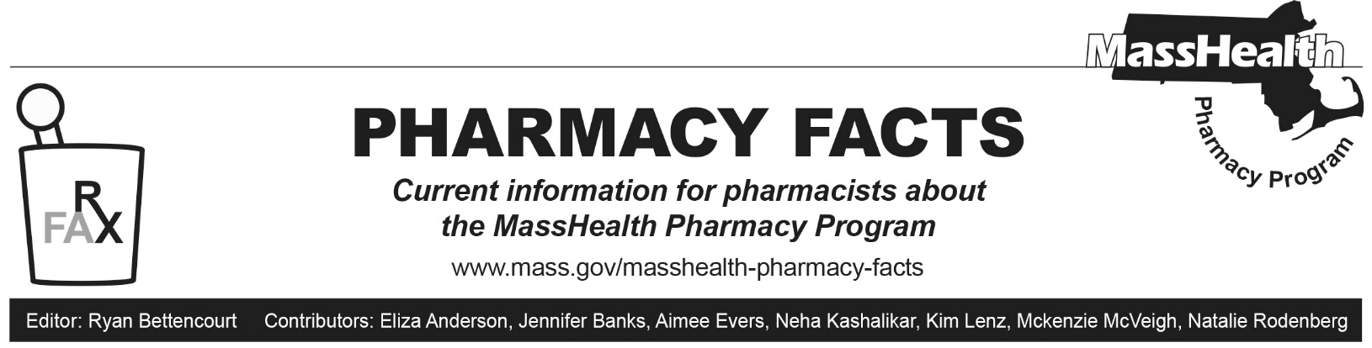

# MHDL Update

Below are certain updates to the MassHealth Drug List (MHDL). See the MHDL for a complete list of updates.

## Additions

Effective July 1, 2024, the following newly marketed drugs have been added to the MassHealth Drug List.

* adalimumab-aaty, unbranded – **PA**
* Augtyro (repotrectinib) – **PA**
* Aphexda (motixafortide) – **PA**; MB
* Bimzelx (bimekizumab-bkzx) – **PA**
* Eylea HD (aflibercept 8 mg); MB
* Jylamvo (methotrexate 2 mg/mL oral solution) – **PA**
* Loqtorzi (toripalimab-tpzi) – **PA**; MB
* Lyfgenia (lovotibeglogene autotemcel) – **PA**; CO, MB
* Ojjaara (momelotinib) – **PA**
* Opfolda (miglustat 65 mg) – **PA**
* Pombiliti (cipaglucosidase alfa-atga) – **PA**; MB
* Truqap (capivasertib) – **PA**
* Velsipity (etrasimod) – **PA**
* Wainua (eplontersen) – **PA**
* Xphozah (tenapanor 20 mg, 30 mg tablet) – **PA**
* Zituvio (sitagliptin) – **PA**; M90
* Zoryve (roflumilast foam) – **PA**

## Change in Prior-Authorization Status

1. Effective July 1, 2024, the following antiviral agent will require prior authorization (PA).

* Valcyte (valganciclovir powder for oral solution) – **PA**; BP; A90

1. Effective July 1, 2024, the following antiviral agent will no longer require PA.

* Denavir (penciclovir); BP

1. Effective July 1, 2024, the following gastrointestinal anti-inflammatory agents will require PA.

* Delzicol DR (mesalamine 400 mg delayed-release capsule) – **PA**; A90
* mesalamine 800 mg delayed-release tablet – **PA**; A90

1. Effective July 1, 2024, the following nonsteroidal anti-inflammatory agent will require PA.

* indomethacin suppository – **PA**

1. Effective July 1, 2024, the following vitamin D analog agent will require PA.

* Rocaltrol (calcitriol solution) – **PA**; M90

1. Effective July 1, 2024, the following otic agent will require PA.

* ciprofloxacin/dexamethasone otic suspension – **PA**; A90

1. Effective July 1, 2024, the following antidepressants will require PA. Pediatric Behavioral Health Medication Initiative criteria will apply. For additional information, please see the Pediatric Behavioral Health Medication Initiative documents at [mass.gov/druglist](http://www.mass.gov/druglist).

* amoxapine – **PA**; A90
* Aplenzin (bupropion hydrobromide extended-release) – **PA**

1. Effective July 1, 2024, the following compounded pharmaceutical products will require PA.

* compounded pharmaceutical product with intradermal route of administration – **PA**; CP

1. Effective July 1, 2024, the following butalbital-containing agent will no longer require PA within age and quantity limits.

* butalbital/aspirin/caffeine capsule – **PA** < 18 years and **PA** > 20 units/30 days

## Change in Coverage Status

Effective July 1, 2024, the following agent will be available through medical billing only and will no longer be available through pharmacy billing.

* Mozobil (plerixafor); MB

## Updated MassHealth Brand Name Preferred Over Generic Drug List

The MassHealth Brand Name Preferred Over Generic Drug List has been updated to reflect recent changes to the MassHealth Drug List.

1. Effective July 1, 2024, the following agents will be added to the MassHealth Brand Name Preferred Over Generic Drug List.

* Denavir (penciclovir); BP
* Valcyte (valganciclovir powder for oral solution) – **PA**; BP, A90

1. Effective July 1, 2024, the following agents will be removed from the MassHealth Brand Name Preferred Over Generic Drug List.

* Delzicol DR (mesalamine 400 mg delayed-release capsule) – **PA**; A90
* Lexiva (fosamprenavir); A90
* Noxafil (posaconazole suspension) – **PA**; A90
* Prezista (darunavir); #, A90
* Proair HFA (albuterol inhaler); A90
* Proventil (albuterol inhaler); A90
* Sorilux (calcipotriene foam) – **PA**; A90

## Updated MassHealth 90-day Initiative

The MassHealth 90-day Initiative has been updated to reflect recent changes to the MassHealth Drug List.

1. Effective July 1, 2024, the following agents may be allowed or mandated to be dispensed in up to a 90-day supply.

* estradiol gel; A90
* Myrbetriq (mirabegron extended-release); BP, A90

1. Effective July 1, 2024, the following agents will no longer be allowed or mandated to be dispensed in up to a 90-day supply.

* Denavir (penciclovir); BP
* Zovirax (acyclovir cream); BP

## Updated MassHealth Over-the-Counter Drug List

The MassHealth Over-the-Counter Drug List has been updated to reflect recent changes to the MassHealth Drug List.

1. Effective July 1, 2024, the following medical food will be added to the MassHealth Over-the-Counter Drug List.

* levomethylfolate tablet ≤ 1 unit/day

1. Effective March 13, 2024, the following oral contraceptive was added to the MassHealth Over-the-Counter Drug List on July 1, 2024.

* Opill (norgestrel tablet); A90

1. Effective March 27, 2024, the following opioid reversal agent was added to the MassHealth Over-the-Counter Drug List on July 1, 2024.

* Rivive (naloxone 3 mg nasal spray)

### Legend

**PA** Prior authorization is required. The prescriber must obtain prior authorization for the drug in order for the pharmacy to receive payment. Note: PA applies to both the brand-name and the FDA “A”-rated generic equivalent of listed product.

# This designates a brand-name drug with FDA “A”-rated generic equivalents.PA is required for the brand, unless a particular form of that drug (for example, tablet, capsule, or liquid) does not have an FDA “A”-rated generic equivalent.

BP Brand preferred over generic equivalents. In general, MassHealth requires a trial of the preferred drug or clinical rationale for prescribing the nonpreferred drug generic equivalent.

MBThis drug is available through the health care professional who administers the drug or in an outpatient or inpatient hospital setting. MassHealth does not pay for this drug to be dispensed through the retail pharmacy. If listed, PA does not apply through the hospital outpatient and inpatient settings. Please refer to 130 CMR 433.408 for PA requirements for other health care professionals. Notwithstanding the above, this drug may be an exception to the unified pharmacy policy; please refer to the applicable MassHealth accountable care partnership plans and managed care organizations for PA status and criteria, if applicable.

A90Allowable 90-day supply. Dispensing in up to a 90-day supply is allowed. May not include all strengths or formulations. Quantity limits and other restrictions may apply.

CO Carve-Out. This agent is listed on the Acute Hospital Carve-Out Drugs List and is subject to additional monitoring and billing requirements.

M90 Mandatory 90-day supply. After a 30-day supply initial fill is dispensed, dispensing in a 90-day supply is required. May not include all strengths or formulations. Quantity limits and other restrictions may also apply.

CP Compounded pharmaceutical products with a total allowed ingredient cost greater than or equal to $100 require PA. In addition, compounded pharmaceutical products with an intradermal, topical, or transdermal route of administration (ROA) require PA. The following ROAs are excluded from the PA requirement for products with a total allowed ingredient cost greater than or equal to $100: infusion, intramuscular, intravenous, intravenous piggyback, intravenous push, subcutaneous. Compounded pharmaceutical products that include any PA-requiring agent or noncovered ingredient require PA.