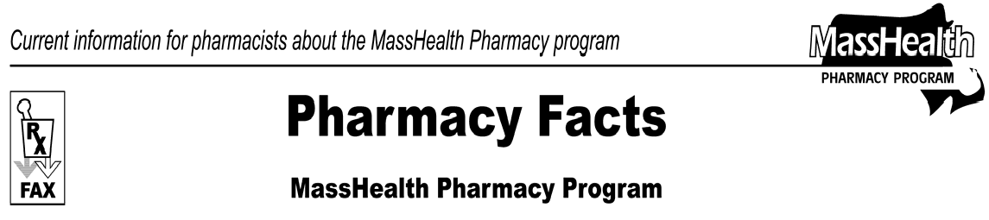
Number 23
December 7, 2006
www.mass.gov/masshealth/pharmacy
 | - Editor: Vic Vangel • Contributors: Chris Burke, Gary Gilmore, Paul Jeffrey, James Monahan, Chuck Young •
 | Plan-B  Plan-B (levonorgestrel) is now available over the counter for females over the age of 18. MassHealth has added Plan-B to the Nonlegend (OTC) Drug List and will continue to pay for Plan-B for female members with a valid prescription. The Commonwealth of Massachusetts, Department of Public Health, Board of Registration in Pharmacy, Board of Registration in Medicine, and Drug Control Program have adopted guidelines that describe the requirement for pharmacists to dispense emergency contraception. According to those guidelines, a pharmacist may dispense Plan-B pursuant to a written standardized procedure or protocol (i.e., standing order) of an actively practicing physician after the pharmacist has completed training from the Accreditation Council for Pharmacy Education (ACPE) or from an “Approved College or School of Pharmacy.”  If a pharmacy submits a claim for Plan-B that originated from a standing order, the pharmacy must enter the prescriber identification number from the prescriber who issued the standing order. (Refer to Board of Registration in Pharmacy Board Policy No. 2006-1 for additional information about standing orders.)  Prior Authorization Automation  The MassHealth Pharmacy Online Processing System (POPS) is now able to access diagnosis codes from MassHealth medical claims and, in some cases, process the claim without the need for a paper prior- authorization request. Even in cases where prior authorization is otherwise required, a prescriber may not need to submit a paper prior authorization (PA) form if a member’s diagnosis in POPS meets the criteria for that drug. | For this reason, MassHealth requests pharmacies to submit all claims through POPS – even if they require Prior Authorization – as POPS will automatically pay for some drugs that are designated as requiring prior authorization on the MassHealth Drug List.  Staffing Announcement  Chuck Young, former Executive Director of the Massachusetts Board of Registration in Pharmacy, has joined the staff of the Pharmacy Program at MassHealth. Chuck will serve as the Pharmacy Manager for Professional Affairs.  NPI (National Provider Identifier)  All pharmacies that submit claims to MassHealth must obtain and use an NPI by May 23, 2007. Information on how to apply for this number can be found at the NCPDP (National Council for Prescription Drug Programs) Web site at www.ncpdp.org.  Claims Submission Tips-Medicare Part D  When submitting claims for a MassHealth dual-eligible member who presents a prescription for a Medicare-D excluded drug (such as a benzodiazepine), the pharmacy does not need to bill the Part-D plan first.  Submit these claims directly to MassHealth. It is not necessary to submit these claims with an Other Coverage Code and/or Reject code.  When submitting a claim for a copay wrap for a dual- eligible member, the pharmacy must enter the amount of the copay required by the Part-D plan in the Patient Paid Amount field (NCPDP field 433-DX). Follow this procedure any time MassHealth is billed as a secondary payer and the primary insurer requires a copay.
Please direct any questions or comments (or to be taken off of this fax distribution) to
Victor Moquin of ACS at 617-423-9830.

