Number 230, August 7, 2024
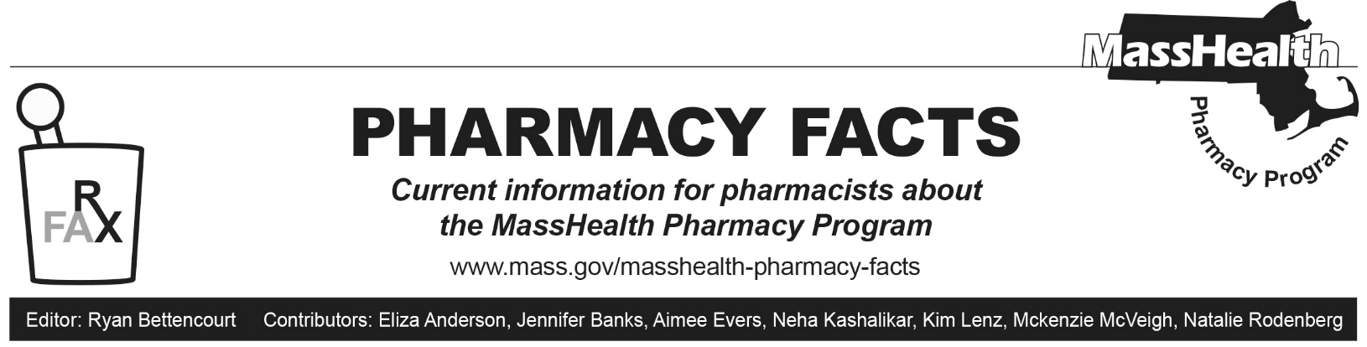
MHDL Update
Below are certain updates to the MassHealth Drug List (MHDL). See the MHDL for a complete listing of updates.
Additions
- Effective August 12, 2024, the following newly marketed drugs have been added to the MassHealth Drug List.
- adalimumab-ryvk, unbranded – PA
- Adzynma (ADAMTS13, recombinant-krhn) – PA
- Amtagvi (lifileucel) – PA; CO, MB
- Eohilia (budesonide oral suspension) – PA
- Filsuvez (birch triterpenes) – PA
- Iwilfin (eflornithine) – PA
- Ogsiveo (nirogacestat) – PA
- Pokonza (potassium chloride powder for oral solution) – PA
- Simlandi (adalimumab-ryvk) – PA
- trientine 500 mg capsule – PA; A90
- Zymfentra (infliximab-dyyb) – PA
- Effective May 9, 2024, the following preventative therapy has been added to the MassHealth Drug List on August 12, 2024.
- Jynneos (smallpox/monkeypox vaccine, live);¹
- Effective June 26, 2024, the following preventative therapy has been added to the MassHealth Drug List on August 12, 2024.
- Capvaxive (pneumococcal 21-valent conjugate vaccine)
Change in Prior Authorization Status
- Effective August 12, 2024, the following the following antipsychotic agents will no longer require PA within age and quantity limits. Pediatric Behavioral Health Medication Initiative criteria will apply. For additional information, please see the Pediatric Behavioral Health Initiative documents found at www.mass.gov/druglist.
- Invega (paliperidone 1.5 mg, 3 mg, 9 mg tablet) – PA < 6 years and PA > 1 unit/day; #; A90
- Invega (paliperidone 6 mg tablet) – PA < 6 years and PA > 2 units/day; #; A90
- Latuda (lurasidone 20 mg, 40 mg, 60 mg, 120 mg) – PA < 6 years and PA > 1 unit/day; #, A90
- Latuda (lurasidone 80 mg) – PA < 6 years and PA > 2 units/day; #, A90
- Effective August 12, 2024, the following the following antipsychotic agents will no longer require PA within updated quantity limits. Pediatric Behavioral Health Medication Initiative criteria will apply. For additional information, please see the Pediatric Behavioral Health Initiative documents found at www.mass.gov/druglist.
- Risperdal (risperidone 0.25 mg, 0.5 mg, 1 mg, 2 mg, 3 mg tablet) – PA < 6 years and PA > 3 units/day; #, A90
- Zyprexa (olanzapine 2.5 mg, 5 mg, 7.5 mg, 10 mg tablet) – PA < 6 years and PA > 3 units/day; #, A90
- Effective August 12, 2024, the following ophthalmic anti-allergy and anti-inflammatory agent will no longer require PA.
- Lastacaft (alcaftadine)
- Effective August 12, 2024, the following constipation agent will no longer require PA.
  - Linzess (linaclotide 72 mcg)
- Effective August 12, 2024, the following estrogen agent will require PA.
  - Duavee (conjugated estrogens/bazedoxifene) – PA
Change in Coverage Status
- Effective August 12, 2024, the following agents will be available through medical billing only and will no longer be available through pharmacy billing.
- Cosentyx (secukinumab vial) – PA; MB
  - ibandronate injection – PA; MB
  - pamidronate; MB
Updated MassHealth Brand Name Preferred Over Generic Drug List
The MassHealth Brand Name Preferred Over Generic Drug List has been updated to reflect recent changes to the MassHealth Drug List.
- Effective August 12, 2024, the following agents will be added to the MassHealth Brand Name Preferred Over Generic Drug List.
- Minivelle (estradiol); BP, M90
- Oxtellar XR (oxcarbazepine extended-release) – PA; BP
- Pred Forte (prednisolone acetate 1% ophthalmic suspension); BP, A90
- Promacta (eltrombopag) – PA; BP
- Tasigna (nilotinib); BP
- Vivelle-Dot (estradiol); BP, M90
- Effective August 12, 2024, the following agents will be removed from the MassHealth Brand Name Preferred Over Generic Drug List.
- Amitiza (lubiprostone) – PA; M90
- Marinol (dronabinol 5 mg, 10 mg) – PA > 2 units/day
Updated MassHealth Over-the-Counter Drug List
The MassHealth Over-the-Counter Drug List has been updated to reflect recent changes to the MassHealth Drug List.
- Effective August 12, 2024, the following probiotic agents will require PA within updated age limits.
- Align (bifidobacterium infantis) – PA ≥ 21 years
- Culturelle (lactobacillus rhamnosus GG) – PA ≥ 21 years
- Florastor (saccaromyces boulardii) – PA ≥ 21 years
- Effective August 12, 2024, the following ophthalmic anti-allergy and anti-inflammatory agent will be added to the MassHealth Over-the-Counter Drug List.
  - Lastacaft (alcaftadine)
- Effective August 12, 2024, the following iron agent will be added to the MassHealth Over-the-Counter Drug List.
  - iron polysaccharide complex; *, M90
Legend

PA Prior authorization is required. The prescriber must obtain prior authorization for the drug in order for the pharmacy to receive payment. Note: PA applies to both the brand-name and the FDA “A”-rated generic equivalent of listed product.

# Designates a brand-name drug with FDA “A”-rated generic equivalents. Prior authorization is required for the brand, unless a particular form of that drug (for example, tablet, capsule, or liquid) does not have an FDA “A”-rated generic equivalent.

^{BP} Brand preferred over generic equivalents. In general, MassHealth requires a trial of the preferred drug or clinical rationale for prescribing the nonpreferred drug generic equivalent.

^{A90} Allowable 90-day supply. Dispensing in up to a 90-day supply is allowed. May not include all strengths or formulations. Quantity limits and other restrictions may apply.

^{CO} Carve-Out. This agent is listed on the Acute Hospital Carve-Out Drugs List and is subject to additional monitoring and billing requirements.

^{MB} This drug is available through the health care professional who administers the drug or in an outpatient or inpatient hospital setting. MassHealth does not pay for this drug to be dispensed through the retail pharmacy. If listed, PA does not apply through the hospital outpatient and inpatient settings. Please refer to 130 CMR 433.408 for PA requirements for other health care professionals. Notwithstanding the above, this drug may be an exception to the unified pharmacy policy; please refer to respective MassHealth Accountable Care Partnership Plans (ACPPs) and Managed Care Organizations (MCOs) for PA status and criteria, if applicable.

^{M90} Mandatory 90-day supply. After dispensing up to a 30-day supply initial fill, dispensing in a 90-day supply is required. May not include all strengths or formulations. Quantity limits and other restrictions may also apply.

¹ Product may be available through the Massachusetts Department of Public Health (DPH). Please check with DPH for availability. MassHealth does not pay for immunizing biologicals (i.e., vaccines) and tubercular (TB) drugs that are available free
of charge through local boards of public health or through the Massachusetts DPH without prior authorization (130 CMR 406.413(C)). In cases where free vaccines are available to providers for specific populations (e.g., children, high risk, etc.), MassHealth will reimburse the provider only for individuals not eligible for the free vaccines. Notwithstanding the above, MassHealth will pay pharmacies for seasonal flu vaccine serum without prior authorization, if the vaccine is administered in the pharmacy.

