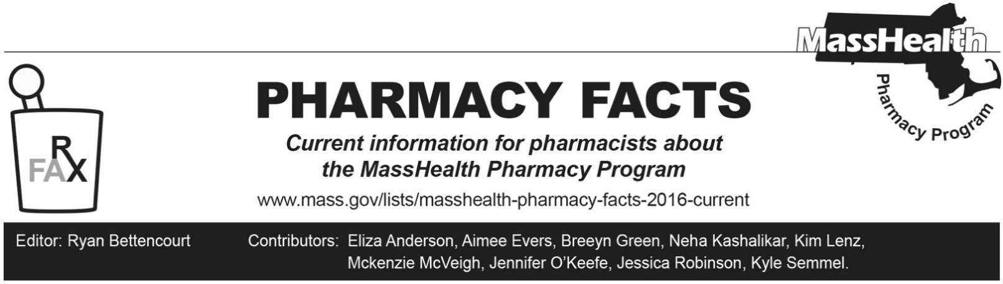
Number 237, December 30, 2024

COVID-19 Vaccination Update
Effective January 6, 2025, MassHealth will be imposing new quantity limits requirements on COVID-19 Vaccines submitted through the Pharmacy Online Processing System. This quantity limit will be 1 dose/year, with built in allowances for the following scenarios.
- 2 doses/year for Novavax COVID-19 vaccine, adjuvanted for members who have not previously been vaccinated,
- 2 doses/year for Moderna COVID-19 vaccine for members < 5 years of age who have not previously been vaccinated,
- 3 doses/year for Pfizer-BioNTech COVID-19 vaccine for members < 5 years of age who have not previously been vaccinated

MassHealth understands that Centers for Disease Control and Prevention (CDC) guidance may change periodically, and that some members may require a CDC-recommended dosing schedule outside of these quantity limits. When billing claims for MassHealth members, a pharmacy may see a rejection that reads as follows.
- 75 – Prior Authorization Required, with text message, Quantity limits exceeded. Please call the DUR program at (800) 745-7318 for claim review.
If a pharmacy encounters this message and believes that administration of the vaccine is clinically appropriate based upon the current CDC recommendations, the pharmacy should reach out to the MassHealth Drug Utilization Review (DUR) program at (800) 745-7318 for an override.

Claims Processing Update for Pediculicide Agents
Certain residential facilities (e.g., nursing, assisted living, custodial care, or group homes facilities) are at higher risk of head lice infestation. In these situations, MassHealth has developed a point-of-sale rule to expedite access to therapies that do not require nit combing to help address this situation. Effective November 14, 2024, spinosad and ivermectin lotion will usually pay at the pharmacy without prior authorization (PA) for members greater than six months of age when the member resides in a facility as noted by a pharmacy claim submission that includes one of the following patient residence codes (NCPDP Field 384-4X):
  - 2=Skilled Nursing Facility
  - 3=Nursing Facility
  - 4=Assisted living facility
  - 5=Custodial Care Facility
  - 6=Group home
  - 11=Hospice

Current coverage status and prior authorization criteria for pediculicide agents can be found on the MassHealth Drug List Therapeutic Table 54: Pediculicides and Scabicides. This new point-of-sale rule will be published in Table 54 on January 6, 2025.

MassHealth Drug List Update

Below are certain updates to the MassHealth Drug List (MHDL). See the MHDL for a complete listing of updates.

Additions
Effective January 6, 2025, the following newly marketed drugs will be added to the MassHealth Drug List.
- Anktiva (nogapendekin alfa inbakic-pmln) – PA; MB
- Defencath (taurolidine/heparin) – PA; MB
- Duvyzat (givinostat) – PA
- Iqirvo (elafibranor) – PA
- Kisunla (donanemab-azbt) – PA
- Livdelzi (seladelpar) – PA
- Nemluvio (nemolizumab-ilto) – PA
- Ohtuvayre (ensifentrine) – PA
- Ojemda (tovorafenib) – PA
- Onyda XR (clonidine extended-release suspension) – PA
- Rinvoq LQ (upadacitinib solution) – PA
- Rytelo (imetelstat) – PA; MB
- Sofdra (sofpironium) – PA
- Sovuna (hydroxychloroquine) – PA
- Tevimbra (tislelizumab-jsgr) – PA; MB
- Tofidence (tocilizumab-bavi) – PA; MB
- Tyenne (tocilizumab-aazg auto-injection, prefilled syringe) – PA
- Tyenne (tocilizumab-aazg vial) – PA; MB
- Vigafyde (vigabatrin solution) – PA
- Xolremdi (mavorixafor) – PA

Change in Prior Authorization Status
- Effective January 6, 2025, the following psoriasis agent will require PA.
  - methoxsalen capsule – PA; A90
- Effective January 6, 2025, the following antidiarrheal agent will no longer require PA.
  - Motofen (difenoxin/atropine)
- Effective January 6, 2025, the following thyroid agent will require PA.
  - Tirosint (levothyroxine capsule) – PA; M90
- Effective January 6, 2025, the following anti-obesity agents will no longer require PA within newly established age limits.
  - Adipex-P (phentermine 37.5 mg capsule, tablet) – PA < 12 years; #
  - Lomaira (phentermine 8 mg tablet) – PA < 12 years or ≥ 18 years
  - phentermine 15 mg, 30 mg capsule – PA < 12 years

Updated MassHealth Brand Name Preferred Over Generic Drug List
The MassHealth Brand Name Preferred Over Generic Drug List has been updated to reflect recent changes to the MassHealth Drug List.
- Effective January 6, 2025, the following agents will be added to the MassHealth Brand Name Preferred Over Generic Drug List.
- Auryxia (ferric citrate) – PA; BP
- Fycompa (perampanel) – PA; BP
- Namzaric (memantine/donepezil extended-release) – PA; BP
- Ravicti (glycerol phenylbutyrate) – PA; BP
- Rytary (carbidopa/levodopa extended-release capsule) – PA; BP
- Sancuso (granisetron transdermal system) – PA; BP
- Sandostatin LAR (octreotide injectable suspension); BP
- Xarelto (rivaroxaban 10 mg, 15 mg, 20 mg tablet, starter pack); BP
- Xarelto (rivaroxaban 2.5 mg tablet) – PA; BP
- Effective January 6, 2025, the following agents will be removed from the MassHealth Brand Name Preferred Over Generic Drug List.
- Afinitor (everolimus 2.5 mg, 5 mg, 7.5 mg, 10 mg) – PA; A90
- Focalin XR (dexmethylphenidate extended-release) – PA < 3 years or ≥ 21 years and PA > 2 units/day; #
- Gelnique (oxybutynin gel)
- Kombiglyze XR (saxagliptin/metformin) – PA; M90
- Revatio (sildenafil oral suspension) – PA; A90
- Samsca (tolvaptan) – PA; A90
- Tirosint (levothyroxine capsule) – PA; M90
- Vascepa (icosapent ethyl) – PA; M90

Change in Coverage Status
- Effective January 6, 2025, the following agents will be available through medical billing only and will no longer be available through pharmacy billing.
  - glycopyrrolate injection – PA; MB
- Effective January 6, 2025, the following agents will no longer be restricted to medical billing.
- Glassia (alpha-1-proteinase inhibitor, human)
- Prolastin-C (alpha-1-proteinase inhibitor, human)
- Tepezza (teprotumumab-trbw) – PA

Updated MassHealth 90-day Initiative
The MassHealth 90-day Initiative has been updated to reflect recent changes to the MassHealth Drug List. Effective January 6, 2025, the following agents may be allowed or mandated to be dispensed in up to a 90-day supply, as indicated below.
  - alcaftadine; A90

Legend

# This designates a brand-name drug with FDA “A”-rated generic equivalents. PA is required for the brand, unless a particular form of that drug (for example, tablet, capsule, or liquid) does not have an FDA “A”-rated generic equivalent.
^{MB} This drug is available through the health care professional who administers the drug or in an outpatient or inpatient hospital setting. MassHealth does not pay for this drug to be dispensed through the retail pharmacy. If listed, PA does not apply through the hospital outpatient and inpatient settings. Please refer to 130 CMR 433.408 for PA requirements for other health care professionals. Notwithstanding the above, this drug may be an exception to the unified pharmacy policy; please refer to respective MassHealth Accountable Care Partnership Plans (ACPPs) and Managed Care Organizations (MCOs) for PA status and criteria, if applicable.
PA Prior authorization is required. The prescriber must obtain prior authorization for the drug in order for the provider to receive reimbursement. Note: PA applies to both the brand-name and the FDA “A”-rated generic equivalent of listed product.
^{A90} Allowable 90-day supply. Dispensing in up to a 90-day supply is allowed. May not include all strengths or formulations. Quantity limits and other restrictions may apply.
^{BP} Brand Preferred over generic equivalents. In general, MassHealth requires a trial of the preferred drug or clinical rationale for prescribing the non-preferred drug generic equivalent.
^{M90} Mandatory 90-day supply. After dispensing up to a 30-day supply initial fill, dispensing in a 90-day supply is required. May not include all strengths or formulations. Quantity limits and other restrictions may also apply.

