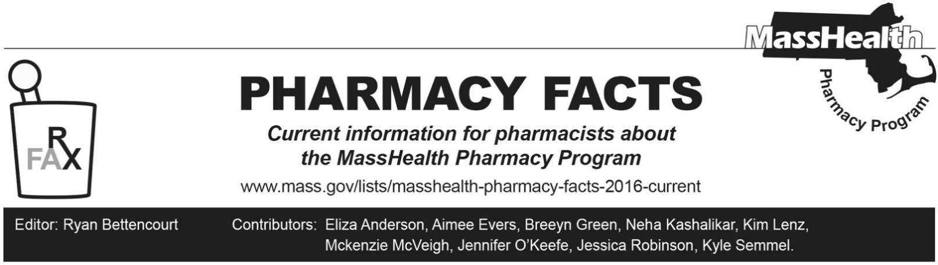
Number 239, January 24, 2025

Children’s Medical Security Plan (CMSP) Pharmacy Copay Changes Effective January 1, 2025
As described in Pharmacy Facts 199 and 224, copayments have been eliminated for MassHealth members and for Health Safety Net (HSN) patients. Effective January 1, 2025, the Executive Office of Health and Human Services also eliminated copayments for Children’s Medical Security Plan (CMSP) members. Updates will be made to 130 CMR 522.004(E) at a future date to effectuate this change.
MassHealth has published an updated copay poster on its website that reflects these changes.
COVID-19 Vaccination Reimbursement Update
As noted in Pharmacy Facts 233, rates for COVID-19 vaccination in 101 CMR 446.00: COVID-19 and Public Health Emergency Payment Rates for Certain Community Health Care Providers were updated on October 1, 2024. The administration fee for COVID-19 vaccines is equal to 100% of the corresponding Medicare Part B payment rate for administration, without geographic adjustment.
The Medicare Part B payment rate for administration of COVID-19 vaccines was updated on January 1, 2025. As a result, for dates of service beginning January 1, 2025, the administration rate for COVID-19 vaccines will be $44.95.
Massachusetts Board of Registration in Pharmacy Nonresident Licensure
Pursuant to changes in Massachusetts Board of Registration in Pharmacy regulation 247 CMR 6.00: Licensure of Pharmacies, all out-of-state pharmacies that ship or dispense into Massachusetts must be licensed by the Massachusetts Board of Registration in Pharmacy as a non-resident Drug Store Pharmacy, a non-resident sterile compounding pharmacy, and/or a non-resident complex non-sterile compounding pharmacy, or be granted a provisional license by the Massachusetts Board of Registration in Pharmacy. This Board of Registration in Pharmacy requirement is in addition to all existing MassHealth out-of-state provider requirements set forth in 130 CMR 406.404(C).

