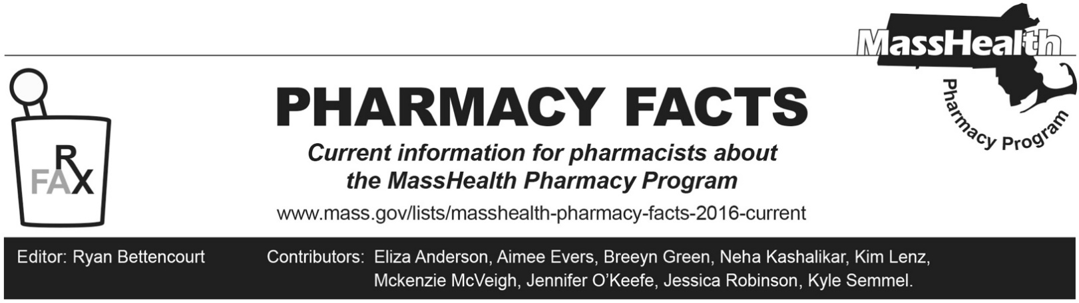
Number 240, February 3, 2025

Standing Orders for Dispensing Over-the-counter Prenatal Vitamins and Over-the-counter Oral Hormonal Birth Control

Summary
- MassHealth has issued standing orders for prenatal vitamins and over-the-counter (OTC) oral hormonal birth control.
- Licensed pharmacists may utilize these standing orders to provide access to covered OTC prenatal vitamin and OTC oral hormonal birth control products for MassHealth members or Health Safety Net patients without a prescription.

Standing Orders for Dispensing Over-the-counter Prenatal Vitamins
Prenatal vitamins are an important part of prenatal care to help ensure that the parent and baby get the nutrients needed during pregnancy and breastfeeding. Prenatal vitamins or multivitamins containing ≥ 400 mcg of folic acid are recommended for any individual of reproductive age who is capable of becoming pregnant, considering pregnancy, attempting to become pregnant, is pregnant, or is nursing.¹
Covered prenatal vitamins through the standing order include
For oral administration:
- Any covered orally administered prenatal or multivitamin containing ≥ 400 mcg of folic acid
- Dispense up to a 90 days’ supply to members.
- Directions for use: Take according to package instructions.
Contraindication: Known hypersensitivity to folic acid or any component of the formulation.
Pharmacists must review counseling points and contraindications and must always counsel the individual to follow up and consult with their primary care physician or obstetrician/gynecologist as directed in the standing order.
Please refer to M.G.L. c. 118E, § 84 for further information on this standing order. Here is the link to the standing order: mass.gov/doc/standing-order-prenatal-vitamins-0/download

Standing Order for Dispensing Over-the-counter Oral Hormonal Contraceptives
Oral hormonal birth control, when taken correctly, can help reduce the likelihood of unwanted pregnancy.² In July 2023, Opill® (norgestrel) was the first FDA approved OTC oral contraceptive. Opill® (norgestrel) is covered on the MassHealth Drug List and included on the MassHealth OTC covered product list. Opill® is covered on the MassHealth Drug List and was included in MassHealth OTC covered product list on July 1, 2024.

This standing order authorizes licensed pharmacists to dispense OTC oral hormonal contraceptives to any MassHealth member or HSN patient who states that they are of reproductive potential and age who wish to prevent pregnancy. Pharmacists utilizing this standing order must counsel members on the importance of consistent timing of dose and what to do if a dose is missed. Pharmacists must also counsel members that OTC oral hormonal contraceptives should not be used for emergency contraception and do not protect against HIV/AIDS.

Pharmacists must check for drug-drug interactions and counsel the member on contraindications (e.g., pregnancy, breast cancer, uterine bleeding, liver tumors, liver disease). The pharmacist is also instructed to counsel on use, administration, and side effects. Pharmacists utilizing this standing order must advise the patient to follow up and consult with their primary care physician or obstetrician/gynecologist.
Covered OTC oral hormonal birth control through the standing order includes:
For oral administration:
- Norgestrel 0.075 mg tablet
- Dispense up to 365 days’ supply
Directions for use: Take one tablet by mouth at the same time every single day. Take within 3 hours from the time the tablet was taken the day before. Administration is continuous, with no interruption between pill packs.
Please refer to M.G.L. c. 118E, § 83 for further information on this standing order. Here is the link to the standing order:
mass.gov/doc/standing-order-over-the-counter-oral-hormonal-birth-control-0/download

References
1. Folic Acid Supplementation to Prevent Neural Tube Defects: Updated Evidence Report and Systematic Review for the US Preventive Services Task Force. Viswanathan M, Urrutia RP, Hudson KN, Middleton JC, Kahwati LC. JAMA. 2023;330(5):460.
2. Opill® [consumer information leaflet on the internet]. Allegan (MI): Perrigo; 2023. [cited 2024 Nov 1].
Available from: https://cdn.shopify.com/s/files/1/0753/6653/1352/files/Consumer_Information_Leaflet.pdf?v=1709218835

