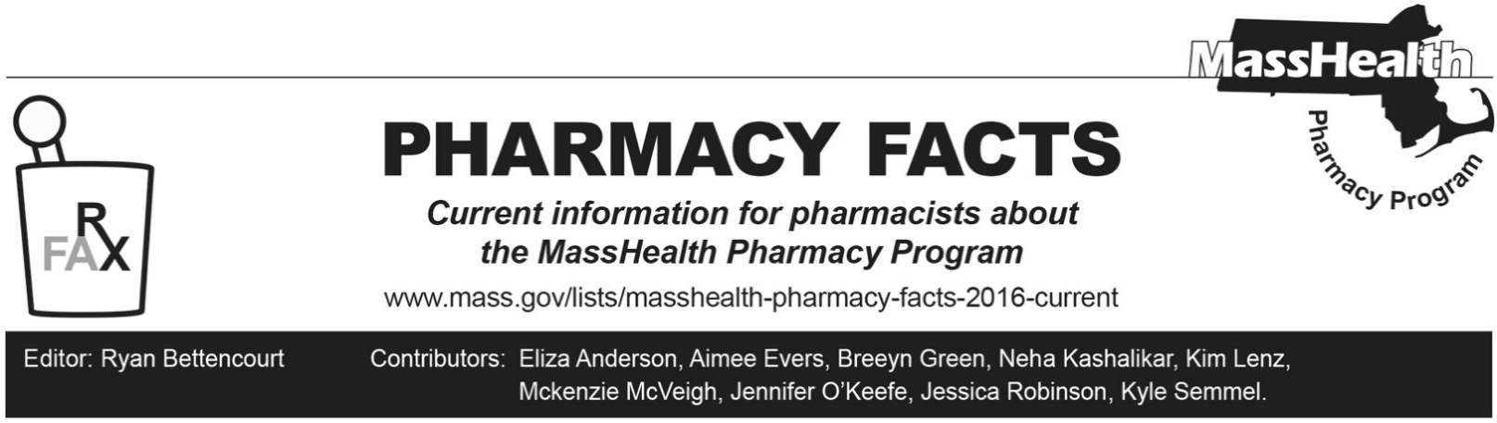
Number 241, February 06, 2025

MassHealth Drug List Update
Below are certain updates to the MassHealth Drug List (MHDL). See the MHDL for a complete listing of updates.

Additions
Effective February 18, 2025, the following newly marketed drugs will be added to the MassHealth Drug List.
- Cobenfy (xanomeline/trospium) – PA
- Crexont (carbidopa/levodopa extended-release capsule) – PA
- Lazcluze (lazertinib) – PA
- Neffy (epinephrine nasal spray) – PA
- PiaSky (crovalimab-akkz) – PA; MB
- Tecelra (afamitresgene autoleucel) – PA; CO, MB
- Tecentriq Hybreza (atezolizumab-hyaluronidase-tqjs) – PA; MB
- Tryvio (aprocitentan) – PA
- Voranigo (vorasidenib) – PA
- Vyalev (foscarbidopa/foslevodopa) – PA

Change in Prior Authorization Status
- Effective February 18, 2025, the following cardiovascular agents will require PA.
  - Accupril (quinapril) – PA; M90
  - Accuretic (quinapril/hydrochlorothiazide) – PA; M90
  - digoxin 62.5 mcg tablet, solution – PA; M90
  - furosemide solution – PA; M90
- Effective February 18, 2025, the following topical immunosuppressive agent will require PA.
  - Elidel (pimecrolimus) – PA; A90
- Effective February 18, 2025, the following medical supply will no longer require PA within established quantity limits.
  - Freestyle Neo (test strips, blood glucose, preferred) – PA > 100 units/30 days; PND

Updated MassHealth Brand Name Preferred Over Generic Drug List
Effective February 18, 2025, the following agents will be removed from the MassHealth Brand Name Preferred Over Generic Drug List.
- Elidel (pimecrolimus) – PA; A90
- Valcyte (valganciclovir powder for oral solution) – PA; A90

Updated MassHealth 90-day Initiative
The MassHealth 90-day Initiative has been updated to reflect recent changes to the MassHealth Drug List.
Effective February 18, 2025, the following agents may be allowed or mandated to be dispensed in up to a 90-day supply, as indicated below.
  - Namzaric (memantine/donepezil extended-release) – PA; BP, A90

Change in Coverage Status
Effective February 18, 2025, the following agents will be available only through medical billing and will no longer be available through pharmacy billing.
  - Brevibloc (esmolol); MB
  - chlorothiazide injection; MB
  - Lanoxin (digoxin injection); MB
  - nicardipine injection; MB
  - nitroglycerin injection; MB

New FDA “A”-Rated Generics
Effective February 18, 2025, the following FDA “A”-rated generic drugs will be added to the MassHealth Drug List. The brand name is listed with a # symbol to indicate that PA is required for the brand.
New FDA “A”-Rated Generic Drug Generic Equivalent of
epinephrine injection Adrenalin #
mesna tablet Mesnex #

Abbreviations, Acronyms, and Symbols
# This designates a brand-name drug with FDA “A”-rated generic equivalents.PA is required for the brand, unless a particular form of that drug (for example, a tablet, capsule, or liquid) does not have an FDA “A”-rated generic equivalent.
^{MB} This drug is available through the healthcare professional who administers the drug or in an outpatient or inpatient hospital setting. MassHealth does not pay for this drug to be dispensed through the retail pharmacy. If listed, PA does not apply through the hospital outpatient and inpatient settings. Please refer to 130 CMR 433.408 for PA requirements for other healthcare professionals. Notwithstanding the above, this drug may be an exception to the unified pharmacy policy; please refer to respective MassHealth Accountable Care Partnership Plans (ACPPs) and Managed Care Organizations (MCOs) for PA status and criteria, if applicable.
^{PA} Prior authorization is required. The prescriber must obtain PA for the drug in order for the provider to receive reimbursement. Note: PA applies to both the brand-name and the FDA “A”-rated generic equivalent of a listed product.
^{A90} Allowable 90-day supply. Dispensing in up to a 90-day supply is allowed. May not include all strengths or formulations. Quantity limits and other restrictions may apply.
^{CO} Carve-Out. This agent is listed on the Acute Hospital Carve-Out Drugs List and is subject to additional monitoring and billing requirements.
^{M90} Mandatory 90-day supply. After dispensing up to a 30-day supply initial fill, dispensing in a 90-day supply is required. May not include all strengths or formulations. Quantity limits and other restrictions may also apply.
^{PND} Preferred Non-Drug Product. This product is a preferred non-drug product for which MassHealth has entered into a rebate agreement with the product manufacturer.

