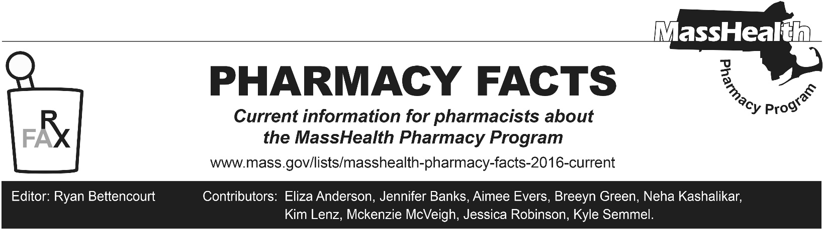
Number 242, February 20, 2025

Medicaid Management Information System (MMIS) and Provider Online Service Center (POSC) Migration to Cloud Architecture
MassHealth will migrate its Medicaid Management Information System (MMIS) and Provider Online Service Center (POSC) to an Amazon Web Services (AWS) data center in early March. The migration to the AWS cloud will provide MassHealth with greater security, scalability, and will enable the agency to implement hardware/software technology refreshes without major disruptions to the MMIS POSC availability.
The cutover to AWS is scheduled from Friday afternoon, 3/14/2025, through Monday morning, 3/17/2025. If a contingency date is necessary, MassHealth expects to cutover to AWS the following weekend.
- On Thursday, March 13, the last remittance advice will be issued before the AWS cutover and will be available for download.
- 12 p.m. on Friday, March 14, will be the last time that MassHealth will accept or process any requests via the MMIS POSC.
- The MMIS POSC will be shut down starting Friday, March 14, at 12 p.m. and will be unavailable until Monday morning, March 17 at 7 a.m. when it opens in the cloud for all providers.
- 6 p.m. on Friday, March 14 will be the last time MassHealth will process any updates to its provider or member profiles via the MMIS POSC.

The Pharmacy Online Processing System will continue to operate, and pharmacies may continue to submit claims to POPS during the cutover timeframe. However, member or provider eligibility changes that occur on Friday, March 14 will not get applied to POPS until Tuesday morning, March 18. If a member has evidence of eligibility, please continue to provide necessary services and process the information in POPS once the cutover is complete.

For additional specifics, including recommended preparation steps and a more detailed timeline, please see All Provider Bulletin 401 and Managed Care Entity Bulletin 124. If you have any questions regarding the AWS cloud migration or this bulletin, please contact MassHealth Customer Service Center at provider@masshealthquestions.com or (800) 841-2900.

Please direct any questions or comments (or to be removed from this fax distribution) to
PharmFactsMA@Conduent.com.

