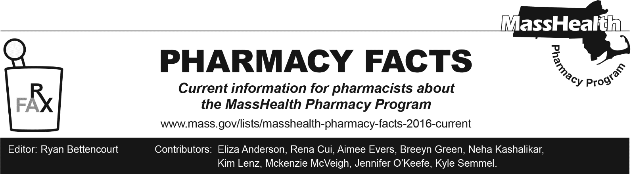
Number 243, March 31, 2025

MassHealth Drug List Update
Below are updates to the MassHealth Drug List (MHDL). See the MHDL for a complete listing of updates.

Additions
Effective April 1, 2025, the following newly marketed drugs will be added to the MassHealth Drug List.
- Alyftrek (vanzacaftor/tezacaftor/deutivacaftor) ^{PD} – PA
- Aqneursa (levacetylleucine) – PA
- Ebglyss (lebrikizumab-lbkz) ^{PD} – PA
- Erzofri (paliperidone extended-release 1-month injection) – PA
- Itovebi (inavolisib) – PA
- Miplyffa (arimoclomol) – PA
- Opipza (aripiprazole film) – PA
- sitagliptin/metformin; M90
- Vafseo (vadadustat) – PA; MB
- Vimkunya (chikungunya virus vaccine, recombinant)
- Vyloy (zolbetuximab-clzb) – PA; MB
- Yorvipath (palopegteriparatide) – PA
- Zituvimet (sitagliptin/metformin) – PA
- Zituvimet XR (sitagliptin/metformin extended-release) – PA

Change in Prior Authorization Status
- Effective April 1, 2025, the following gastrointestinal anti-inflammatory agent will require PA.
  - Lialda (mesalamine 1.2 gram delayed-release tablet) – PA; A90
- Effective April 1, 2025, the following antipsychotic will require PA within updated age and quantity limits. Pediatric Behavioral Health Medication Initiative criteria will still apply. For additional information, please see the Pediatric Behavioral Health Initiative documents found at www.mass.gov/druglist.
  - aripiprazole solution – PA < 10 years or ≥ 13 years and PA ≥ 10 mL/day; A90
- Effective April 1, 2025, the following insulin agent will require PA.
  - insulin aspart – PA
- Effective April 1, 2025, the following gastrointestinal agent will no longer require PA within newly established age limits.
  - Nexium (esomeprazole magnesium 10 mg suspension) – PA ≥ 2 years and PA > 1 unit/day; BP, M90
  - Nexium (esomeprazole magnesium 2.5 mg, 5 mg suspension) – PA ≥ 2 years and PA > 1 unit/day; #, M90
- Effective April 1, 2025, the following antidiabetic agent will require PA.
  - glimepiride 3 mg – PA; M90
- Effective February 18, 2025, the following cardiovascular agents will no longer require PA within newly established age limits.
  - digoxin solution – PA ≥ 13 years; A90
  - furosemide solution – PA ≥ 13 years; M90
- Effective February 18, 2025, the following vaccine will no longer require PA within updated age limits.
  - Abrysvo (respiratory syncytial virus vaccine) – PA < 18 years; 1

Updated MassHealth Brand Name Preferred Over Generic Drug List
- Effective April 1, 2025, the following agents will be added to the MassHealth Brand Name Preferred Over Generic Drug List.
- Atrovent HFA (ipratropium inhalation aerosol); BP
- Betimol (timolol) – PA; BP
- Jentadueto (linagliptin/metformin); BP
- Jentadueto XR (linagliptin/metformin); BP
- Mestinon (pyridostigmine bromide 60 mg tablet, 180 mg extended-release tablet); BP, A90
- Tradjenta (linagliptin); BP
- Zituvio (sitagliptin) – PA; BP, M90
- Effective April 1, 2025, the following agents will be removed from the MassHealth Brand Name Preferred Over Generic Drug List.
- Emend (aprepitant trifold pack) – PA; A90
- Marinol (dronabinol 2.5 mg) – PA > 2 units/day; #
- Mycobutin (rifabutin); #; A90
- Neupro (rotigotine transdermal system) – PA > 1 unit/day
- Nucynta (tapentadol) – PA > 300 mg/day
- Nucynta ER (tapentadol extended-release) – PA > 300 mg/day
- Thalomid (thalidomide)

Updated MassHealth 90-day Initiative
Effective April 1, 2025, the following agents may be allowed or mandated to be dispensed in up to a 90-day supply, as indicated below.
- cetirizine syrup; *, A90
- clobetasol propionate 0.025% cream – PA; A90
- digoxin 62.5 mcg tablet – PA; A90
- digoxin 125 mcg, 250 mcg tablet; A90
- digoxin solution – PA ≥ 13 years; A90
- levocetirizine solution – PA; A90
- loratadine solution; *, A90
- prazosin – PA < 6 years; A90
- propranolol immediate-release; A90
- psyllium capsule; *, A90
- Purixan (mercaptopurine oral suspension) – PA; A90
- sitagliptin/metformin; M90
- terbinafine 1% cream; *, A90

Updated MassHealth Over-the-Counter Drug List
Effective April 1, 2025, the following topical antifungal agent will be added to the MassHealth Over-the-Counter Drug List.
  - terbinafine 1% cream; *, A90

Change in Coverage Status
- Effective April 1, 2025, PA requests for one-time cell and gene therapies for members with Accountable Care Partnership Plans (ACPPs) and Managed Care Organizations (MCOs) plans will be reviewed by the MassHealth Drug Utilization Review (DUR) Program. One-time cell and gene therapies are part of the ACPP and MCO unified pharmacy policy.
- Effective April 1, 2025, the following agents will be available through medical billing only and will no longer be available through pharmacy billing.
  - Jesduvroq (daprodustat) – PA; MB

Abbreviations, Acronyms, and Symbols
# This designates a brand-name drug with FDA “A”-rated generic equivalents. PA is required for the brand, unless a particular form of that drug (for example, tablet, capsule, or liquid) does not have an FDA “A”-rated generic equivalent.
^{MB} This drug is available through the healthcare professional who administers the drug or in an outpatient or inpatient hospital setting. MassHealth does not pay for this drug to be dispensed through the retail pharmacy. If listed, PA does not apply through the hospital outpatient and inpatient settings. Please refer to 130 CMR 433.408 for PA requirements for other healthcare professionals. Notwithstanding the above, this drug may be an exception to the unified pharmacy policy; please refer to respective MassHealth Accountable Care Partnership Plans (ACPPs) and Managed Care Organizations (MCOs) for PA status and criteria, if applicable.
* The generic OTC and, if any, generic prescription versions of the drug are payable under MassHealth without PA.
PA Prior authorization is required. The prescriber must obtain PA for the drug in order for the provider to receive reimbursement. Note: PA applies to both the brand-name and the FDA “A”-rated generic equivalent of listed product.
^{A90} Allowable 90-day supply. Dispensing in up to a 90-day supply is allowed. May not include all strengths or formulations. Quantity limits and other restrictions may apply.
^{BP} Brand Preferred over generic equivalents. In general, MassHealth requires a trial of the preferred drug or clinical rationale for prescribing the non-preferred drug generic equivalent.
^{M90} Mandatory 90-day supply. After dispensing up to a 30-day supply initial fill, dispensing in a 90-day supply is required. May not include all strengths or formulations. Quantity limits and other restrictions may also apply.
^{PD} Preferred Drug. In general, MassHealth requires a trial of the preferred drug or clinical rationale for prescribing a non-preferred drug within a therapeutic class.
¹ Product may be available through the Massachusetts Department of Public Health (DPH). Please check with DPH for availability. MassHealth does not pay for immunizing biologicals (i.e., vaccines) and tubercular (TB) drugs that are available free of charge through local boards of public health or through the Massachusetts Department of Public Health without PA (130 CMR 406.413(C)). In cases where free vaccines are available to providers for specific populations (e.g. children, high risk, etc.), MassHealth will reimburse the provider only for individuals not eligible for the free vaccines. Notwithstanding the above, MassHealth will pay pharmacies for seasonal flu vaccine serum without prior authorization, if the vaccine is administered in the pharmacy.

