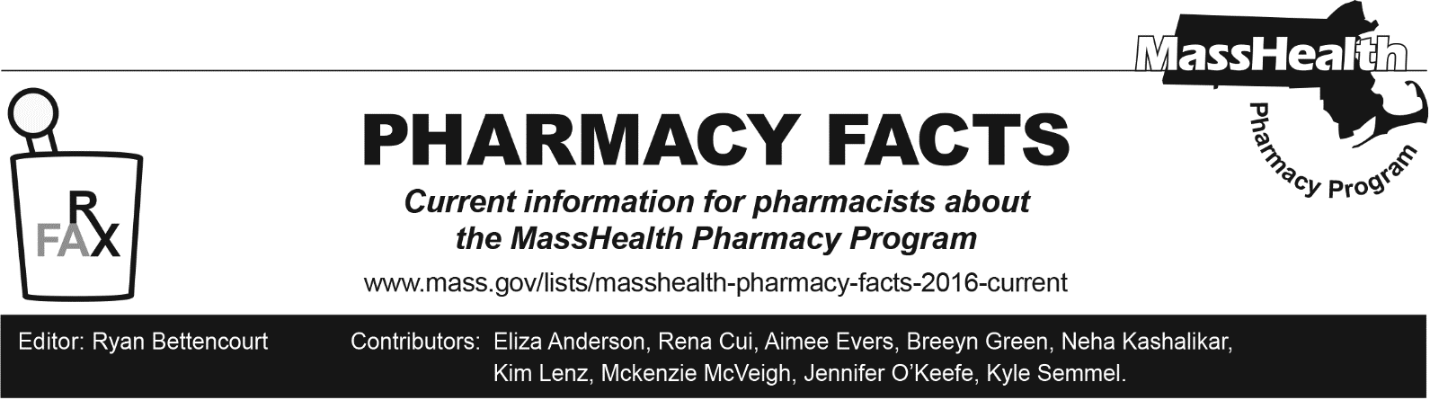**Number 244, April 1, 2025**

Health Safety Net Program Changes to Management of Anti-Obesity Medications

In accordance with Health Safety Net (HSN) regulations at 101 CMR 613.03(2)(e), the HSN does not pay for drugs used for the treatment of obesity. Effective April 15, 2025, the following drugs will no longer be payable for HSN patients for weight loss. Existing prior authorizations will be payable through May 15, 2025.

|  |
| --- |
| **Anti-Obesity Agents** |
| benzphetamine |
| diethylpropion, diethylpropoin extended-release |
| Saxenda® (liraglutide) |
| Xenical (orlistat) |
| phendimetrazine, phendimetrazine extended-release |
| Lomaira®, Adipex-P® (phentermine capsule, tablet) |
| Wegovy® (semaglutide) |
| Zepbound® (tirzepatide) |

* Any drug being used off-label for weight loss is not payable for HSN patients.
* HSN patients stable on an anti-obesity agent, including patients with existing prior authorizations for anti-obesity agents, will be able to continue getting the drug through May 15, 2025.
* Wegovy® (semaglutide) and Zepbound® (tirzepatide) may still be payable for other medically accepted indications. A new prior authorization will be required to review for medical necessity.

Providers should work with patients to transition to alternative therapies where appropriate.

* Patients with diabetes may be switched to Victoza® (liraglutide) which is available without prior authorization. Prior authorization status and criteria for other diabetic GLP-1 medications can be found on the MassHealth Drug List.

The MassHealth Drug List is on the MassHealth Pharmacy Program website at [www.mass.gov/masshealth/pharmacy](http://www.mass.gov/masshealth/pharmacy).