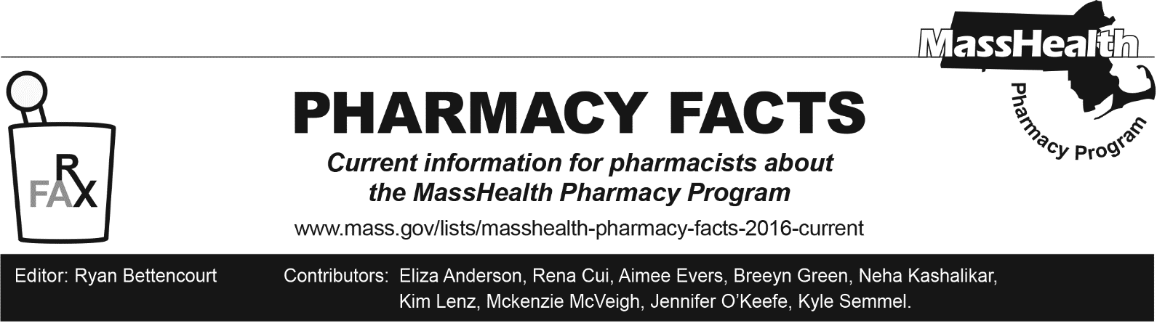
Number 245, May 5, 2025

MassHealth Drug List Update
Below are updates to the MassHealth Drug List (MHDL). See the MHDL for a complete listing of updates.

Additions
Effective May 12, 2025, the following newly marketed drugs have been added to the MassHealth Drug List.
- Aucatzyl (obecabtagene autoleucel) – PA; CO
- Axtle (pemetrexed dipotassium) – PA; MB
- Azmiro (testosterone cypionate) – PA
- Danziten (nilotinib tablet) – PA
- edaravone – PA
- Hympavzi (marstacimab-hncq) – PA
- Journavx (suzetrigine) ^{PD} – PA < 18 years of age and > 29 units/60 days
- Ocrevus Zunovo (ocrelizumab/hyaluronidase-ocsq) – PA
- Pemrydi RTU (pemetrexed disodium) – PA; MB
- Ziihera (zanidatamab-hrii) – PA; MB

Updated MassHealth Brand Name Preferred Over Generic Drug List
- Effective May 12, 2025, the following agents will be added to the MassHealth Brand Name Preferred Over Generic Drug List.
- Entresto (sacubitril/valsartan tablet) – PA; BP
- Mesnex (mesna tablet); BP
- Motegrity (prucalopride) – PA; BP
- Nexium (esomeprazole magnesium 2.5 mg, 5 mg suspension) – PA ≥ 2 years and PA > 1 unit/day; BP, M90
- Spritam (levetiracetam tablet for oral suspension) – PA; BP
- Effective May 12, 2025, the following agents will be removed from the MassHealth Brand Name Preferred Over Generic Drug List.
- Biltricide (praziquantel); #, A90
- Cleocin T (clindamycin lotion); #, A90
- Pred Forte (prednisolone acetate 1% ophthalmic suspension); #, A90
- Sporanox (itraconazole solution); #, A90
- Zegerid (omeprazole/sodium bicarbonate capsule, powder for oral suspension); #, M90

Updated MassHealth 90-day Initiative
Effective May 12, 2025, the following agents may be allowed or mandated to be dispensed in up to a 90-day supply, as indicated below.
- Auryxia (ferric citrate) – PA; BP, A90
- Brilinta (ticagrelor); #, A90
  - Xarelto (rivaroxaban 2.5 mg tablet) – PA > 2 units/day; BP, A90

Change in Coverage Status
Effective May 12, 2025, the following agents will no longer be restricted to medical billing.
  - Fensolvi (leuprolide) ^{PD} – PA

New FDA “A”-Rated Generics
Effective May 12, 2025, the following FDA “A”-rated generic drugs have been added to the MassHealth Drug List. The brand name is listed with a # symbol to indicate that PA is required for the brand.
New FDA “A”-Rated Generic Drug Generic Equivalent of
ticagrelor Brilinta #

Abbreviations, Acronyms, and Symbols
# This designates a brand-name drug with FDA “A”-rated generic equivalents. PA is required for the brand, unless a particular form of that drug (for example, tablet, capsule, or liquid) does not have an FDA “A”-rated generic equivalent.
^{CO} Carve-Out. This agent is listed on the Acute Hospital Carve-Out Drugs List and is subject to additional monitoring and billing requirements. All requests for one-time cell and gene therapies (as listed on the Acute Hospital Carve-Out Drug List), including for members enrolled in an Accountable Care Partnership Plan (ACPP) or Managed Care Organization (MCO), will be reviewed by the MassHealth Drug Utilization Review (DUR) Program.
^{MB} This drug is available through the healthcare professional who administers the drug or in an outpatient or inpatient hospital setting. MassHealth does not pay for this drug to be dispensed through the retail pharmacy. If listed, PA does not apply through the hospital outpatient and inpatient settings. Please refer to 130 CMR 433.408 for PA requirements for other healthcare professionals. Notwithstanding the above, this drug may be an exception to the unified pharmacy policy; please refer to respective MassHealth Accountable Care Partnership Plans (ACPPs) and Managed Care Organizations (MCOs) for PA status and criteria, if applicable.
* The generic OTC and, if any, generic prescription versions of the drug are payable under MassHealth without PA.
PA Prior authorization is required. The prescriber must obtain PA for the drug in order for the provider to receive reimbursement. Note: PA applies to both the brand-name and the FDA “A”-rated generic equivalent of listed product.
^{A90} Allowable 90-day supply. Dispensing in up to a 90-day supply is allowed. May not include all strengths or formulations. Quantity limits and other restrictions may apply.
^{BP} Brand Preferred over generic equivalents. In general, MassHealth requires a trial of the preferred drug or clinical rationale for prescribing the non-preferred drug generic equivalent.
^{M90} Mandatory 90-day supply. After dispensing up to a 30-day supply initial fill, dispensing in a 90-day supply is required. May not include all strengths or formulations. Quantity limits and other restrictions may also apply.
^{PD} Preferred Drug. In general, MassHealth requires a trial of the preferred drug or clinical rationale for prescribing a non-preferred drug within a therapeutic class.

