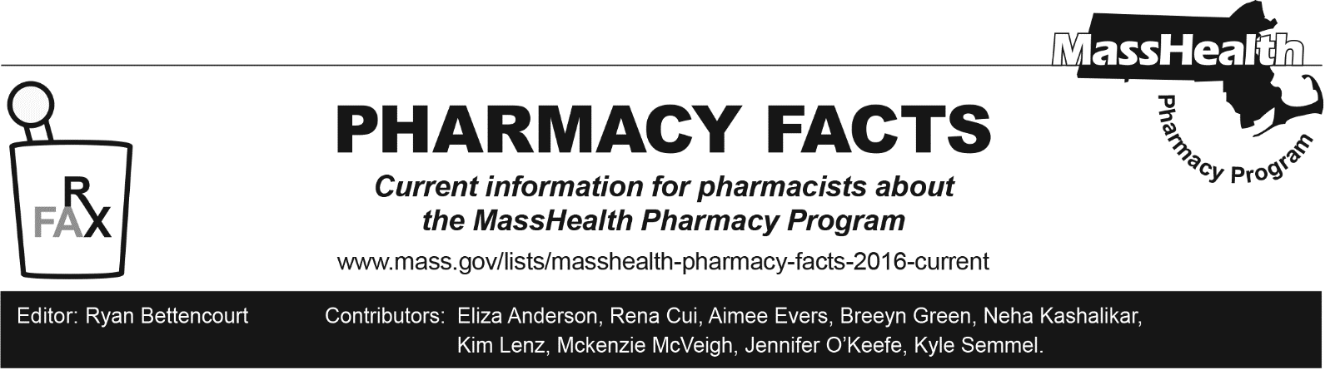
Number 246, June 12, 2025

New Legislative Requirements for Opioid Reversal Drugs

An Act Relative to Treatments and Coverage for Substance Use Disorder and Recovery Coach Licensure, Chapter 285 of the Acts of 2024, expands access to opioid reversal drugs (emergency opioid antagonists or EOAs) to enhance patient safety and address opioid-related overdoses. These measures aim to ensure broader access to life-saving opioid reversal drugs and enhance education and availability for at-risk patients. Key provisions include:

- Hospital Requirements. Hospitals must educate patients on EOAs and prescribe or dispense at least two doses of EOAs to patients with a history of overdose, opioid use, or opioid use disorder (OUD) upon discharge.

- Substance Use Disorder (SUD) Treatment Facilities. SUD treatment facilities are required to educate patients on EOAs and dispense two doses of EOAs to patients upon discharge.

- Pharmacy Requirements. Pharmacies in areas with high incidences of overdoses must maintain a sufficient and consistent supply of EOAs. This includes stocking EOAs approved for over-the-counter sale in addition to those requiring a prescription. Pharmacies unable to comply due to insufficient supply must report to the Department of Public Health (DPH).
  - Although MassHealth generally requires a prescription before it will cover drugs, there is a standing order that allows pharmacists to dispense naloxone without an individual prescription. Please refer to the standing order for naloxone at www.mass.gov/doc/naloxonestanding-order-1/download and M.G.L. c. 94C, § 19B for further information.
  - MassHealth covers EOAs such as naloxone without cost-sharing or prior authorization.

Additional information regarding drug coverage can be found on the MassHealth Drug List.

