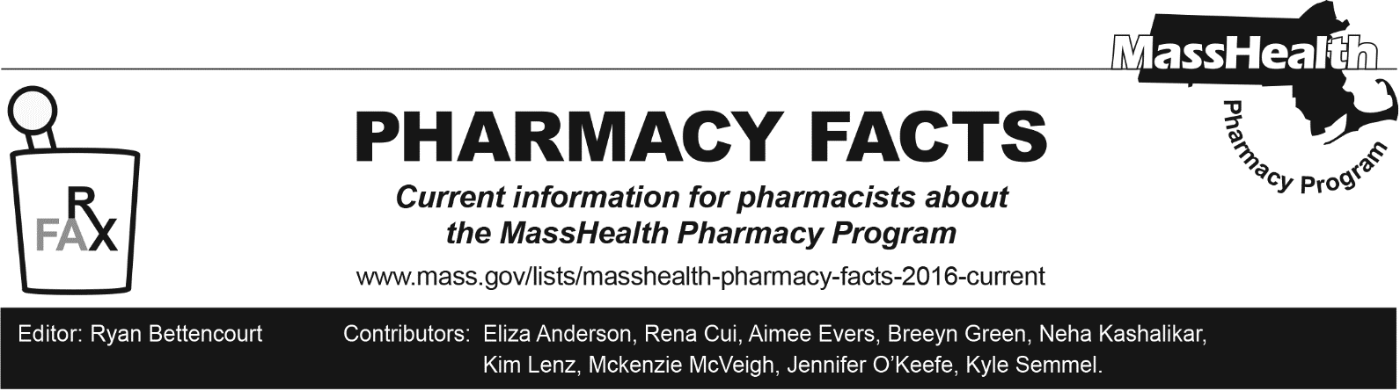
Number 247, June 18, 2025

MassHealth Drug List Update
Below are updates to the MassHealth Drug List (MHDL). See the MHDL for a complete listing of updates.

Additions
- Effective July 1, 2025, the following newly marketed drugs have been added to the MassHealth Drug List.
- Alhemo (concizumab-mtci) – PA
- Bizengri (zenocutuzumab-zbco) – PA; MB
- Crenessity (crinecerfont) – PA
- Datroway (datopotamab deruxtecan-dlnk) – PA; MB
- Hercessi (trastuzumab-strf) – PA; MB
- Kebilidi (eladocagene exuparvovec-tneq) – PA; CO
- metronidazole 125 mg tablet – PA
- Opdivo Qvantig (nivolumab-hyaluronidase-nvhy) – PA; MB
- Otulfi (ustekinumab-aauz prefilled syringe) – PA
- Otulfi (ustekinumab-aauz vial) – PA; MB
- Pyzchiva (ustekinumab-ttwe prefilled syringe) - PA
- Pyzchiva (ustekinumab-ttwe vial) – PA; MB
- Qlosi (pilocarpine 0.4% ophthalmic solution) – PA
- Revuforj (revumenib) – PA
- Ryzumvi (phentolamine) – PA; MB
- Selarsdi (ustekinumab-aekn prefilled syringe) – PA
- Selarsdi (ustekinumab-aekn vial) - PA; MB
- Steqeyma (ustekinumab-stba prefilled syringe) – PA
- Steqeyma (ustekinumab-stba vial) – PA; MB
- ustekinumab-aekn, unbranded prefilled syringe – PA
- ustekinumab-ttwe, unbranded prefilled syringe – PA
- ustekinumab-ttwe, unbranded vial – PA; MB
- Xromi (hydroxyurea solution) – PA
- Yesintek (ustekinumab-kfce prefilled syringe, 45 mg/0.5 mL vial) – PA
- Yesintek (ustekinumab-kfce 130 mg/26 mL vial) – PA; MB
- Effective April 23, 2025, the following COVID-19 treatment agent was added to the MassHealth Drug List on July 1, 2025.
- Paxlovid (nirmatrelvir/ritonavir 300/150-100 mg) ^{PD}

Updated MassHealth Brand Name Preferred Over Generic Drug List
The MassHealth Brand Name Preferred Over Generic Drug List has been updated to reflect recent changes to the MassHealth Drug List.
- Effective July 1, 2025, the following agents will be added to the MassHealth Brand Name Preferred Over Generic Drug List.
- Adzenys XR-ODT (amphetamine extended-release orally disintegrating tablet) – PA; BP
- Depen (penicillamine tablet); BP, A90
- Ridaura (auranofin); BP
- Xeljanz (tofacitinib) – PA; BP
- Xeljanz XR (tofacitinib extended-release) – PA; BP
- Effective July 1, 2025, the following agents will be removed from the MassHealth Brand Name Preferred Over Generic Drug List.
- Dermotic (fluocinolone oil, otic drops); #, A90

Updated MassHealth 90-day Initiative
The MassHealth 90-day Initiative has been updated to reflect recent changes to the MassHealth Drug List.
Effective July 1, 2025, the following agents may be allowed or mandated to be dispensed in up to a 90-day supply, as indicated below.
  - Anoro (umeclidinium/vilanterol); A90
  - Aptiom (eslicarbazepine) – PA; A90

Updated MassHealth Over-the-Counter Drug List
The MassHealth Over-the-Counter Drug List has been updated to reflect recent changes to the MassHealth Drug List. Effective July 1, 2025, the following diabetic agent will no longer require PA within updated age limits.
  - glucose products – PA ≥ 21 years; A90

Updated MassHealth Supplemental Rebate/Preferred Drug List
The MassHealth Supplemental Rebate/Preferred Drug List has been updated to reflect recent changes to the MassHealth Drug List.
- Effective April 23, 2025, the following COVID-19 treatment agent was added to the MassHealth Supplemental Rebate/Preferred Drug List.
- Paxlovid (nirmatrelvir/ritonavir 300/150-100mg) ^{PD}
- Effective July 1, 2025, the following opioid dependence agent will be added to the MassHealth Supplemental Rebate/Preferred Drug List.
  - Brixadi (buprenorphine extended-release injection) ^{PD}

Abbreviations, Acronyms, and Symbols
# This designates a brand-name drug with FDA “A”-rated generic equivalents. PA is required for the brand, unless a particular form of that drug (for example, tablet, capsule, or liquid) does not have an FDA “A”-rated generic equivalent.
^{CO} Carve-Out. This agent is listed on the Acute Hospital Carve-Out Drugs List and is subject to additional monitoring and billing requirements. All requests for one-time cell and gene therapies (as listed on the Acute Hospital Carve-Out Drug List), including for members enrolled in an Accountable
Care Partnership Plan (ACPP) or Managed Care Organization (MCO), will be reviewed by the MassHealth Drug Utilization Review (DUR) Program.
^{MB} This drug is available through the healthcare professional who administers the drug or in an outpatient or inpatient hospital setting. MassHealth does not pay for this drug to be dispensed through the retail pharmacy. If listed, PA does not apply through the hospital outpatient and inpatient settings. Please refer to 130 CMR 433.408 for PA requirements for other healthcare professionals. Notwithstanding the above, this drug may be an exception to the unified pharmacy policy; please refer to respective MassHealth Accountable Care Partnership Plans (ACPPs) and Managed Care Organizations (MCOs) for PA status and criteria, if applicable.
* The generic OTC and, if any, generic prescription versions of the drug are payable under MassHealth without PA.
PA Prior authorization is required. The prescriber must obtain PA for the drug in order for the provider to receive reimbursement. Note: PA applies to both the brand-name and the FDA “A”-rated generic equivalent of listed product.
^{A90} Allowable 90-day supply. Dispensing in up to a 90-day supply is allowed. May not include all strengths or formulations. Quantity limits and other restrictions may apply.
^{BP} Brand Preferred over generic equivalents. In general, MassHealth requires a trial of the preferred drug or clinical rationale for prescribing the non-preferred drug generic equivalent.
^{M90} Mandatory 90-day supply. After dispensing up to a 30-day supply initial fill, dispensing in a 90-day supply is required. May not include all strengths or formulations. Quantity limits and other restrictions may also apply.
^{PD} Preferred Drug. In general, MassHealth requires a trial of the preferred drug or clinical rationale for prescribing a non-preferred drug within a therapeutic class.

