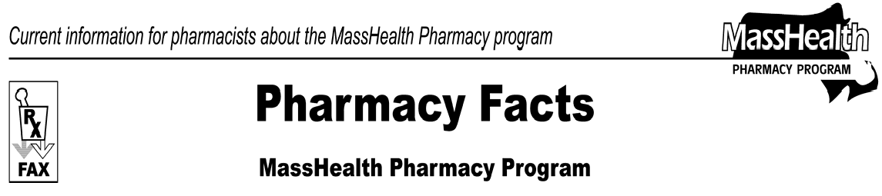

Number 25
January 5, 2007

www.mass.gov/masshealth/pharmacy
- Editor: Vic Vangel • Contributors: Chris Burke, Gary Gilmore, Paul Jeffrey, James Monahan, Chuck Young •
Medicare Part D Prescription Drug Coverage Update

Expiration of one-time 30-day supplies
Due to the expiration date included in the state legislation governing assistance available to MassHealth members with Medicare (dual eligibles), effective January 5, 2007, at 12:01 A.M., MassHealth will no longer pay for one-time 30-day supplies for dually eligible members.
If a dually eligible member is not yet in a Medicare prescription drug plan, bill the point-of-sale facilitator (Wellpoint/Anthem), which provides temporary coverage for dual eligible members not yet enrolled in a Medicare prescription drug plan. Call 1-800-662-0210 and choose option “7” if you need help processing a Wellpoint/Anthem point-of-sale claim.

One-time 72-hour supplies continue
If you are unable to bill a Medicare prescription drug plan and unable to bill the point-of-sale facilitator (Wellpoint/Anthem), you may bill MassHealth for a one-time 72-hour supply by using level-of-service code 03 (emergency fill). This assistance does not have an expiration date.

Copayment assistance continues
MassHealth assistance with Medicare prescription drug plan copayments will also continue. In 2007, the maximum copayment that a Medicare prescription drug plan is permitted to charge a dually eligible member is $5.35. If a Medicare prescription drug plan charges a dually eligible member a copayment (up to $5.35) that is higher than what the individual would have paid under MassHealth, charge the individual what she or he would have paid under MassHealth and submit a claim to MassHealth for the difference.
In the event that the drug plan assesses a copayment in excess of $5.35 for a dual eligible member, contact the plan. If the plan refuses to correct the copayment, MassHealth will supplement the copayment to standard MassHealth levels.

Please direct any questions or comments (or to be taken off of this fax distribution) to
Victor Moquin of ACS at 617-423-9830.

