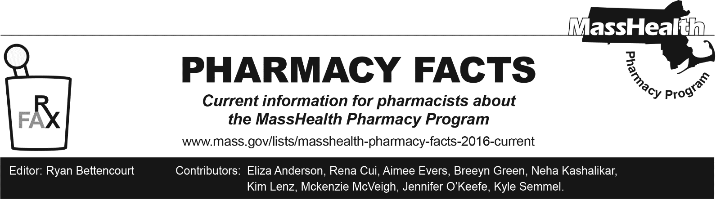
Number 251, August 7, 2025

Third Party Liability Billing and Use of Other Coverage Codes Reminder
MassHealth regulations at 130 CMR 450.316 require pharmacies to identify and obtain payment from available third-party payers before submitting a claim to MassHealth. Claims must be submitted in accordance with each payer’s billing and authorization requirements to obtain appropriate reimbursement. If a primary payer requires prior authorization for coverage of a drug, a pharmacy is responsible for ensuring the prescriber has sought prior authorization for coverage from the other payer before billing MassHealth directly with an Other Coverage Code value of “03.”

MassHealth reminds pharmacies that Other Coverage Code value of “04” must be used only when the other payer has paid $0 because 100% of the allowed amount was applied to the patient responsibility (i.e., deductible). If a pharmacy is not within the primary payer’s network, pharmacies should make diligent efforts to transfer the member’s prescription to an in-network pharmacy so that MassHealth may remain the payer of last resort.

Use of Other Coverage Code values “03” and “04” will be monitored and validated by MassHealth. Claims with inappropriate use of Other Coverage Code values of “03” and “04” may be subject to audit and recovery.

For detailed information, please see Section 4.0 Third-Party Liability (TPL) Billing of the Pharmacy Online Processing System (POPS) Billing Guide.

Emergency Overrides Reminder
To ensure that MassHealth members do not experience gaps in care, pharmacists may initiate an emergency override if they encounter a rejected claim for a medication requiring prior authorization. MassHealth will pay the pharmacy for at least a 72-hour, non-refillable supply of the drug.
To obtain an emergency override for members enrolled in the PCC Plan or a PCACO, pharmacists should contact the Drug Utilization Review (DUR) Unit at (800) 745-7318 during normal business hours.
Outside business hours, pharmacies may submit an emergency override claim with a value of “03” for Level of Service (field 418). After the prescription is adjudicated, the pharmacy should remove the “03” from the Level of Service field before the next fill.
For members in ACPPs and MCOs, pharmacies should follow specific directions in Appendix B of Pharmacy Facts 236 to submit emergency override claims.

Adherence and Blister Packaging Claims Needing Day Supply Overrides
MassHealth regulations 130 CMR 406.411(D) requires that all drugs be dispensed in a 30-day supply, unless the drug is available only in a larger minimum package size, except as specified in 130 CMR 406.411(D)(1)(b) and 130 CMR 406.411(D)(2).
To assist in medication adherence and regimen understanding among all MassHealth members, pharmacies may contact the DUR Unit at (800) 745-7318 during normal business hours if they are receiving the rejection “THIS MEDICATION DOES NOT MEET THE CRITERIA FOR EXCEPTION TO THE DAY SUPPLY LIMITATION DESCRIBED AT 130 CMR 406.411(D)” while attempting to use adherence or blister packaging for a calendar month with more than 30 days. DUR will review the claim and provide an override if necessary.

