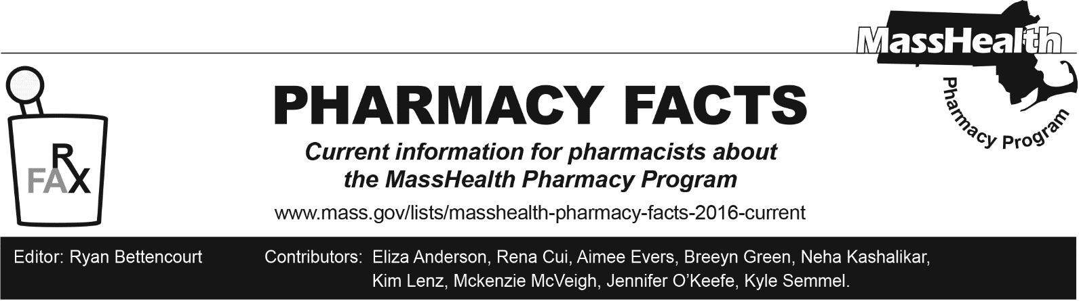
Number 254, September 10, 2025

MassHealth Coverage of COVID-19 Vaccines
The Massachusetts Department of Public Health (DPH) has recently issued a standing order allowing all qualified pharmacy personnel at Massachusetts pharmacies to dispense and administer COVID-19 vaccines in Massachusetts to all eligible persons.

MassHealth will continue to cover all COVID-19 vaccinations, as well as all other medically necessary vaccinations recommended by DPH. All DPH-recommended vaccinations will be covered at no cost to MassHealth members.

The MassHealth Pharmacy Online Processing System (POPS) has been updated to accept claims for the 2025-2026 COVID-19 vaccines. MassHealth managed care entities (MCEs) are working to update their respective pharmacy processing systems to allow for billing of the 2025-2026 COVID-19 vaccines. Pharmacies experiencing any issues billing the 2025-2026 COVID-19 vaccines should contact the appropriate MCE pharmacy help desk for assistance with claim adjudication, including overrides. Appropriate pharmacy help desk numbers can be found in Pharmacy Facts 236.

Link to Department of Public Health standing order:
https://www.mass.gov/news/standing-order-for-dispensing-and-administration-of-covid-2025-2026

