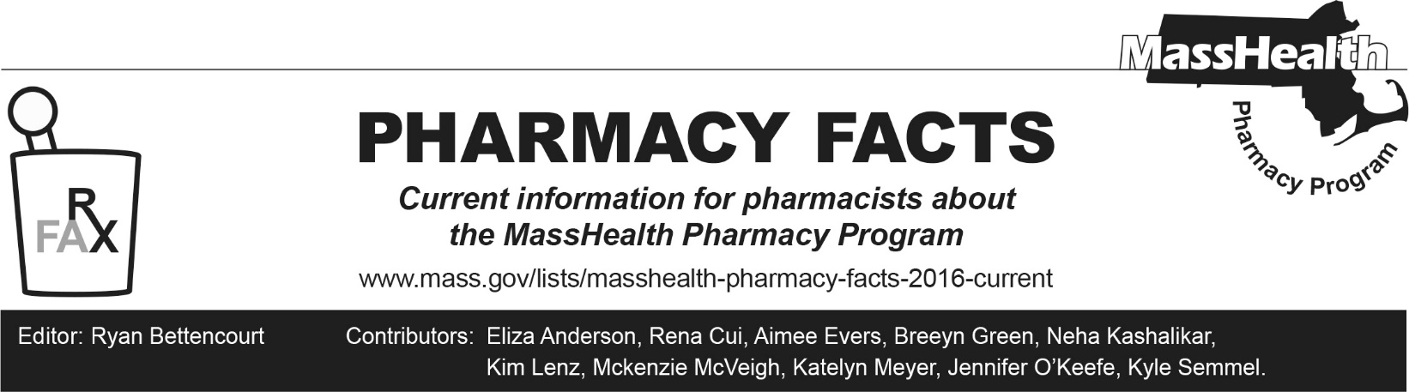
Number 255, September 16, 2025

Bausch Health (Bausch & Lomb) Announces Withdrawal from Participation in Medicaid Drug Rebate Program (MDRP)

Effective October 1, 2025, Bausch Health US, LLC (Bausch Health or Bausch & Lomb) and many of its subsidiaries will no longer participate in the Medicaid Drug Rebate Program (MDRP). Therefore, effective October 1, 2025, MassHealth will no longer cover non-rebate drugs manufactured by Bausch Health or its subsidiaries. See 130 CMR 406.412(A)(1). For MassHealth Standard and CommonHealth members younger than 21 years of age, MassHealth will review all submitted requests for medical necessity through Early Periodic Screening, Diagnostic and Treatment (EPSDT).
Drugs impacted by these rebate changes can be found in the table at the bottom of this Pharmacy Facts.

Continued Access through Patient Assistance Programs
Effective October 1, 2025, claims for non-rebate Bausch Health drugs for MassHealth members will reject at point-of-sale. While MassHealth will no longer cover non-rebate Bausch Health medications, generic formulations or clinically appropriate alternatives from manufacturers which participate in the MDRP may be covered. Additional information on covered medications can be found on the MassHealth Drug List.
For non-rebate Bausch Health medications without a generic alternative, members are advised to seek coverage through Bausch Health’s patient assistance program. Bausch Health has created a new patient assistance program structured specifically for Medicaid members. Please find more information here: www.bauschhealthpap.com/

MassHealth Drug List Changes Related to Bausch Health Change
Effective October 1, 2025, the following non-rebate drugs will be removed from the MassHealth Drug List.

Topical Medications | Oral Medications | Injectable or Intranasal Medications
- Acanya (clindamycin/benzoyl peroxide)  - Altreno (tretinoin 0.05% lotion)  - Anusol-HC (hydrocortisone hemorrhoidal cream)  - Arazlo (tazarotene lotion) | - Ancobon (flucytosine)  - Aplenzin (bupropion hydrobromide ER)  - Apriso (mesalamine 0.375-gram ER capsule)  - Ativan (lorazepam tablet)  - Cardizem CD (diltiazem ER capsule)  - Cardizem LA (diltiazem ER tablet) | - Ammonul (sodium phenylacetate/sodium benzoate)  - Migranal (dihydroergotamine nasal spray)  - Relistor (methylnaltrexone injection)

Topical Medications | Oral Medications | Injectable or Intranasal Medications
- Benzamycin (benzoyl peroxide/erythromycin)  - Bryhali (halobetasol lotion)  - Cabtreo (clindamycin/adapalene/benzoyl peroxide)  - Carac (fluorouracil 0.5% cream)  - Clindagel (clindamycin gel)  - Duobrii (halobetasol/tazarotene lotion)  - Efudex (fluorouracil 5% cream)  - Elidel (pimecrolimus)  - Ertaczo (sertaconazole)  - Jublia (efinaconazole)  - Klaron (sulfacetamide 10% lotion)  - Luzu (luliconazole)  - Noritate (metronidazole 1% cream)  - Onexton (clindamycin/benzoyl peroxide gel, gel pump)  - Retin-A (tretinoin)  - Retin-A Micro (tretinoin microspheres)  - Uceris (budesonide rectal foam)  - Vanos (fluocinonide 0.1% cream)  - Xerese (acyclovir/hydrocortisone)  - Ziana (clindamycin/tretinoin)  - Zovirax (acyclovir cream, ointment)  - Zyclara (imiquimod 2.5%, 3.75% cream) | - Cardizem (diltiazem)  - Colazal (balsalazide)  - Cuprimine (penicillamine capsule)  - Cycloset (bromocriptine 0.8 mg tablet)  - Demser (metyrosine)  - Diuril (chlorothiazide suspension)  - Edecrin (ethacrynic acid tablet)  - Isordil (isosorbide dinitrate tablet)  - Librax (chlordiazepoxide/clidinium)  - Lodosyn (carbidopa)  - Mestinon (pyridostigmine bromide tablet, ER tablet, solution)  - Moviprep (polyethylene glycol-electrolyte solution)  - Mysoline (primidone)  - Pepcid (famotidine tablet)  - Plenvu (polyethylene glycol-electrolyte solution)  - Relistor (methylnaltrexone tablet)  - Syprine (trientine 250 mg capsule)  - Targretin (bexarotene)  - Tasmar (tolcapone)  - Tiazac ER (diltiazem)  - Trulance (plecanatide)  - Uceris (budesonide ER tablet)  - Vaseretic (enalapril/hydrochlorothiazide)  - Vasotec (enalapril)  - Wellbutrin XL (bupropion hydrochloride ER 150 mg, 300 mg tablet)  - Xifaxan (rifaximin 200 mg, 550 mg)  - Zelapar (selegiline ODT) | - Siliq (brodalumab)  - Visudyne (verteporfin)  - Zegalogue (dasiglucagon)
ER=extended release, ODT=orally disintegrating tablet

