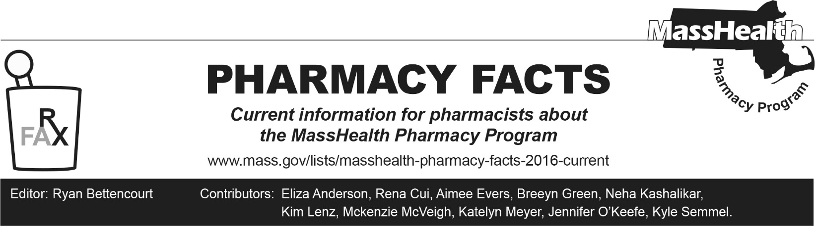
Number 256, October, 1, 2025

MassHealth Drug List Update
Below are updates to the MassHealth Drug List (MHDL). See the MHDL for a complete listing of updates

Additions
- Effective October 1, 2025, the following newly marketed drugs have been added to the MassHealth Drug List.
- Attruby (acoramidis) – PA
- Avgemsi (gemcitabine vial); MB
- Brynovin (sitagliptin solution) – PA
- Edurant (rilpivirine tablet for oral suspension) – PA > 6 units/day
- Encelto (revakinagene taroretcel-lwey) – PA; CO
- gabapentin 100 mg, 400 mg tablet – PA
- Gomekli (mirdametinib) – PA
- Inzirqo (hydrochlorothiazide suspension) – PA
- metformin immediate-release 750 mg – PA; M90
- Ryoncil (remestemcel-l-rknd) – PA; MB
- Tezruly (terazosin solution) – PA
- Vanrafia (atrasentan) – PA
- Zelsuvmi (berdazimer) – PA
- Effective July 23, 2025, the following preventative therapy was added to the MassHealth Drug List on October 1, 2025. Penmenvy (pentavalent meningococcal groups A, B, C, W and Y vaccine)
- Effective September 3, 2025, the following preventative therapies were added to the MassHealth Drug List on October 1, 2025.
- Mnexspike (Moderna COVID-19 vaccine, mRNA); 1
- Nuvaxovid (Novavax COVID-19 vaccine, adjuvanted); 1

Change in Prior Authorization Status
- Effective October 1, 2025, the following drug cessation agents will require prior authorization when exceeding the updated dose limit.
  - buprenorphine/naloxone sublingual tablet – PA > 32 mg/day
  - Suboxone (buprenorphine/naloxone film)^{PD} – PA > 32 mg/day; BP
- Effective October 1, 2025, the following antiretroviral agent will require PA.
  - Norvir (ritonavir packet) – PA
- Effective October 1, 2025, the following anti-inflammatory ophthalmic agent will no longer require PA.
  - bromfenac 0.09%; A90
- Effective October 1, 2025, the following anti-allergy ophthalmic agent will require PA.
  - epinastine – PA; A90
- Effective October 1, 2025, the following topical corticosteroid agent will no longer require PA.
  - Taclonex (betamethasone/calcipotriene topical suspension); BP, A90
- Effective October 1, 2025, the following topical corticosteroid agent will require PA.
  - Olux-E (clobetasol propionate foam/ emollient) – PA; A90
- Effective October 1, 2025, the following dermatological agent will require PA.
  - fluorouracil 0.5% cream – PA; A90
- Effective October 1, 2025, the following antidiabetic agents will require PA.
  - glipizide 2.5 mg – PA; M90
  - Janumet (sitagliptin/metformin) – PA
  - Janumet XR (sitagliptin/metformin extended-release) – PA
  - Januvia (sitagliptin tablet) – PA
  - sitagliptin/metformin – PA

Change in Coverage Status
- Effective October 1, 2025, the following agents will be available through medical billing only and will no longer be available through pharmacy billing.
  - diltiazem injection; MB
  - metoprolol injection; MB
  - propranolol injection; MB
  - verapamil injection; MB
- Effective October 1, 2025, the following agent will no longer be restricted to medical billing.
- Trelstar (triptorelin) – PA

Updated MassHealth Brand Name Preferred Over Generic Drug List

The MassHealth Brand Name Preferred Over Generic Drug List has been updated to reflect recent changes to the MassHealth Drug List.
- Effective October 1, 2025, the following agents will be added to the MassHealth Brand Name Preferred Over Generic Drug List.
- Bosulif (bosutinib) – PA; BP
- Edarbi (azilsartan); BP
- FML (fluorometholone 0.1%); BP, A90
- Halog (halcinonide 0.1% cream) – PA; BP, A90
- Simbrinza (brinzolamide/brimonidine); BP
- Effective October 1, 2025, the following agents will be removed from the MassHealth Brand Name Preferred Over Generic Drug List.
- Ancobon (flucytosine); A90
- Apriso (mesalamine 0.375 gram extended-release capsule); A90
- Atralin (tretinoin 0.05% gel) – PA; A90
- Carac (fluorouracil 0.5% cream) – PA
- Clindagel (clindamycin gel)
- Cuprimine (penicillamine capsule); A90
- Demser (metyrosine)
- Isordil (isosorbide dinitrate 40 mg tablet) – PA; M90
- Lotemax (loteprednol 0.5%); A90
- Mestinon (pyridostigmine bromide 60 mg tablet, 180 mg extended-release tablet); A90
- Mestinon (pyridostigmine bromide solution); A90
- Moviprep (polyethylene glycol-electrolyte solution); A90
- Noxafil (posaconazole injection) – PA
- Olux-E (clobetasol propionate foam/emollient) – PA; A90
- Onexton (clindamycin/benzoyl peroxide gel pump) – PA; A90
- Retin-A (tretinoin) – PA ≥ 21 years; A90
- Retin-A Micro (tretinoin microspheres) – PA; A90
- Syprine (trientine 250 mg capsule); A90
- Targretin (bexarotene); A90
- Uceris (budesonide extended-release tablet); A90
- Zovirax (acyclovir cream)
- Zyclara (imiquimod 2.5%, 3.75% cream) – PA; A90

Updated MassHealth 90-day Initiative
The MassHealth 90-day Initiative has been updated to reflect recent changes to the MassHealth Drug List.
Effective October 1, 2025, the following agent may be allowed or mandated to be dispensed in up to a 90-day supply, as indicated below.
  - Arnuity (fluticasone furoate inhalation powder); A90
- Eprontia (topiramate solution) – PA; A90
- Xarelto (rivaroxaban suspension) – PA ≥ 18 years; #, A90
  - Zituvimet XR (sitagliptin/metformin extended-release) – PA; M90

Abbreviations, Acronyms, and Symbols
# Designates a brand-name drug with FDA “A”-rated generic equivalents. Prior authorization is required for the brand, unless a particular form of that drug (for example, tablet, capsule, or liquid) does not have an FDA “A”-rated generic equivalent.
CO Carve-Out. This agent is listed on the Acute Hospital Carve-Out Drugs List and is subject to additional monitoring and billing requirements. All requests for one-time cell and gene therapies (as listed on the Acute Hospital Carve-Out Drug List), including for members enrolled in an Accountable Care Partnership Plan (ACPP) or Managed Care Organization (MCO), will be reviewed by the MassHealth Drug Utilization Review (DUR) Program.
MB This drug is available through the healthcare professional who administers the drug or in an outpatient or inpatient hospital setting. MassHealth does not pay for this drug to be dispensed through the retail pharmacy. If listed, PA does not apply through the hospital outpatient and inpatient settings. Please refer to 130 CMR 433.408 for PA requirements for other healthcare professionals. Notwithstanding the above, this drug may be an exception to the unified pharmacy policy; please refer to respective MassHealth Accountable Care Partnership Plans (ACPPs) and Managed Care Organizations (MCOs) for PA status and criteria, if applicable.
PA Prior authorization is required. The prescriber must obtain PA for the drug in order for the provider to receive reimbursement. Note: PA applies to both the brand-name and the FDA “A”-rated generic equivalent of listed product.
A90 Allowable 90-day supply. Dispensing in up to a 90-day supply is allowed. May not include all strengths or formulations. Quantity limits and other restrictions may apply.
BP Brand Preferred over generic equivalents. In general, MassHealth requires a trial of the preferred drug or clinical rationale for prescribing the non-preferred drug generic equivalent.
M90 Mandatory 90-day supply. After dispensing up to a 30-day supply initial fill, dispensing in a 90-day supply is required. May not include all strengths or formulations. Quantity limits and other restrictions may also apply.
PD Preferred Drug. In general, MassHealth requires a trial of the preferred drug or clinical rationale for prescribing a non-preferred drug within a therapeutic class.

