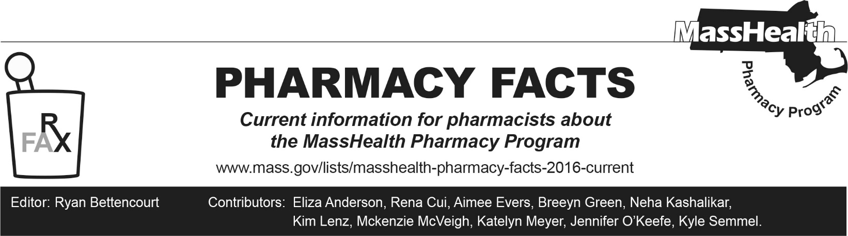
Number 257, October 16, 2025

Independent Pharmacy and FQHC/RHC Entity-Owned Pharmacy Annual Attestation
MassHealth requires independent pharmacies and Federally Qualified Health Center/Rural Health Center (FQHC/RHC) entity-owned pharmacies to complete an attestation form on an annual basis if they wish to be considered independent pharmacies or FQHC/RHC entity-owned pharmacies by MassHealth. Independent pharmacies are defined as one of three or fewer pharmacies under common ownership. FQHC/RHC entity-owned pharmacies are owned by the FQHC/RHC and do not include pharmacies with solely a contract relationship with an FQHC/RHC. Only independent pharmacies and FQHC/RHC entity-owned pharmacies should complete the attestation form.

MassHealth requires that qualifying pharmacies be approved through this annual attestation process to assign the appropriate professional dispensing fee for independent pharmacies and FQHC/RHC entity-owned pharmacies, to the extent that MassHealth sets new dispensing fees for these pharmacies. In addition, MassHealth requires that managed care entities reimburse these pharmacies at or above the rates set forth in 101 CMR 331.04.

This year’s attestation period begins October 16, 2025, and will conclude end-of-day October 30, 2025. No attestations will be accepted after October 30, 2025.

The Independent Pharmacy and FQHC/RHC Entity-Owned Pharmacy Attestation form can be found at MassHealth Drug List - Health and Human Services under the section titled "Independent Pharmacy/Federally Qualified Health Center/Rural Health Center Entity-Owned Pharmacy Attestation." The completed attestation should be emailed to MassHealth for review at Masshealth.Pharmacy.Attestations@mass.gov.

