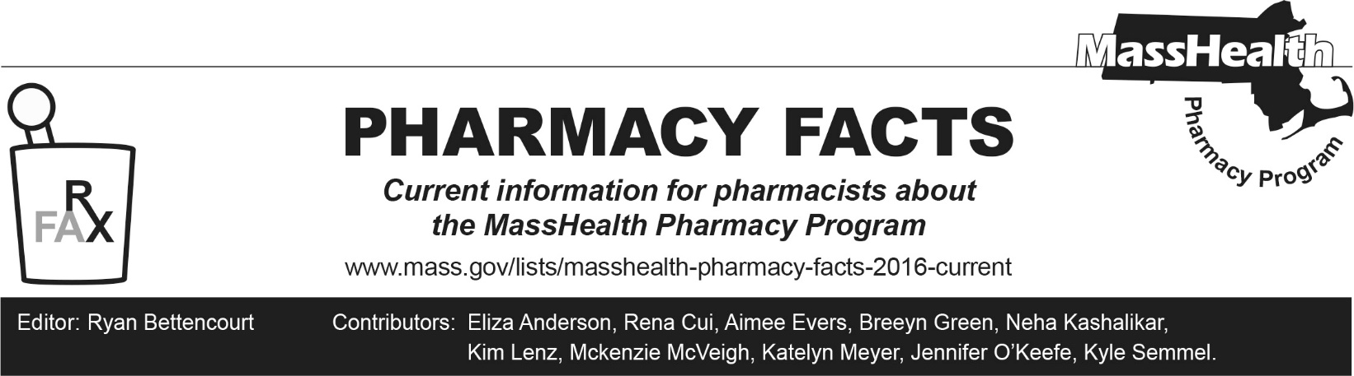
Number 258, October 21, 2025

Upcoming Changes to the Health Safety Net Formulary – Effective January 12, 2026
The Health Safety Net (HSN) is changing the management of the HSN formulary, effective January 12, 2026. Historically, reimbursable HSN pharmacy services have largely matched the MassHealth formulary.
The following key changes are effective January 12, 2026:
Generally reimbursable without prior authorization (PA): | Generally reimbursable with PA:
- Generic medications (including unbranded biosimilars)  - Select brand medications on the MassHealth brand-over generic list (BOGL)  - Select non-drug products (i.e., alcohol swabs, ketone test strips, lancets, pen needles, syringes, urine glucose test strips)  - Preferred test strips within quantity limits  - Vaccines | - Preferred non-drug products (e.g., continuous glucose monitors, continuous subcutaneous insulin infusion devices)  - Brand medications not listed on the MassHealth BOGL  - Other medications when clinically necessary

Effective January 12, 2026, PA will be required for most brand medications and all preferred non-drug products (see table above). All currently approved PAs will be terminated effective January 12, 2026.
Please note that HSN is not insurance. Uninsured or underinsured HSN patients may be eligible to receive brand medications through manufacturer patient assistance programs, if available. Please see the MassHealth Drug List Upcoming HSN Formulary Changes page for more information on patient assistance programs.
Requests for brand medications not on the BOGL will be evaluated for appropriate diagnosis, trial(s) with all clinically appropriate generic and BOGL alternatives, medical necessity, and documentation of application to manufacturer patient assistance program (if available).
Providers should work with patients to apply to manufacturer patient assistance programs where appropriate and are encouraged to do so ahead of the upcoming HSN formulary changes. Please see the MassHealth Drug List Upcoming HSN Formulary Changes page for a list of medications reimbursable without PA for highly utilized therapeutic classes.
Additionally, HSN will enforce cost-avoidance at the pharmacy for patients with other payment options or existing insurance coverage to ensure HSN is the payer of last resort. Emergency overrides will also be limited to a 72-hour supply of medication, and vacation overrides will no longer be available.

Pharmacists and prescribers who have questions regarding HSN PAs may contact the Drug Utilization Review Program at (800) 745-7318.

