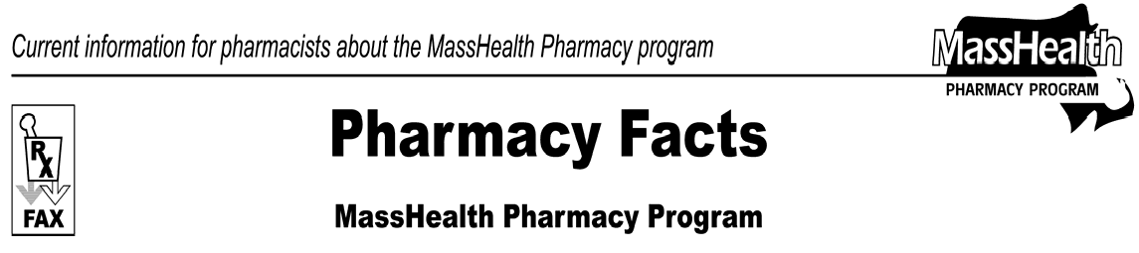
Number 26
March 8, 2007
www.mass.gov/masshealth/pharmacy
- Editor: Vic Vangel • Contributors: Chris Burke, Gary Gilmore, Paul Jeffrey, James Monahan, Chuck Young •
Claims Processing  When billing MassHealth as a secondary insurer using Other Coverage Code-2 or Other Coverage Code-8, the pharmacy must enter the amount of the patient responsibility required by the primary insurer in the Patient Paid Amount field (NCPDP field 433-DX). If the MassHealth maximum allowed amount for the claim submitted is less than the amount entered in field 433-DX, MassHealth will pay the claim at the maximum allowed amount. Claims where the Other Payer Paid Amount is greater than the MassHealth Allowed Amount will be paid at $0.00. Claims paid at $0.00 will have a paid disposition.  You may have noticed pharmacy claims denying in the Pharmacy Online Processing System (POPS) with new error messaging. Some of these error messages are:  70-Non-FDA Approved: Some drug products have entered the marketplace without ever receiving approval from the FDA. These are not payable by MassHealth. The MassHealth denial applies at the level of the NDC number, and does not mean that all forms of the drug are unavailable through MassHealth.  70-Device Not Covered: With certain exceptions, MassHealth can accept claims for drugs only through POPS. Devices are not payable through POPS but they may be payable through other program types in MassHealth, such as on claim form no. 9.  70-Non-Covered Outpatient Drug: The Centers for Medicare and Medicaid Services (CMS) has determined that these NDC numbers do not meet the definition of a covered outpatient product. Again, this applies only to the NDC number being submitted. There may be other NDCs for the drug that MassHealth will pay for.  E7- Invalid Quantity Dispensed: MassHealth has instituted a maximum billing units limit for many drugs to prevent inadvertently high quantities from being submitted. If you receive this denial message and you feel there is a clinical reason to submit the claim with the specified quantity, please call the DUR Program at 1-800-745-7318 to request an override.  MassHealth Drug List Update  There are two notable changes to the MassHealth Drug List, effective April 2, 2007. MassHealth will pay only for generic forms of vitamins. Brand-name vitamins will require prior authorization (PA) for any new prescription. | In addition, Zaditor OTC will become the first mast cell stabilizer/antihistamine available without PA on the MassHealth Drug List. The following newly marketed drugs have been added to the MassHealth Drug List:  Abilify IM (aripiprazole injection)  Coreg CR (carvedilol extended-release) – PA Humalog 50/50 (insulin lispro) vial  Invega (paliperidone)  Orapred ODT (prednisolone, orally disintegrating tablet)  – PA  Zaditor OTC (ketotifen)  Ziana (clindamycin/tretinoin) – PA Zolinza (vorinostat)  Change in Prior-Authorization Status  MassHealth has changed the prior-authorization status of the Hepatitis B antiviral medications. The following quantity limits will be effective April 2, 2007.  Baraclude (entecavir) solution – PA > 600ml/month Baraclude (entecavir) tablet – PA > 30 units/month Epivir HBV (lamivudine) solution – PA > 600ml/month Epivir HBV (lamivudine) tablet – PA > 30 units/month Hepsera (adefovir) – PA > 30 units/month  Tyzeka (telbivudine) – PA > 30 units/month  MassHealth has changed the prior authorization requirements of the Occular Anti-Allergy medications. The following drug requires prior authorization, effective April 2, 2007.  Alrex (loteprednol) – PA  MassHealth has changed the prior-authorization requirements for brand-name vitamins. Only the generic names of single and combination vitamins will be listed. The brand names of such products will not be listed, and therefore will require prior authorization.  The following drugs no longer require prior authorization.  Leukine (sargramostim) Neulasta (pegfilgrastim) Neupogen (filgrastim)  The coverage status of the following drug has changed; it is no longer restricted to an inpatient hospital setting.  Dacogen (decitabine)
Please direct any questions or comments (or to be taken off of this fax distribution) to
Victor Moquin of ACS at 617-423-9830.

