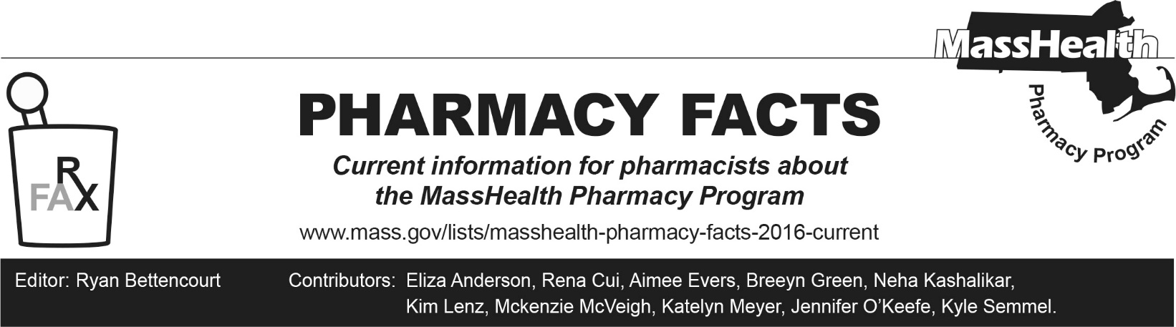
Number 261, November 10, 2025

MassHealth Drug List Update
Below are updates to the MassHealth Drug List (MHDL). See the MHDL for a complete listing of updates

Additions
Effective November 17, 2025, the following newly marketed drugs have been added to the MassHealth Drug List.
- Bkemv (eculizumab-aeeb) – PA; MB
- Bomyntra (denosumab-bnht) – PA
- Ctexli (chenodiol) – PA
- Conexxence (denosumab-bnht) – PA
- Enflonsia (clesrovimab-cfor) – PA ≥ 8 months of age; ¹
- Epysqli (eculizumab-aagh) – PA; MB
- Flumist (influenza vaccine live intranasal spray for home administration) – PA
- Imaavy (nipocalimab-aahu) – PA; MB
- Jubbonti (denosumab-bbdz) – PA
- Onapgo (apomorphine injection) – PA
- Osenvelt (denosumab-bmwo) – PA
- Qfitlia (fitusiran) – PA
- Stoboclo (denosumab-bmwo) – PA
- Symbravo (meloxicam/rizatriptan) – PA
  - Vyvgart Hytrulo (efgartigimod alfa/hyaluronidase-qvfc prefilled syringe) – PA
- Wyost (denosumab-bbdz) – PA
- Yeztugo (lenacapavir) – PA
- Zevaskyn (prademagene zamikeracel) – PA; CO
- Zunveyl (benzgalantamine) – PA

Change in Prior Authorization Status
- Effective November 17, 2025, the following immunomodulator agent will require PA.
  - methotrexate 5 mg, 7.5 mg, 10 mg, 15 mg tablet – PA; A90
- Effective November 17, 2025, the following muscle relaxant agent will require PA.
  - methocarbamol 1,000 mg tablet – PA
- Effective November 17, 2025, the following urinary antispasmodic agent will no longer require PA when exceeding quantity limits.
  - darifenacin; A90
- Effective November 17, 2025, the following inhaled respiratory agent will require PA.
  - Tudorza (aclidinium) – PA
- Effective November 17, 2025, the following antihistamine agent will no longer require PA.
  - Clarinex (desloratadine tablet); #, M90
- Effective November 17, 2025, the following antihistamine agent will require PA.
  - promethazine suppository – PA; A90
- Effective November 17, 2025, the following antibiotic agents will require PA.
  - amoxicillin/clavulanate chewable tablet – PA; A90
  - cephalexin tablet – PA; A90
  - erythromycin delayed-release capsule – PA; A90
  - minocycline extended-release 55 mg, 65 mg, 80 mg, 115 mg tablet – PA; A90
- Effective November 17, 2025, the following antipsychotic agent will no longer require PA within established quantity and age limits.
  - Erzofri (paliperidone extended-release 1-month injection) ^{PD} – PA <10 years and PA >1 injection/28 days
- Effective November 17, 2025, the following antibiotic agents will no longer require PA.
  - doxycycline hyclate 75 mg, 150 mg tablet; A90
  - minocycline extended-release 135 mg tablet; A90
- Effective November 17, 2025, the following headache therapy agents will now require PA when exceeding updated quantity limits.
  - Imitrex (sumatriptan tablet) – PA > 16 units/30 days; #, A90
  - Maxalt MLT (rizatriptan orally disintegrating tablet) – PA > 16 units/30 days; #, A90
  - Maxalt (rizatriptan tablet) – PA > 16 units/30 days; #, A90
  - naratriptan – PA > 16 units/30 days; A90
  - sumatriptan 5 mg, 20 mg nasal spray – PA < 6 years and > 16 units/30 days; #, A90
  - Zomig (zolmitriptan tablet) – PA > 16 units/30 days; #, A90

Updated MassHealth Brand Name Preferred Over Generic Drug List

The MassHealth Brand Name Preferred Over Generic Drug List has been updated to reflect recent changes to the MassHealth Drug List.
- Effective November 17, 2025, the following agents will be added to the MassHealth Brand Name Preferred Over Generic Drug List.
- Arnuity (fluticasone furoate inhalation powder) – BP, A90
- Cardura (doxazosin immediate-release); BP, M90
- Dificid (fidaxomicin tablet) – PA; BP
- Timoptic Ocudose (timolol 0.25% ophthalmic unit dose solution) – PA; BP, M90
- Xarelto (rivaroxaban suspension) – PA ≥ 18 years; BP, A90
- Xopenex HFA (levalbuterol inhaler); BP, A90
- Effective November 17, 2025, the following agents will be removed from the MassHealth Brand Name Preferred Over Generic Drug List.
- Airduo Respiclick (fluticasone/salmeterol inhalation powder) – PA; A90
- Pradaxa (dabigatran capsule); #, M90
- Qudexy XR (topiramate extended-release capsule) – PA < 6 years; #, A90

Updated MassHealth 90-day Initiative
Effective November 17, 2025, the following agents will no longer be allowed or mandated to be dispensed in up to a 90-day supply, as indicated below.
  - methocarbamol 1,000 mg tablet – PA

Abbreviations, Acronyms, and Symbols
# Designates a brand-name drug with FDA “A”-rated generic equivalents. Prior authorization is required for the brand, unless a particular form of that drug (for example, tablet, capsule, or liquid) does not have an FDA “A”-rated generic equivalent.
CO Carve-Out. This agent is listed on the Acute Hospital Carve-Out Drugs List and is subject to additional monitoring and billing requirements. All requests for one-time cell and gene therapies (as listed on the Acute Hospital Carve-Out Drug List), including for members enrolled in an Accountable Care Partnership Plan (ACPP) or Managed Care Organization (MCO), will be reviewed by the MassHealth Drug Utilization Review (DUR) Program.
MB This drug is available through the healthcare professional who administers the drug or in an outpatient or inpatient hospital setting. MassHealth does not pay for this drug to be dispensed through the retail pharmacy. If listed, PA does not apply through the hospital outpatient and inpatient settings. Please refer to 130 CMR 433.408 for PA requirements for other healthcare professionals. Notwithstanding the above, this drug may be an exception to the unified pharmacy policy; please refer to respective MassHealth Accountable Care Partnership Plans (ACPPs) and Managed Care Organizations (MCOs) for PA status and criteria, if applicable.
PA Prior authorization is required. The prescriber must obtain PA for the drug in order for the provider to receive reimbursement. Note: PA applies to both the brand-name and the FDA “A”-rated generic equivalent of listed product.
A90 Allowable 90-day supply. Dispensing in up to a 90-day supply is allowed. May not include all strengths or formulations. Quantity limits and other restrictions may apply.
BP Brand Preferred over generic equivalents. In general, MassHealth requires a trial of the preferred drug or clinical rationale for prescribing the non-preferred drug generic equivalent.
M90 Mandatory 90-day supply. After dispensing up to a 30-day supply initial fill, dispensing in a 90-day supply is required. May not include all strengths or formulations. Quantity limits and other restrictions may also apply.
PD Preferred Drug. In general, MassHealth requires a trial of the preferred drug or clinical rationale for prescribing a non-preferred drug within a therapeutic class.
1 Product may be available through the Massachusetts Department of Public Health (DPH). Please check with DPH for availability. MassHealth does not pay for immunizing biologicals (i.e., vaccines) and tubercular (TB) drugs that are available free of charge through local boards of public health or through the Massachusetts Department of Public Health without PA (130 CMR 406.413(C)). In cases where free vaccines are available to providers for specific populations (e.g. children, high risk, etc.), MassHealth will reimburse the provider only for individuals not eligible for the free vaccines. Notwithstanding the above, MassHealth will pay pharmacies for seasonal flu vaccine serum without PA, if the vaccine is administered in the pharmacy.

