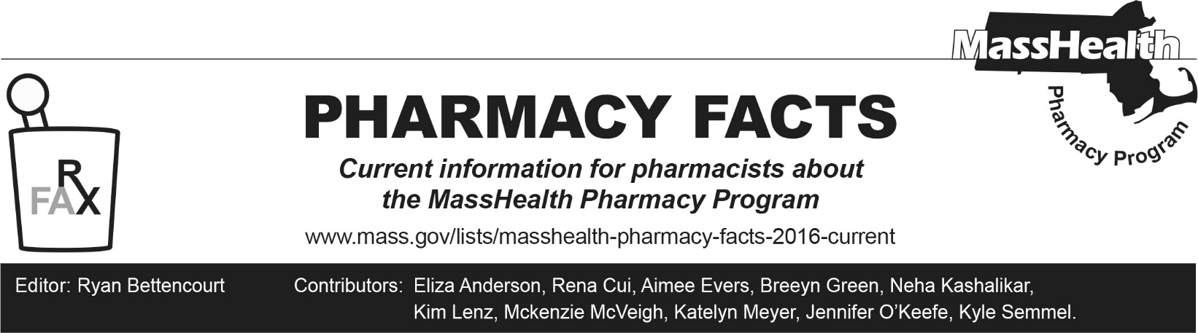
Number 263, November 20, 2025

Pharmacy Claims Processing Update and Reminders
Medication Synchronization
MassHealth allows for the synchronization of multiple prescriptions so that members may pick up their medications on the same refill date. To facilitate this process, the MassHealth Pharmacy Online Processing System (POPS) now allows the use of value "61" (Synchronization Fill) in the Submission Clarification Code field (NCPDP field 420-DK) when processing claims for maintenance medications and noncontrolled substances.
MassHealth members are eligible for one synchronization override per maintenance medication within a one-year timeframe. Pharmacy providers should work with practitioners and patients when determining a synchronization date to limit excess supplies of medication.
If the member has exceeded the allowed synchronization fill limit for the in-process medication, pharmacies will see a detailed rejection message instructing them that the medication synchronization override is not available. If an additional medication synchronization is clinically necessary, pharmacies may contact the MassHealth Drug Utilization Review Program at (800) 745-7318 for authorization.
Pharmacy providers are advised that the use of Submission Clarification Code 61will be closely monitored and may be subject to audit.
Automatic Refills are Not Allowed for MassHealth Members
Pharmacies are reminded that prescriptions for a MassHealth member cannot be refilled automatically without a specific request being made for that refill. MassHealth pharmacy regulations at 130 CMR 406.411(C)(6) state the following.
The MassHealth agency does not pay for any refill without an explicit request from a member or caregiver for each filling event. The possession by a provider of a prescription with remaining refills authorized does not in itself constitute a request to refill the prescription.
Secondary Payment Claims for Items Covered by Medicare Part B
MassHealth reminds pharmacy providers that claims for any Medicare B-covered drug, durable medical equipment, or supply that is payable through the Pharmacy Online Processing System (POPS), must be submitted for secondary payment from MassHealth through POPS in the same manner for Medicare-eligible members as for members with any other primary insurance. A pharmacy should never assume a claim for any item paid through POPS will be paid as a crossover claim.

