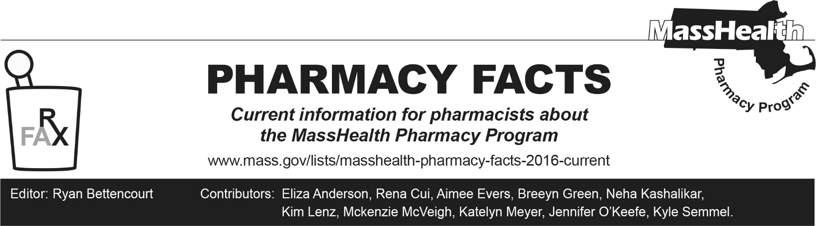
Number 265, December 18, 2025

Upcoming Changes to Health Safety Net Pharmacy Reimbursement of Non-Drug Products
Health Safety Net (HSN) coverage of non-drug products has historically matched the MassHealth Non-Drug Product List. However, effective January 12, 2026, the Health Safety Net is changing the management of the HSN formulary. Please see Pharmacy Facts 258 for detailed information on these changes.
Effective January 12, 2026, only select non-drug products will be reimbursable as an HSN pharmacy service. The table below summarizes HSN reimbursable non-drug products effective January 12, 2026.

Non-drug products that will generally be reimbursable without prior authorization | Non-drug products that will generally be reimbursable with prior authorization
- Alcohol swabs  - Preferred blood glucose test strips within quantity limits  - Lancets  - Pen needles  - Disposable needles and syringes  - Ketone test strips  - Urine glucose test strips | - Preferred continuous glucose monitors  - Preferred continuous subcutaneous insulin infusion devices  - Preferred blood glucose test strips above quantity limits

Although existing prior authorizations (PA) for medications will be terminated effective January 12, 2026, existing PAs for preferred non-drug products will be honored through the current expiration dates.

Health Safety Net Will No Longer Reimburse for Enteral Non-Drug Products
Any non-drug products not listed above will no longer be reimbursable as an HSN pharmacy service. This includes, but is not limited to, pediatric enteral special formulas, thickening agents, medically necessary enteral nutritional liquid, or medically necessary formula for HSN patients.
Please note this update applies to HSN patients only. These enteral non-drug products continue to be covered under the pharmacy benefit for MassHealth members, including members enrolled in MassHealth Standard, CommonHealth, Children’s Medical Security Plan (CSMP), MassHealth fee-for-service, the Primary Care Clinician (PCC) plan, in a Primary Care Accountable Care Organization (PCACP), or a managed care entity.

Additional Resources for Enteral Non-Drug Products
Providers should refer HSN patients who have been receiving infant formula through the pharmacy to the Massachusetts Department of Public Health’s (DPH) Women, Infants, and Children (WIC) program. This nutrition program provides healthy foods, nutrition education, breastfeeding support, and referrals to healthcare and other services, free of charge, to Massachusetts families who qualify. Infant formula and specialty medical formulas are available as part of the WIC food package for patients who are not fully breastfeeding or need special formula for medical need.

What other resources are available?
- Massachusetts WIC Program
- USDA WIC Breastfeeding Support

