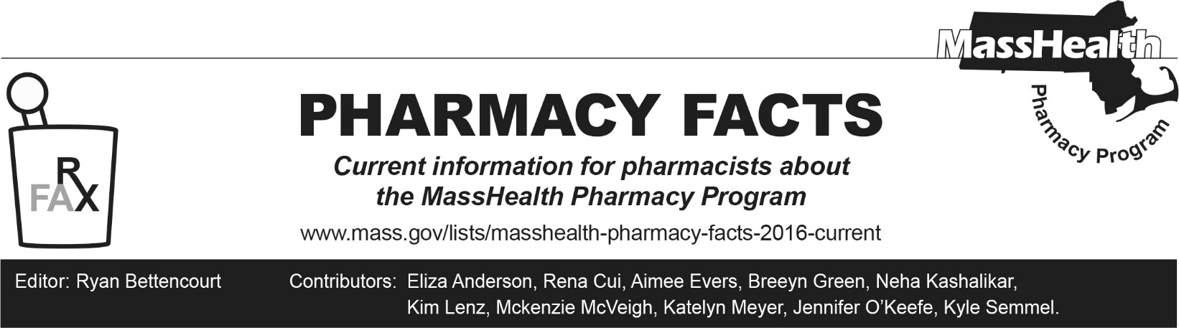
Number 266, December 18, 2025

Changes in Pulmicort® Rebate Status Impacting MassHealth Coverage

Pulmicort Flexhaler® (budesonide) has recently been issued a new National Drug Code (NDC), and the prior NDCs have been discontinued by the manufacturer. The new NDCs are associated with labeler Rubicon Holdings (labeler code 85612), which does not participate in the Medicaid Drug Rebate Program (MDRP). These new NDCs will not be covered by MassHealth. See 130 CMR 406.412(A)(1).

Pharmacies may have remaining stock of NDCs from labelers that participate in MDRP (labeler codes 00186 and 61269). MassHealth will continue to cover the NDCs associated with labeler codes that participate in MDRP (labeler codes 00186 and 61269) until remaining supply in circulation has been depleted.

MassHealth Covered Alternative Inhaled Corticosteroids
Pharmacies and prescribers should work to transition members to therapeutically appropriate covered alternatives. MassHealth covers several inhaled corticosteroids without prior authorization (PA), including the following.
- Arnuity Ellipta® (fluticasone furoate inhalation powder)
- Asmanex HFA® (mometasone inhalation aerosol)
- Asmanex Twisthaler® (mometasone inhalation powder)
- Generic fluticasone propionate HFA for patients < 12 years of age

Please note that MassHealth management of budesonide respules is not impacted by this change and remain available without PA for members ≤13 years of age. Please see the MassHealth Drug List Therapeutic Table 23: Respiratory Agents - Inhaled for more information on coverage of inhaled corticosteroids.

