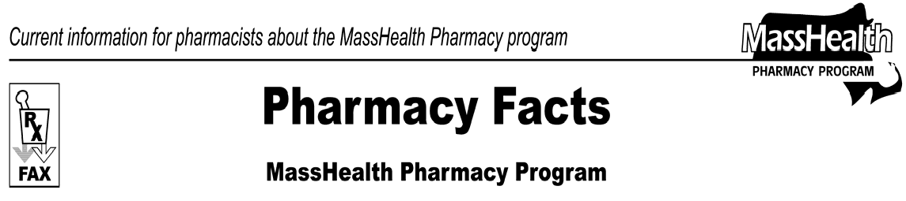
Number 27
April 20, 2007
www.mass.gov/masshealth/pharmacy
- Editor: Vic Vangel • Contributors: Chris Burke, Gary Gilmore, Paul Jeffrey, James Monahan, Chuck Young •
National Provider Identifier (NPI)  All MassHealth pharmacy claims must be submitted using the pharmacy’s NPI number as the pharmacy identifier beginning on May 23, 2007. When using the NPI number as the pharmacy identifier, the service provider ID qualifier (NCPDP-field 202-B2) must be entered as 01. Pharmacies may submit claims using their NPI number beginning May 1st, but submission  with an NPI number becomes mandatory beginning May 23, 2007. MassHealth will continue to accept the prescriber’s DEA number as the prescriber identifier. The prescriber’s DEA number will continue to be the preferred prescriber identifier on a MassHealth pharmacy claim. At this time MassHealth will not accept a prescriber’s NPI number on a pharmacy claim.  Payment Error Rate Measurement (PERM)  Pharmacy providers need to be aware that Massachusetts was selected to participate in the federal implementation of the Payment Error Rate Measurement (PERM) project during 2007. The Centers for Medicare & Medicaid Services (CMS) implemented the PERM project to measure improper payments in the Medicaid program. The Improper Payments Information Act (IPIA) directs federal agency heads to conduct annual reviews of programs that are susceptible to erroneous payments. The PERM project requires states to work with CMS in developing a national payment error rate to comply with the IPIA. Massachusetts will work closely with CMS and their partners to support this federal project. Pharmacy providers who have claims selected as part of the PERM project will be contacted by CMS representatives to provide information so that CMS can determine the validity of payments made. Once the pharmacy receives the documentation request, the information must be submitted electronically or in hard copy within 90 days. All providers will receive a document with more details about this project.  For more information about PERM go to the CMS Web site at http://www.cms-perm.org/. | MassHealth Drug List Update Effective April 17, 2007  The following products will be payable through the Pharmacy Online Processing System (POPS) beginning on April 17, 2007. They will be listed in a new section of the MassHealth Drug List titled Non-Drug Product List in the near future.  Euflexxa (hyaluronate) – PA Hyalgan (hyaluronate) – PA Orthovisc (hyaluronan) – PA Supartz (hyaluronate) – PA Synvisc (hylan polymers) – PA
Please direct any questions or comments (or to be taken off of this fax distribution) to
Victor Moquin of ACS at 617-423-9830.

