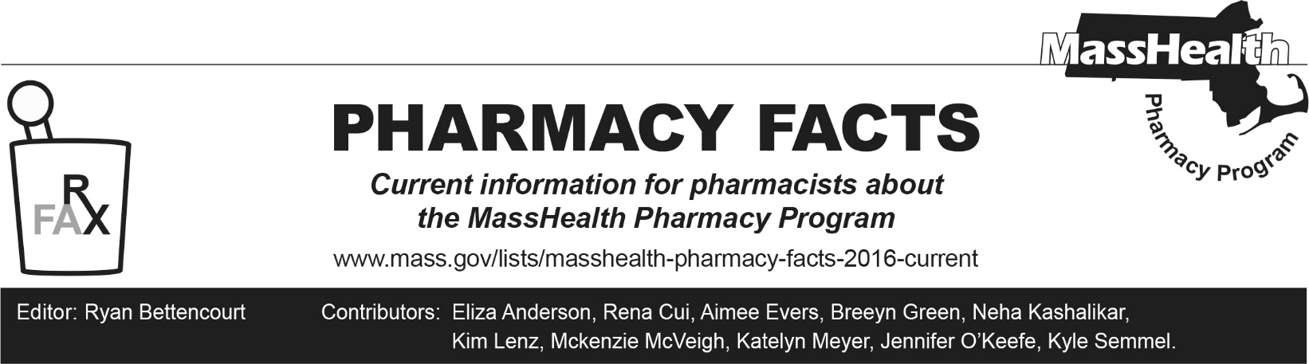
Number 272, April 10, 2026

MassHealth Drug List Update
Below are updates to the MassHealth Drug List (MHDL). See the MHDL for a complete listing of updates.

Additions
Effective April 1, 2026, the following newly marketed drugs have been added to the MassHealth Drug List.
- Andembry (garadacimab-gxii) – PA
- Blujepa (gepotidacin) – PA
- Brinsupri (brensocatib) – PA
- Dawnzera (donidalorsen) – PA
- Ekterly (sebetralstat) – PA
- Ensacove (ensartinib) – PA
- Leqembi Iqlik (lecanemab-irmb) – PA
- Lynkuet (elinzanetant) – PA
- Modeyso (dordaviprone) – PA
- Orlynvah (sulopenem etzadroxil/probenecid) – PA
- Papzimeos (zopapogene imadenovec-drba) – PA; MB
- Rhapsido (remibrutinib) – PA
  - tramadol 75 mg – PA
  - ustekinumab-ttwe, unbranded 45 mg/0.5 mL vial – PA
  - Vizz (aceclidine ophthalmic solution) – PA

Change in Prior Authorization Status
- Effective April 1, 2026, the following acetylcholinesterase inhibitor requires PA.
  - pyridostigmine bromide solution – PA; A90
- Effective April 1, 2026, the following drug cessation agent no longer requires PA within updated dose and duration limits.
  - buprenorphine sublingual tablet – PA > 5 days treatment/180 days and PA > 32 mg/day
- Effective April 1, 2026, the following hereditary angioedema agents no longer requires PA within newly established quantity limits.
  - Berinert (c1 esterase inhibitor, human) – PA > 14 injections/30 days
  - Firazyr (icatibant) – PA > 6 injections/30 days; #
  - Kalbitor (ecallantide) – PA > 12 injections/30 days; MB
  - Ruconest (c1 esterase inhibitor, recombinant) – PA > 8 injections/30 days
- Effective April 1, 2026, the following chemotherapy agent no longer requires PA.
  - lomustine
- Effective April 1, 2026, the following antiretroviral agent no longer requires PA.
  - Yeztugo (lenacapavir)

Updated MassHealth Brand Name Preferred Over Generic Drug List

The MassHealth Brand Name Preferred Over Generic Drug List has been updated to reflect recent changes to the MassHealth Drug List.
- Effective April 1, 2026, the following agents were added to the MassHealth Brand Name Preferred Over Generic Drug List.
- Cipro HC (ciprofloxacin/hydrocortisone); BP
- Mavenclad (cladribine tablet) – PA; BP
- Rowasa (mesalamine enema); BP, A90
- Effective April 1, 2026, the following agents were removed from the MassHealth Brand Name Preferred Over Generic Drug List.
- Cardura (doxazosin immediate-release); #, M90
- Daytrana (methylphenidate transdermal) – PA < 3 years or ≥ 21 years and PA > 1 unit/day; #
- Entresto (sacubitril/valsartan tablet) – PA
- Inspra (eplerenone); #, M90
- Sancuso (granisetron transdermal system) – PA

Updated MassHealth 90-day Initiative
- Effective April 1, 2026, the following agent may be allowed or mandated to be dispensed in up to a 90-day supply, as indicated below.
  - Edurant (rilpivirine tablet); BP; A90
  - Jentadueto (linagliptin/metformin); BP, M90
- Effective April 1, 2026, the following agent is no longer allowed or mandated to be dispensed in up to a 90-day supply, as indicated below.
  - Farxiga (dapagliflozin); BP

Updated MassHealth Supplemental Rebate/Preferred Drug List
The MassHealth Supplemental Rebate/Preferred Drug List has been updated to reflect recent changes to the MassHealth Drug List.
- Effective April 1, 2026, the following antiretroviral agent were added to the MassHealth Supplemental Rebate/Preferred Drug List.
- Yeztugo (lenacapavir) ^{PD}
- Effective April 1, 2026, the following targeted immunomodulators were removed from the MassHealth Supplemental Rebate/Preferred Drug List.
- Humira (adalimumab) – PA
- Stelara (ustekinumab 45 mg/0.5 mL prefilled syringe, 90 mg/mL prefilled syringe, 45 mg/0.5 mL vial) – PA

Abbreviations, Acronyms, and Symbols
# Designates a brand-name drug with FDA “A”-rated generic equivalents. Prior authorization is required for the brand, unless a particular form of that drug (for example, tablet, capsule, or liquid) does not have an FDA “A”-rated generic equivalent.
MB This drug is available through the healthcare professional who administers the drug or in an outpatient or inpatient hospital setting. MassHealth does not pay for this drug to be dispensed through the retail pharmacy. If listed, PA does not apply through the hospital outpatient and inpatient settings. Please refer to 130 CMR 433.408 for PA requirements for other healthcare professionals. Notwithstanding the above, this drug may be an exception to the unified pharmacy policy; please refer to respective MassHealth Accountable Care Partnership Plans (ACPPs) and Managed Care Organizations (MCOs) for PA status and criteria, if applicable.
PA Prior authorization is required. The prescriber must obtain PA for the drug in order for the provider to receive reimbursement. Note: PA applies to both the brand-name and the FDA “A”-rated generic equivalent of listed product.
A90 Allowable 90-day supply. Dispensing in up to a 90-day supply is allowed. May not include all strengths or formulations. Quantity limits and other restrictions may apply.
BP Brand Preferred over generic equivalents. In general, MassHealth requires a trial of the preferred drug or clinical rationale for prescribing the non-preferred drug generic equivalent.
M90 Mandatory 90-day supply. After dispensing up to a 30-day supply initial fill, dispensing in a 90-day supply is required. May not include all strengths or formulations. Quantity limits and other restrictions may also apply.
PD Preferred Drug. In general, MassHealth requires a trial of the preferred drug or clinical rationale for prescribing a non-preferred drug within a therapeutic class.

