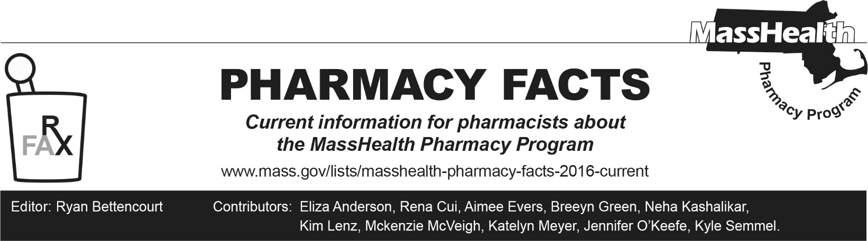
Number 273, May 4, 2026

MassHealth Drug List Update
Below are updates to the MassHealth Drug List (MHDL). See the MHDL for a complete listing of updates.

Additions
Effective May 11, 2026, the following newly marketed drugs have been added to the MassHealth Drug List.
- Bildyos (denosumab-nxxp) – PA
- Bilprevda (denosumab-nxxp) – PA
- Bynfezia (octreotide auto-injection)
- Egrifta WR (tesamorelin) – PA
- Enoby (denosumab-qbde) – PA
- Imkeldi (imatinib solution) – PA
- Itvisma (onasemnogene abeparvovec-brve) ^{PD} – PA; CO
- Jascayd (nerandomilast) – PA
- Kirsty (insulin aspart-xjhz) – PA
- Merilog (insulin aspart-szjj) – PA
- Otezla XR (apremilast extended-release) – PA
- Palsonify (paltusotine) – PA
- Redemplo (plozasiran) – PA
- Steqeyma (ustekinumab-stba 45 mg/0.5 mL vial) – PA
- Wayrilz (rilzabrutinib) – PA
- Wegovy (semaglutide tablet) ^{PD} – PA
- Xtrenbo (denosumab-qbde) – PA

Change in Prior Authorization Status
- Effective May 11, 2026, the following antiemetic agent will require PA.
  - Sustol (granisetron extended-release injection) – PA
- Effective May 11, 2026, the following anti-hemophilia agent will require PA.
  - Hemlibra (emicizumab-kxwh) – PA
- Effective May 11, 2026, the following antidiabetic agents will require PA.
  - Humalog (insulin lispro 200 units/mL) – PA
  - Novolin (insulin NPH/regular insulin 70/30) – PA
  - Toujeo (insulin glargine) – PA; BP
  - Tresiba (insulin degludec) – PA; BP
- Effective May 11, 2026, the following anticoagulant agents will no longer require PA.
  - Eliquis (apixaban sprinkle capsule)
  - Eliquis (apixaban tablet for oral suspension)

Change in Coverage Status
Effective May 11, 2026, the following agent will no longer be restricted to medical billing.
- Supprelin LA (histrelin) – PA

Updated MassHealth Brand Name Preferred Over Generic Drug List
The MassHealth Brand Name Preferred Over Generic Drug List has been updated to reflect recent changes to the MassHealth Drug List.
- Effective May 11, 2026, the following agents will be added to the MassHealth Brand Name Preferred Over Generic Drug List.
- Besivance (besifloxacin ophthalmic suspension); BP
- Eliquis (apixaban sprinkle capsule, tablet for oral suspension) ^{PD}; BP
- Zylet (tobramycin/loteprednol ophthalmic suspension); BP
- Effective May 11, 2026, the following agent will be removed from the MassHealth Brand Name Preferred Over Generic Drug List.
- Sporanox (itraconazole 100 mg capsule); #, A90

Updated MassHealth 90-day Initiative
- Effective May 11, 2026, the following agents may be allowed or mandated to be dispensed in up to a 90-day supply, as indicated below.
  - Atrovent HFA (ipratropium inhalation aerosol); BP; A90
  - melatonin; *, M90
  - Ofev (nintedanib) – PA; A90
  - Savella (milnacipran); BP, A90
  - Ultravate (halobetasol lotion) – PA; A90
- Effective May 11, 2026, the following agents will no longer be allowed or mandated to be dispensed in up to a 90-day supply, as indicated below.
  - dihydroergotamine nasal spray – PA
  - ergotamine/caffeine suppository – PA
  - Golytely (polyethylene glycol-electrolyte solution); #
  - palonosetron 0.25 mg/2 mL injection – PA > 2 injections/28 days
  - polyethylene glycol-electrolyte solution
  - Suprep (sodium sulfate/potassium sulfate/magnesium sulfate); BP

Updated MassHealth Over-the-Counter Drug List
The MassHealth Over-the-Counter Drug List has been updated to reflect recent changes to the MassHealth Drug List.
- Effective May 11, 2026, the following topical antifungal agent will be added to the MassHealth Over-the-Counter Drug List.
- butenafine; *
- Effective May 11, 2026, the following agents were removed from the MassHealth Over-the-Counter Drug List.
  - cod liver oil; *, M90
  - magaldrate; *, M90
  - witch hazel; *, A90

Abbreviations, Acronyms, and Symbols
# Designates a brand-name drug with FDA “A”-rated generic equivalents. Prior authorization is required for the brand, unless a particular form of that drug (for example, tablet, capsule, or liquid) does not have an FDA “A”-rated generic equivalent.
MB This drug is available through the healthcare professional who administers the drug or in an outpatient or inpatient hospital setting. MassHealth does not pay for this drug to be dispensed through the retail pharmacy. If listed, PA does not apply through the hospital outpatient and inpatient settings. Please refer to 130 CMR 433.408 for PA requirements for other healthcare professionals. Notwithstanding the above, this drug may be an exception to the unified pharmacy policy; please refer to respective MassHealth Accountable Care Partnership Plans (ACPPs) and Managed Care Organizations (MCOs) for PA status and criteria, if applicable.
* The generic OTC and, if any, generic prescription versions of the drug are payable under MassHealth without PA.
PA Prior authorization is required. The prescriber must obtain PA for the drug in order for the provider to receive reimbursement. Note: PA applies to both the brand-name and the FDA “A”-rated generic equivalent of listed product.
A90 Allowable 90-day supply. Dispensing in up to a 90-day supply is allowed. May not include all strengths or formulations. Quantity limits and other restrictions may apply.
BP Brand Preferred over generic equivalents. In general, MassHealth requires a trial of the preferred drug or clinical rationale for prescribing the non-preferred drug generic equivalent.
M90 Mandatory 90-day supply. After dispensing up to a 30-day supply initial fill, dispensing in a 90-day supply is required. May not include all strengths or formulations. Quantity limits and other restrictions may also apply.
^{CO} Carve-Out. This agent is listed on the Acute Hospital Carve-Out Drugs List and is subject to additional monitoring and billing requirements
PD Preferred Drug. In general, MassHealth requires a trial of the preferred drug or clinical rationale for prescribing a non-preferred drug within a therapeutic class.

