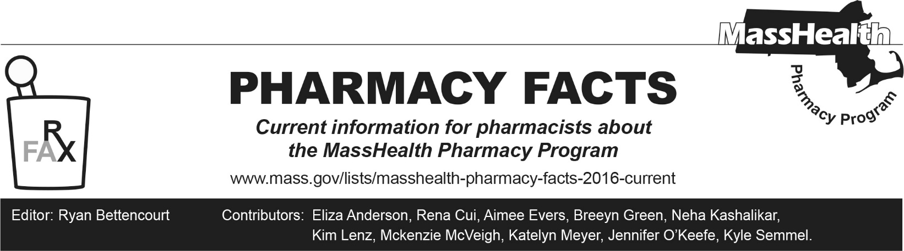
Number 274, May 8, 2026

Changes in Exclusion of Designated 340B Drugs for MassHealth Fee-for-Service Coverage
MassHealth is expected to make changes to its fee-for-service (FFS) coverage of 340B drugs dispensed by pharmacies and billed through pharmacy point-of-sale adjudication. This Pharmacy Facts will expand upon the information provided in All Provider Bulletin 414, focusing on pharmacy claims submission in the Pharmacy Online Processing System (POPS).

All anticipated changes are subject to final rulemaking in 130 CMR 405.000, 130 CMR 406.000, and 130 CMR 410.000.

Pharmacy Claims Processing
MassHealth anticipates that as of effective date of July 1, 2026, we will no longer pay for drugs acquired through the 340B Drug Pricing Program when those drugs are billed through pharmacy point-of-sale adjudication in MassHealth fee-for-service (FFS). This change applies to pharmacy claims submitted to POPS to MassHealth FFS, the primary care clinician (PCC) Plan, Primary Care Accountable Care Organization (PCACO-B), or the Children’s Medical Security Plan as a primary payer (Other Coverage Code “00”, “01”, or “03”). This change does not apply to pharmacy claims in which MassHealth FFS, the PCC Plan, PCACO-B, or the Children’s Medical Security Plan is a secondary payer (other Coverage Code “02” or “04”), Health Safety Net pharmacy claims, or MassHealth Managed Care Entity pharmacy claims.

Pharmacies that are registered with the MassHealth Pharmacy Program to use drugs acquired through the 340B Drug Pricing Program will begin seeing the following a rejection message on July 1, 2026:

70 – Product/Service Not Covered, with text message, 340B PHARMACY CLAIMS ARE ONLY PERMITTED WHEN MASSHEALTH OR CMSP ARE BILLED AS A SECONDARY PAYER.

When a pharmacy sees this message, they should resubmit the pharmacy claim without any 340B identifiers (e.g., as a non-340B pharmacy claim). Pharmacies should work with the MassHealth Pharmacy Program to ensure they can submit non-340B pharmacy claims.

MassHealth Pharmacy Program 340B Registration and 340B Office of Pharmacy Affair Information System (OPAIS) Instructions
Pharmacies will continue to be required to register directly with the MassHealth Pharmacy Program prior to billing MassHealth as a secondary payer for any drugs acquired through the 340B Drug Pricing Program. If a pharmacy is already registered, new registration will not be needed. In addition, 340B pharmacy claims submitted to MassHealth as a secondary payer are still required to be submitted with correct 340B identifiers (i.e. Submission clarification code “20”, Basis of Cost “08”, authorization number). Please see Pharmacy Facts 238 for more information on 340B claim identification and registration.

When a 340B pharmacy is registered with the MassHealth Pharmacy Program, a 340B claim processing arrangement is agreed upon between the entity and MassHealth to prevent duplicate discounts. Upon agreement, specific claim processing instructions are provided by MassHealth. As a part of the agreement, MassHealth requires the 340B entity to report accurate information to 340B OPAIS.

340B entities that choose to submit 340B pharmacy claims to MassHealth as a secondary payer should continue to report accurate carve-in information to 340B OPAIS. This includes the following.
- For entity-owned pharmacies that have a dedicated 340B pharmacy NPI and a non-340B pharmacy NPI, only the 340B pharmacy NPI and Medicaid ID should be included on 340B OPAIS.
- For entity-owned or contract pharmacies who choose to utilize one submitting pharmacy NPI and must include the NPI of the 340B entity in the PA Number Submitted Field of the 340B claim, the NPI and Medicaid ID of the 340B entity should continue to be included on 340B OPAIS. The submitting pharmacy’s NPI and Medicaid ID should not be included on 340B OPAIS, as those are used to bill non-340B claims.

