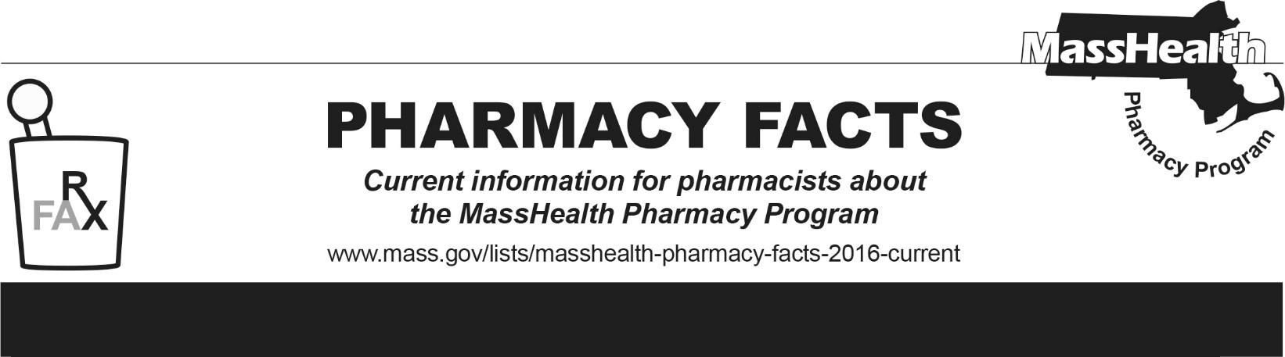
Editor: Ryan Bettencourt Contributors: Eliza Anderson, Sarah Dube, Rena Cui, Aimee Evers, Breeyn Green, Neha Kashalikar, Kim Lenz, Mckenzie McVeigh, Katelyn Meyer, Jennifer O’Keefe, Kyle Semmel
Number 275, May 12, 2026

Upcoming Changes to MassHealth and Health Safety Net (HSN) Management of NPH Insulin Effective July 1, 2026
MassHealth currently covers Novolin® N (insulin NPH) without prior authorization (PA) and Humulin® N (insulin NPH) with PA. Effective July 1, 2026, MassHealth will require PA for Novolin® N (insulin NPH) and remove PA from Humulin® N (insulin NPH). Additionally, Humulin® N (insulin NPH) will be added to the MassHealth Brand Preferred Over Generic List (BOGL).

Effective July 1, 2026 – Changes to MassHealth Management
- Novolin® N (insulin NPH) will require PA
- Humulin® N (insulin NPH) will no longer require PA

Novolin® N (insulin NPH) and Humulin® N (insulin NPH) contain the same active medication and are identical in dosing and administration frequency; however, they are not considered interchangeable at the pharmacy level. As a result of this change, MassHealth patients prescribed Novolin® N (insulin NPH) will need a new prescription for Humulin® N (insulin NPH), or have their provider submit a PA for continued use of Novolin® N (insulin NPH). For those that require Novolin® N (insulin NPH), prior authorizations must document an appropriate diagnosis and an inadequate response, adverse reaction, or contraindication to Humulin® N (insulin NPH).

Effective July 1, 2026 – Changes to HSN Management
Humulin® N (insulin NPH) will be added to the MassHealth Brand Preferred Over Generic list (BOGL). As a result, Humulin® N (insulin NPH) will be available without PA for HSN patients.

The MassHealth Drug List is on the MassHealth Pharmacy Program website at www.mass.gov/masshealth/pharmacy.

