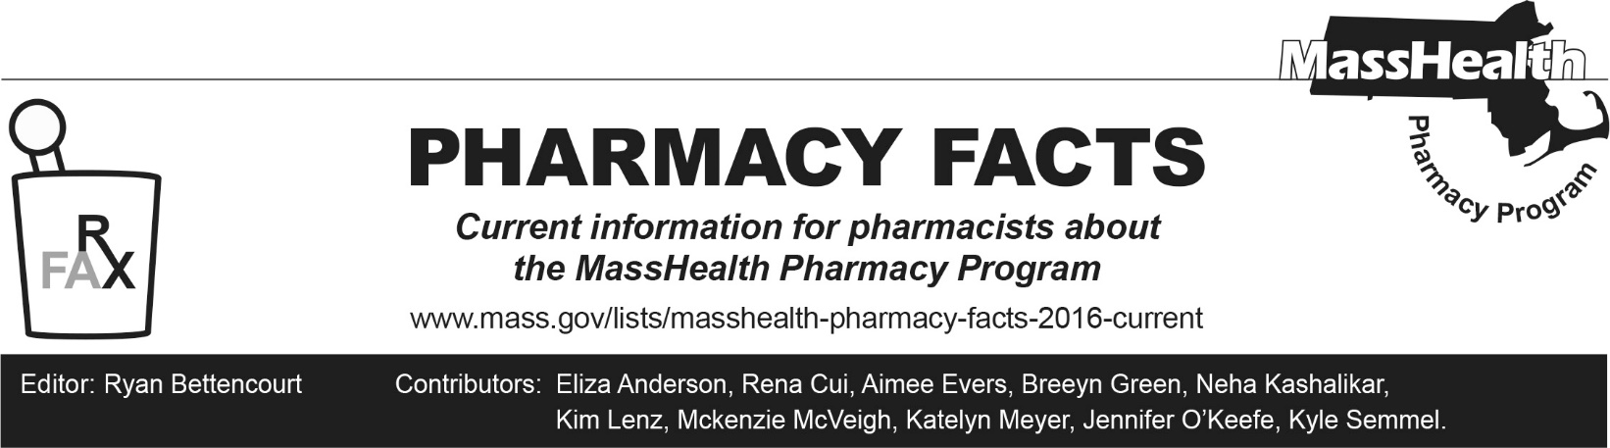
Number 276, May 13, 2026

MassHealth Changes to Management of Anti-Obesity Medications
As originally noted in Pharmacy Facts 271 and in accordance with anticipated forthcoming changes to MassHealth regulations at 130 CMR 406.413(B), MassHealth will no longer cover drugs used only for the treatment of obesity or overweight.

Effective July 1, 2026, the drugs listed below in Table 1 will no longer be covered for MassHealth members when used only for the treatment of obesity or overweight. This applies to all members, whether enrolled in Fee for Service (FFS); managed care organizations (MCOs); Program of All-inclusive Care for the Elderly (PACE); accountable care partnership plans (ACPP); primary care accountable care organizations (PCACOs); and Primary Care Clinician (PCC), Senior Care Options (SCO), or One Care plans.

Table 1: Anti-Obesity Medications
Anti-Obesity Medications*
benzphetamine
diethylpropion, diethylpropion extended-release
Saxenda (liraglutide)
Xenical (orlistat)
phendimetrazine, phendimetrazine extended-release
Lomaira, Adipex-P (phentermine capsule, tablet)
phentermine/topiramate extended-release
Wegovy (semaglutide)
Zepbound (tirzepatide)
*Any drug being used off label for weight loss is not payable for MassHealth patients.

End-Dating of Prior Authorizations Submitted Before February 17, 2026, and Review of New Prior Authorizations
All prior authorizations (PAs) for weight loss medications submitted before February 17, 2026, will be end-dated for June 30, 2026, regardless of indication, and will need to be resubmitted and approved to receive paid claims beyond June 30, 2026.
Medically accepted indications for use of a weight loss medication beyond June 30, 2026, include the following.
- Body mass index (BMI) >27 kg/m² and established cardiovascular disease to reduce the risk of major adverse cardiovascular events (MACE)
- BMI >30 kg/m² and moderate-to-severe obstructive sleep apnea (OSA)
- Metabolic dysfunction-associated steatohepatitis (MASH)
- Members younger than 21 when deemed medically necessary under Early and Periodic Screening, Diagnostic, and Treatment (EPSDT) requirements

Effective July 1, 2026, Wegovy® (semaglutide) will be the sole preferred drug for ALL other medically accepted indications.
Effective July 1, 2026, Zepbound® (tirzepatide) will no longer be a preferred drug. PAs for continued treatment with Zepbound® (tirzepatide), beyond June 30, 2026, for the medically accepted indications above, will require a trial of Wegovy® (semaglutide) for all patients.

To ease the transition, members with an approved PA for Zepbound® (tirzepatide), for a medically accepted indication, that extends beyond June 30, 2026, will have their PA replaced with an approved PA for Wegovy® (semaglutide) for the remainder of the original Zepbound® (tirzepatide) authorization. A new prescription for Wegovy® (semaglutide) will be required.

Please see Table 2 for guidance on the dosing conversions when switching patients to Wegovy® (semaglutide).

Table 2. Dosing Conversions for Injectable Non-Diabetic GLP-1 and GLP-1/GIP Medications¹
Medication Comparative Dose (mg)
Liraglutide once daily | 0.6 | 1.2 | 1.8-3 | - | - | - | - | - | -
Semaglutide once weekly | - | 0.25 | 0.5 | 1 | 2-2.4 | 2.4 | 2.4 | 2.4 | 2.4
Tirzepatide once weekly | - | - | 2.5 | - | 5 | 7.5 | 10 | 12.5 | 15
GLP-1=glucagon-like peptide-1, GIP=glucose-dependent insulinotropic polypeptide

References
- Whitley HP, Trujillo JM, Neumiller JJ; Special Report: Potential Strategies for Addressing GLP-1 and Dual GLP-1/GIP Receptor Agonist Shortages. Clin Diabetes 1 July 2023; 41 (3): 467–473

